Section 1- The Fundamentals

**Security**

**Authentication:-**

It is the process of letting an application know who we are whether we have access or not

**Authorization**

It is the process of application determining how much access we have depending on the role that is assigned to the user

Ex:- when we login in banking application , we need to give user id and pw and banking application will validate user id and pw. This process is called authentication

Once we login in application , it uses role to do authorization.

Each role is mapped to certain urls or method in the application and user with certain role have access to certain functionality within the application and certain user will not have access to certain functionality in the application.

**There are different way of authentication**

**Http :-**

Basic

Form based

**Restful**

Oauth single sign on

Note : we can create our own authentication and authorization process as well

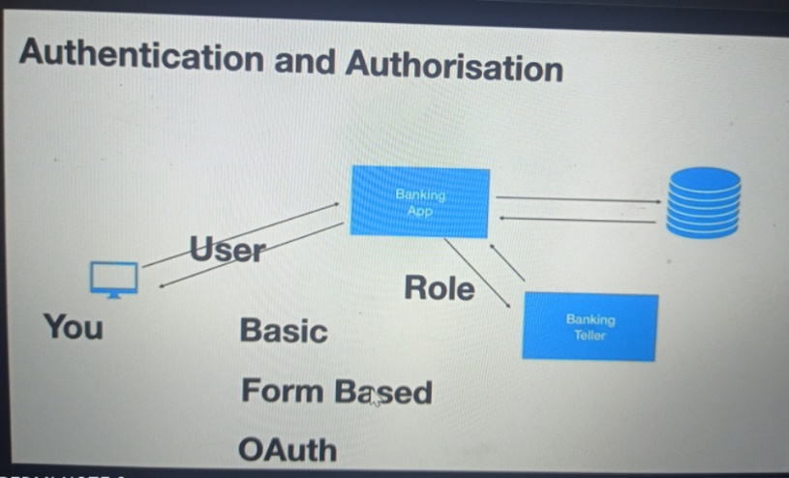

**Confidentiality**

Application ensure that the data they are sharing is not vulnerable to hackers

**Example :--**

if our neighborhood hack the credential over the n/w then what will happen that is where encryption and decryption come in . The simplest way of doing encrypting and decrypting is by using https

Hackers not able to do anything even they got credential until they got private key which will use by application to decrypt data

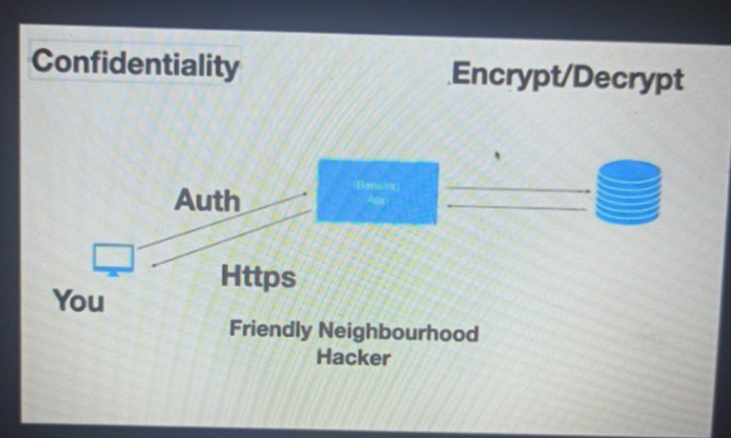

**Integrity**

Integrity is check using signature , when token send it will be signature

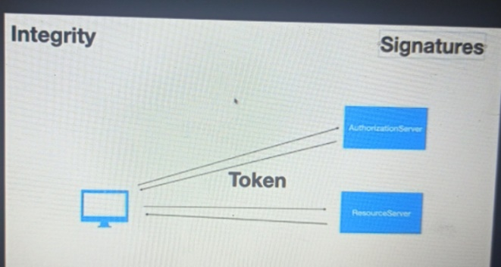

**CSRF:-**

**Cross site request forgery (prevent)**

Will prevent another website to submit data on your behalf

**CORS**

**CROSS origin resource sharing (allow)**

Browser donts allow cors we should enable cors in server side application , frontend and backend running on different domain

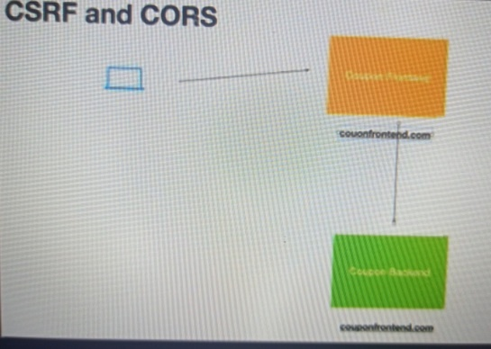

**The key security components**

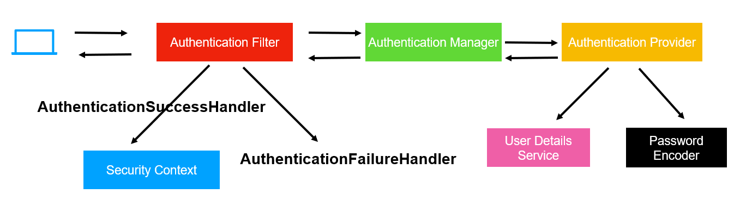

When end user or restful client send a request to restful application the very first component in spring security

Intercept the request is the **authenticationFilter** . AuthenticationFilter is servlet filter class that will see

If user has been authenticated if not it will send back that request to **Authentication Manager** to check that the details sends by the user is correct( user name and password are valid). Authentication Manager intern uses

**Authentication Provider** this is where login logic or authentication logic is defined. Authentication Provider will

Not fetch user details from ldap, d/b or in memory, it will use User Details Service for that purpose.

It also uses **Password Encode**r because we don’t want save p/w in plain text. Once the authentication provider

Check the user detail and password is correct it will send the appropriate response back to the

Authentication Manager. The Authentication Manager hand back to Authentication Filter. If the authentication

Or user details is ok means authentication success then Authentication Filter use **AuthenticationSuccessHandler**

And store the user information , the user entity itself in instance of **SecurityContext**. If the Authentication failed it will use **AuthenticationFailureHandler** to send appropriate response back to the client.

**UserDetailsService** is responsible for fetching the information , it could be ldap, authorization server of oauth,

It could be d/b or in memory etc

**PasswordEncoder :** is responsible for encoding the pw

**SecurityContext :** is where user information is stored for future

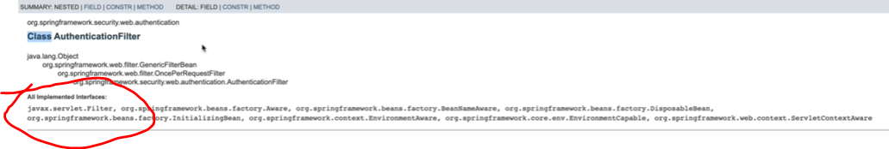

**AuthenticationProvider ---- interface ------**

having method authenticate while will take Authentication as object

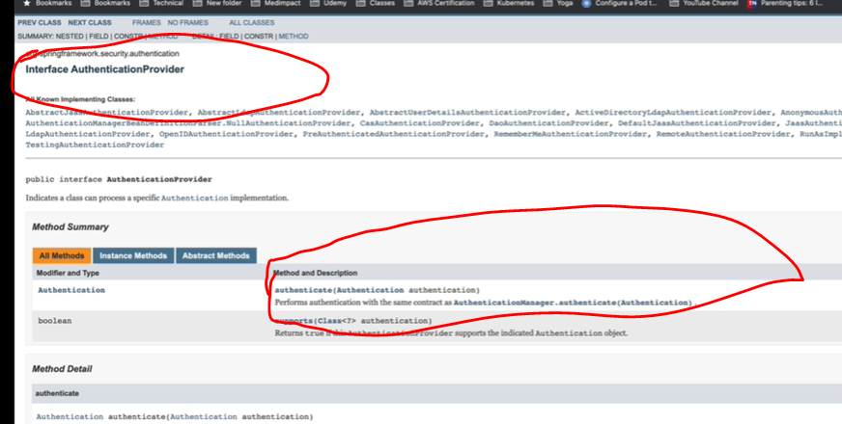

Except AuthenticationFilter all are interface

**Note**

**Spring provides default implementation that will be enabled when we use spring security**

PasswordEncoder

AuthenticationManager

AuthenticationProvider

UserDetailsService

We can customize when we want to use our own security we will override UserDetailsService,AuthenticationManager

**Note:** if we don’t want default we can configure this

**Spring security**

**Note :**

By default it uses basic authentication

**Spring Security in action**

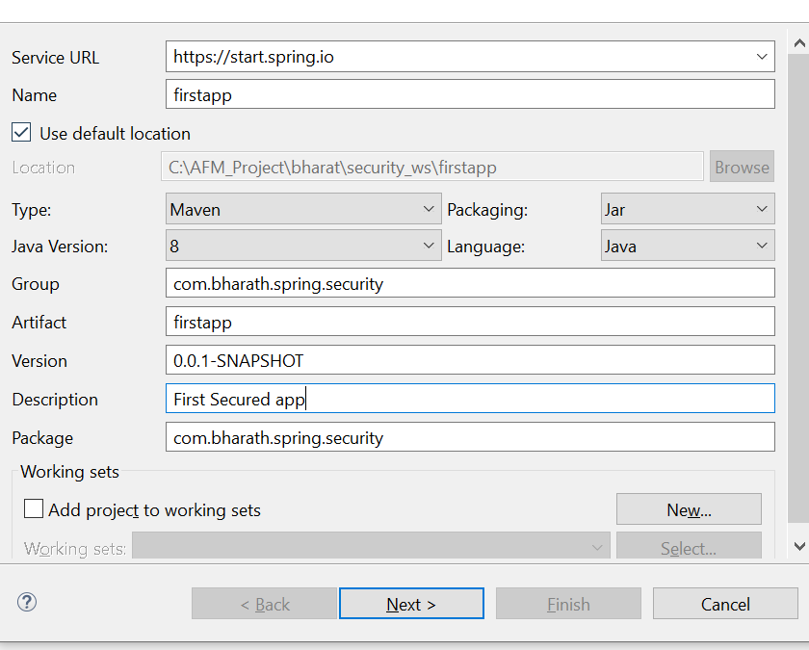

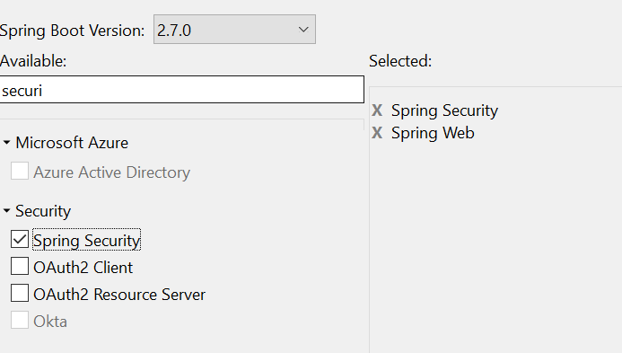

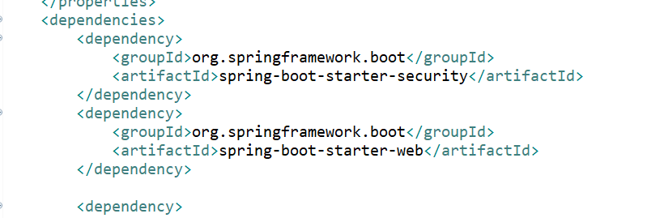

Note:--

As soon as will add spring-boot-starter-security, security is enabled for authentication

UserDetailsService job (default):---- it will create pw in console and create user by name user

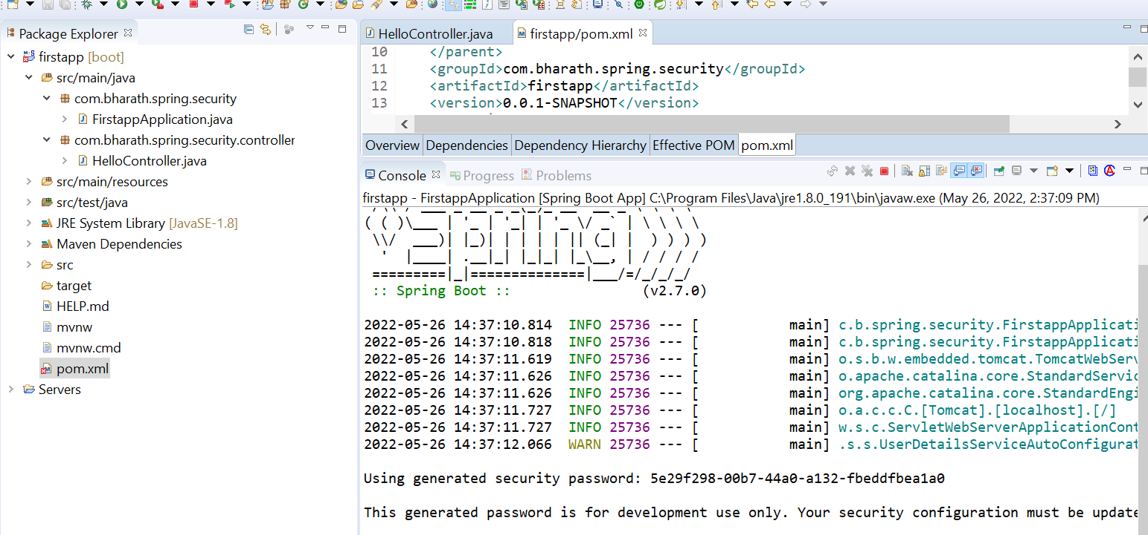

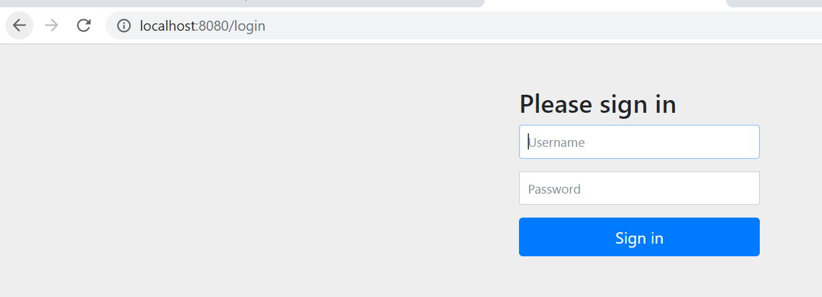

**Note:-**

And it stores username and pw in memory. If we restart application both are gone

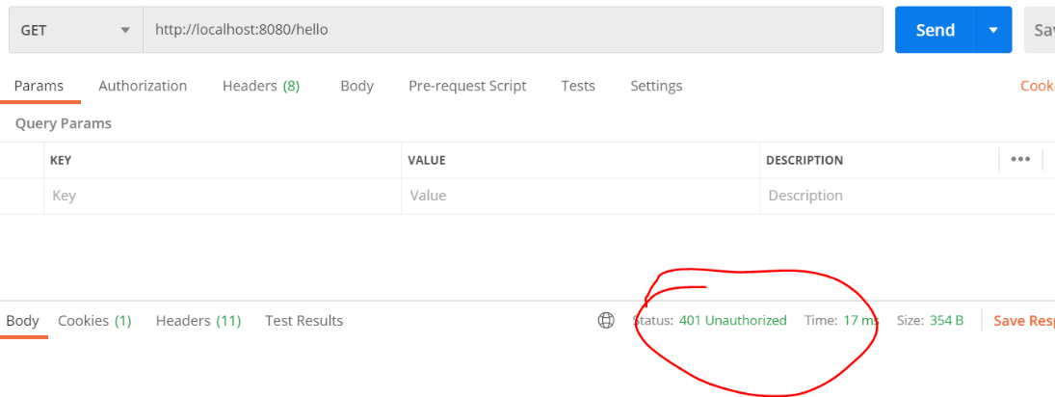

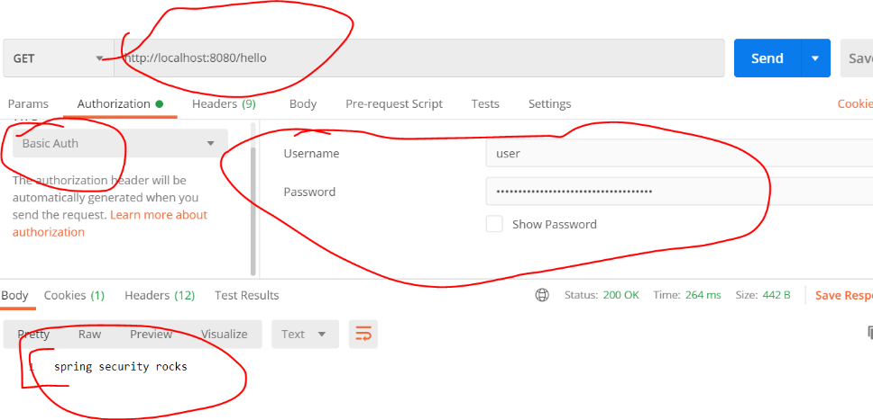

**Note :--**

the default passwordencoder does not encode pw. It uses the plain text

**Resending Basic Auth details**

How basic authentication flow work behind the scene

**It will generate a cookie**

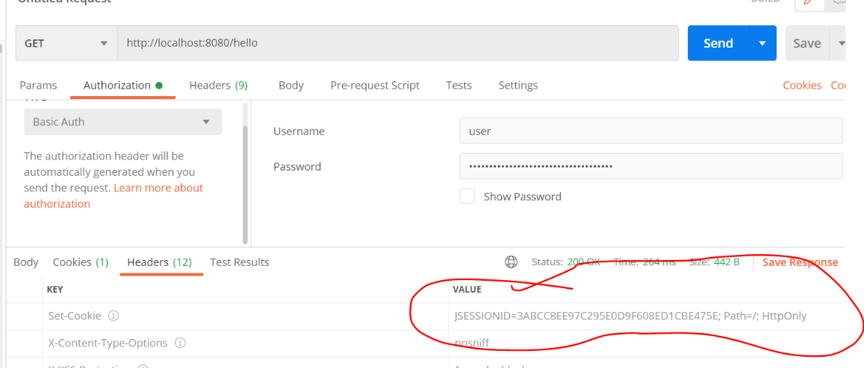

In web application it will generate a cookie , jsessionid and it stores it inside security context.

They will send cookie back along with the request everytime we are hitting it . The next time filter will see the cookie and check if there is corresponding response is there. That is the reason from second time onwards it doesn't asked basic authentication

First time request :-- jsessionid will create

Second time request :-- jsessionid will use as key and it will check by AuthenticationFilter

**Create Custom Security Configuration**

**Requirement :-** will create our own user and p/w

**httpSecurity** :---

how the url within the application should be accessed

**AuthenticationManager :**

Will configure user name and pw

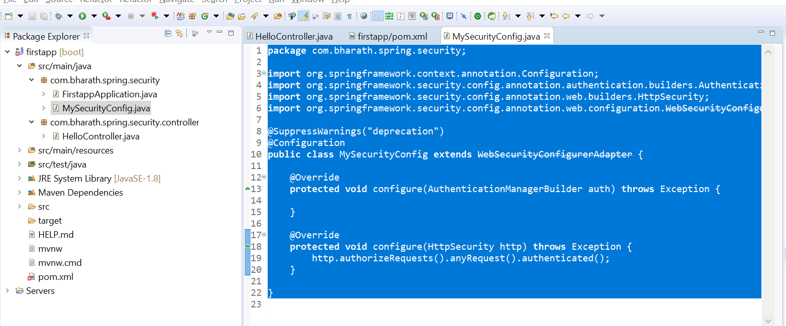

**Use Custom UserDetailsService**

How to Use UserDetailsService and password encoder

**Imp**

1-AuthenticationManagerBuilder auth have method UserDetailsService

**2-AuthenticationManager** which internally uses **AuthenticationBuilder** knows how to use **UserDetailsService**

**3-But UserDetailsService doesn’t know which user need to use while using below line**

4-InMemoryUserDetailsManager userDetailsService = new InMemoryUserDetailsManager();

Note:

When we run our application internally authenticationprovider use passwordencoder automtically

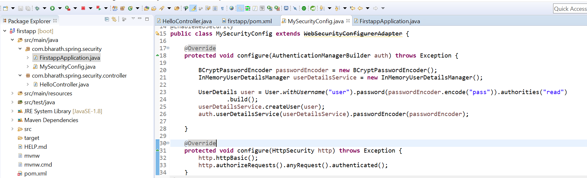

Whatever we are storing in memory like pw that also should be encoded

**Test**

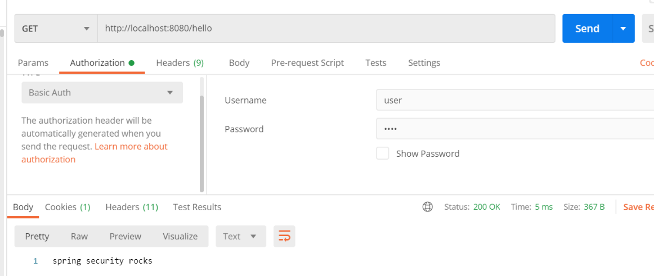

**Tweak the password encoder**

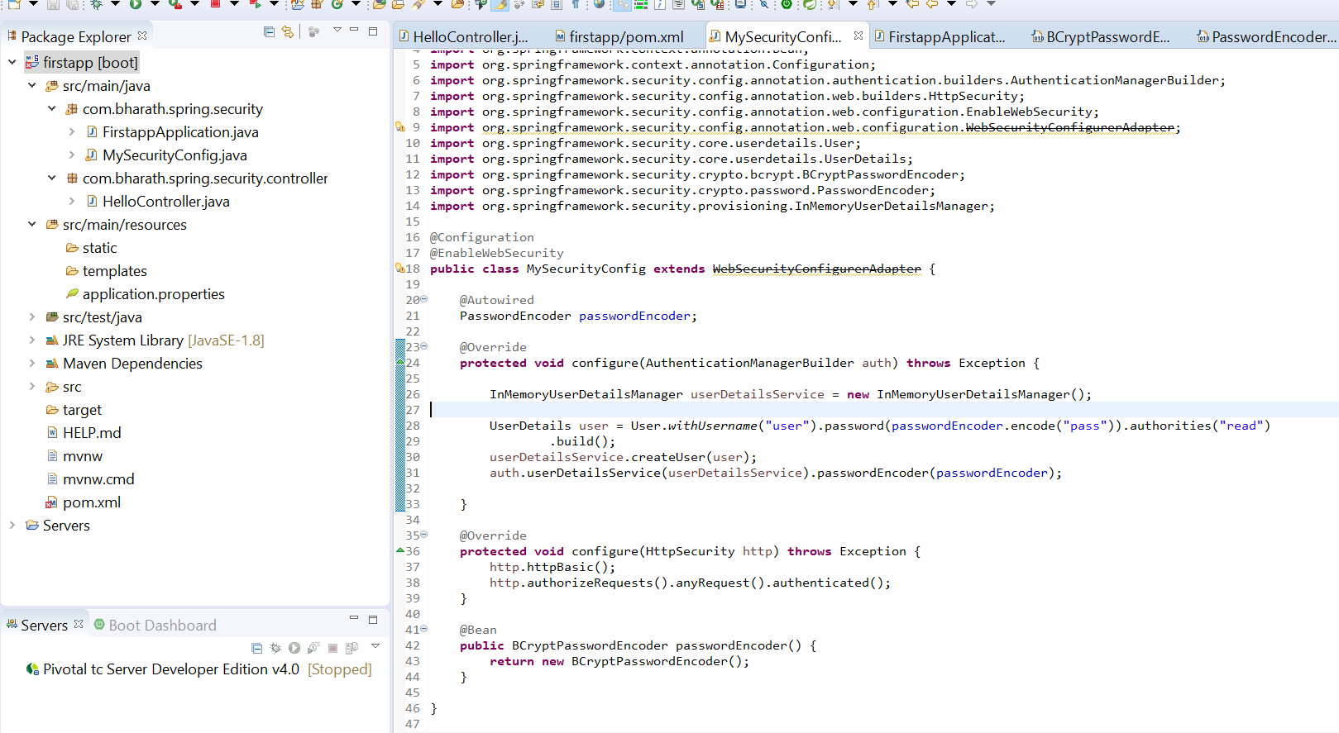

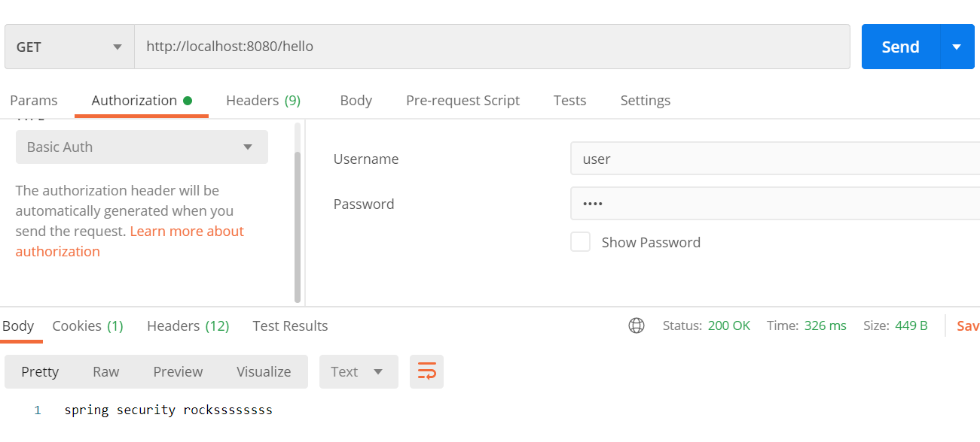

**AuthenticationManager will find passwordEncoder automatically**

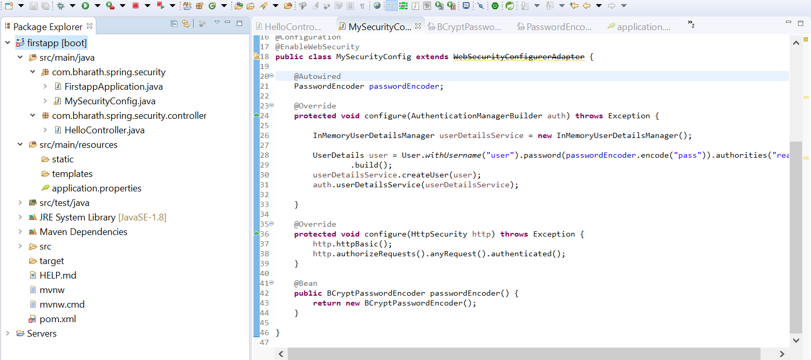

**Create Custom AuthenticationProvider**

UsernamePasswordAuthenticationToken will go back to AuthenticatoinManager

AuthenticatoinManager passes authentication object in support method and it check whether this type of authentication is supported or not

The job of AuthenticationManager to to see all AuthenticationProvider and see it is supported or not

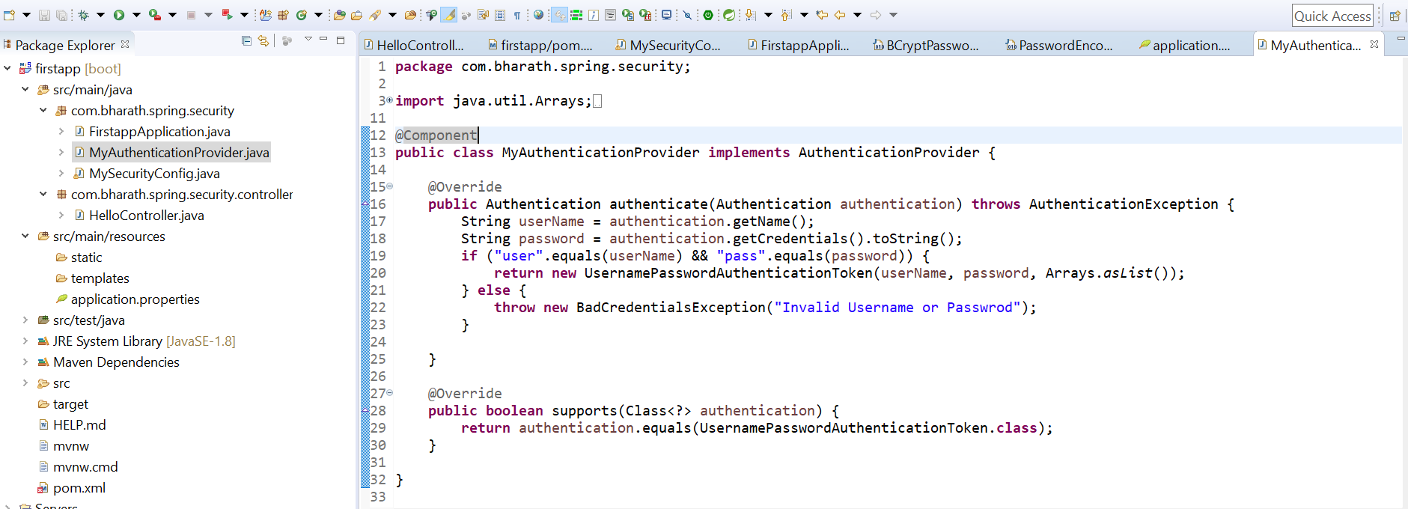

**Note :**

The first method write the authentication logic and second method tell the authenticationmanager this guys support UsernamePasswordAuthenticationToken

**Test**

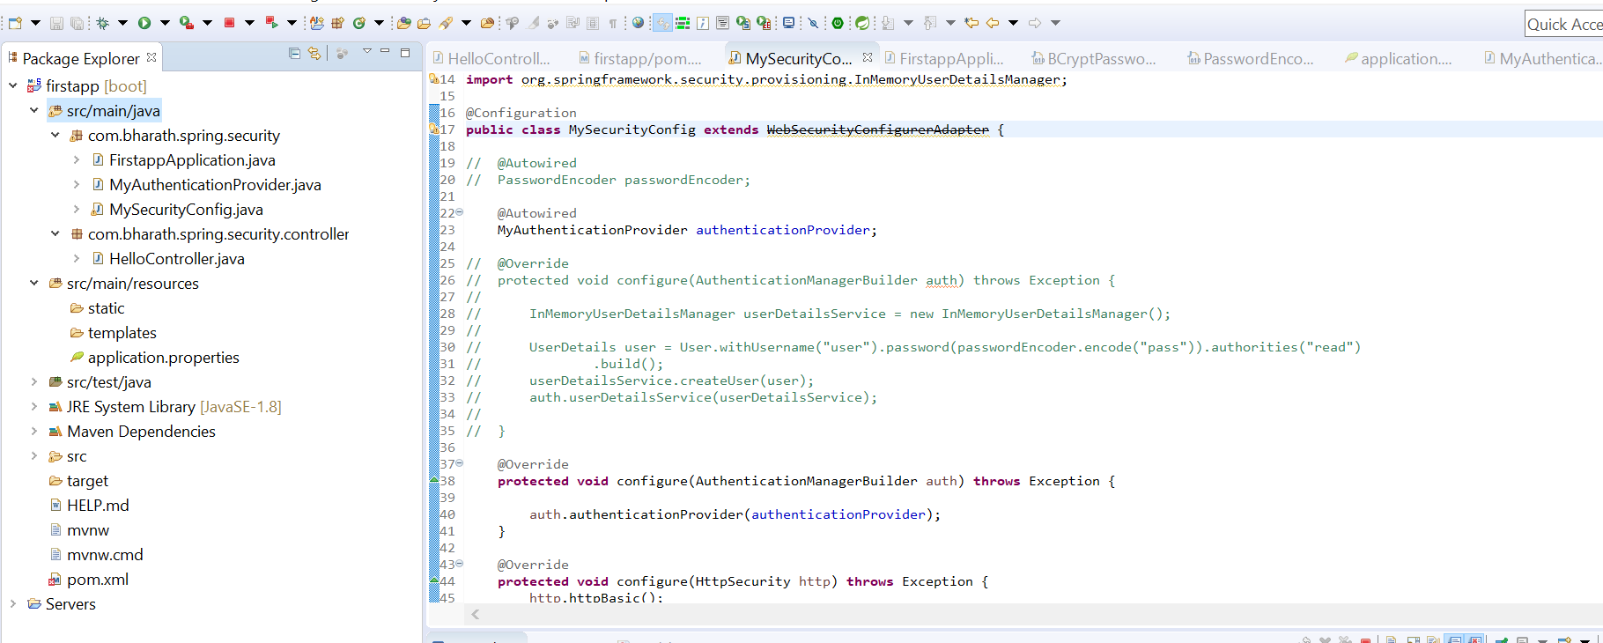

**Use form based login**

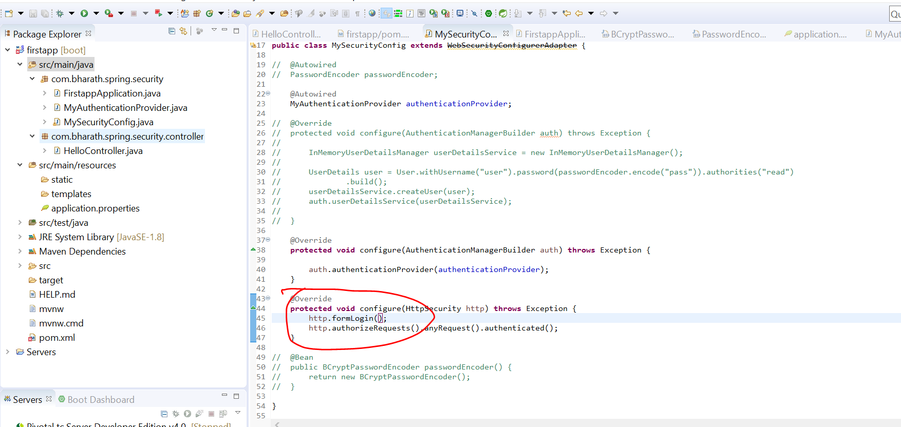

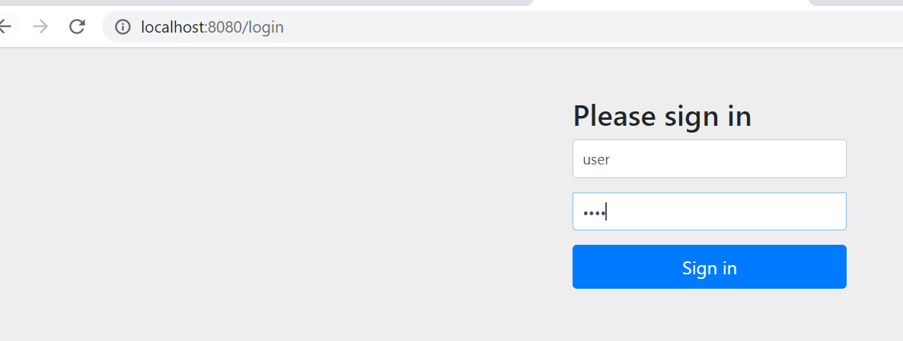

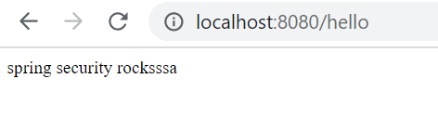

Note : spring security have different filter for various authentication

**Few More Methods**

**So far we test for all url**

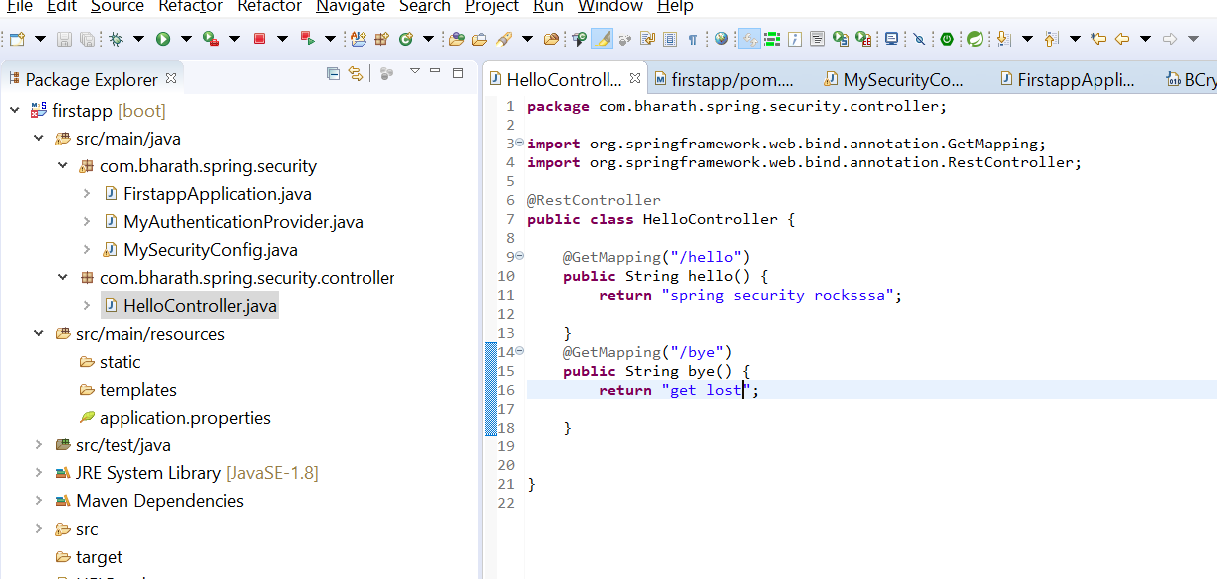

**Note :--**

**Only authenticated user will able to access hello endpoint**

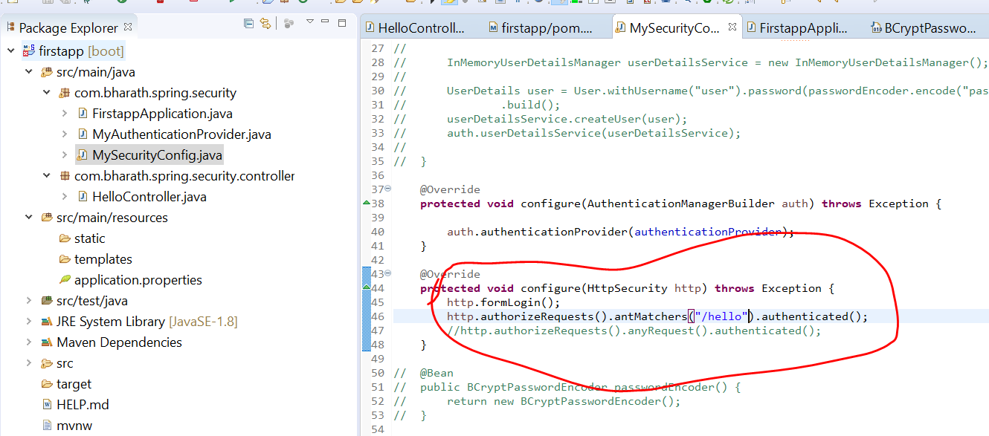

**In this case we are able to access bye endpoint without security**

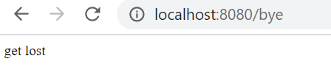

**But in case of hello end point will get security page**

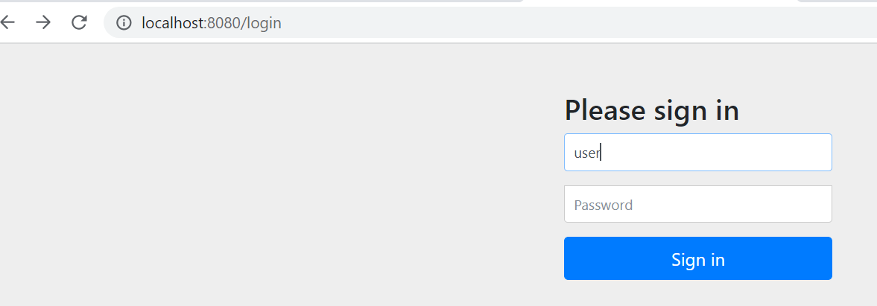

**In this case only hello endpoint will be access and any other endpoint will not access**

DenyAll is rarely used



**Create Custom filter**

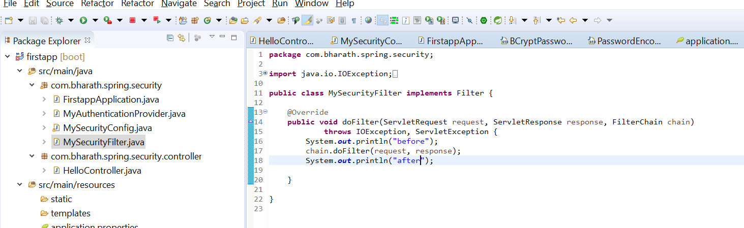

**We need to add this filter**

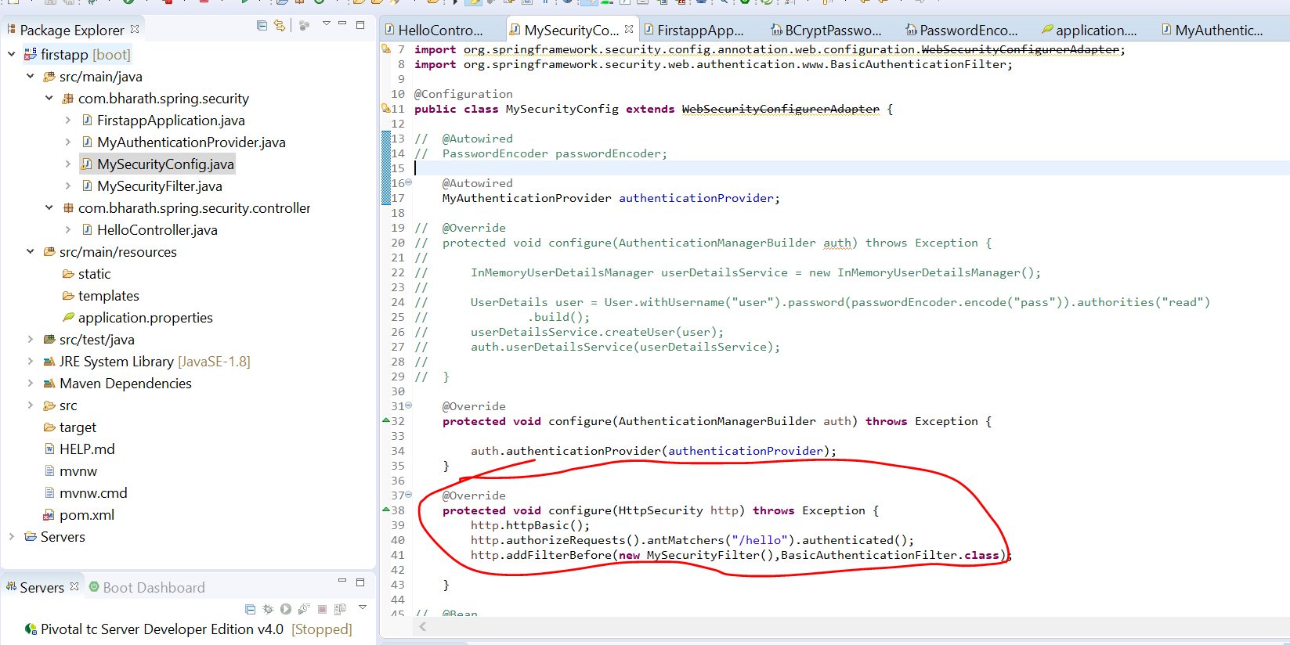

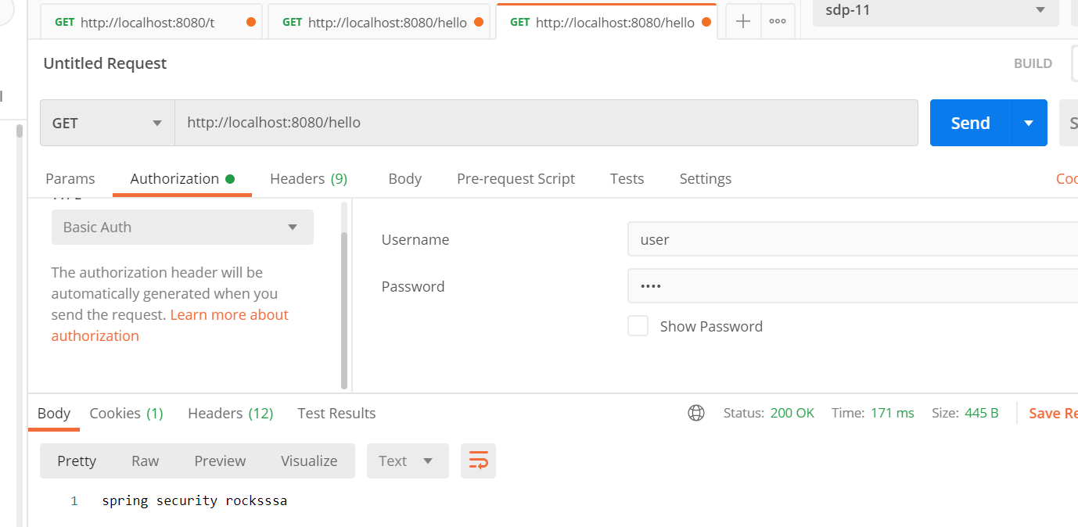

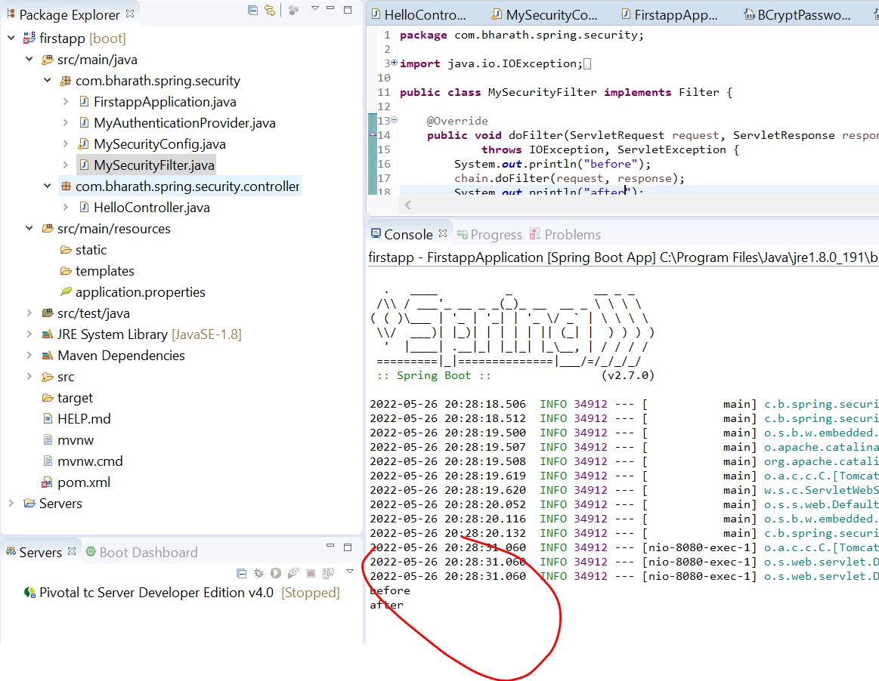

**Other PasswordEncoder**

BCryptPasswordEncoder is an implementation of PasswordEncoder interface in spring security. Spring security provide various implementation of encoders not only BCryptPasswordEncoder .

It is reponsibility of PasswordEncoder encode that pw that is coming from client and matches with pw that is already encoded and save

In d/b and return a boolean value.

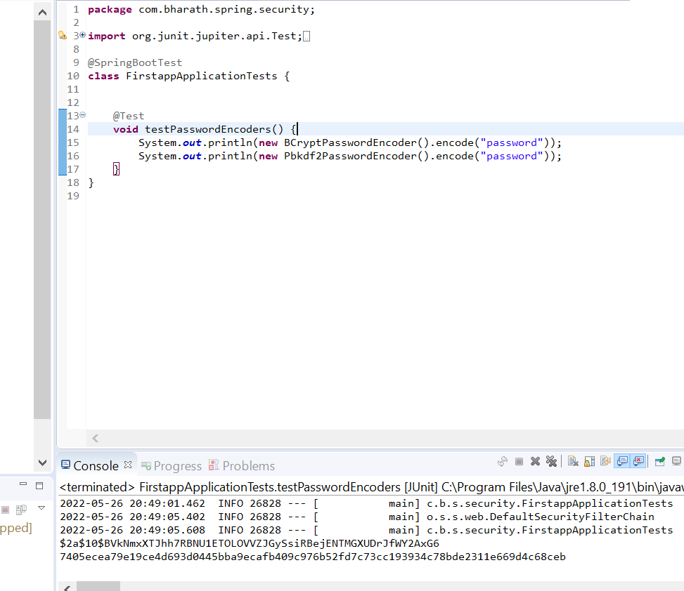

**DelegatingPasswordEncoder :-**

can be used to support multiple encoders

It works list of encoder we need to give then at runtime we need to pass key

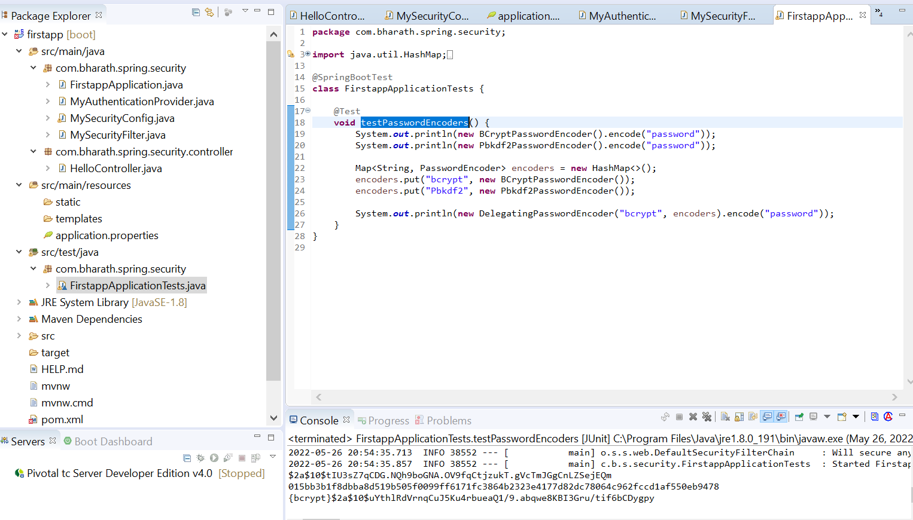

**Section 2 :-Create Microservices**

**Usecase**

Product m/s

Coupon m/s

These two m/s will expose restful api which will allow client to create a product and in the process

Product service will use a coupon service to apply a coupon code that client passes in and

Get the discount so all the coupon information is maintained by coupon service and product service is only responsible for creating the product in the d/b along with price and description details which the client passes.

**The process here ;-**

is take client request , the product service will call the coupon service get the discount for coupon code which the client would have passed apply the discount on the price which the client passes

And then save the product to the d/b. all the coupon info will save in coupon service d/b

**Client ------------product service (ms1)------------couponcode -------------coupon service (ms 2)**

**Table info**

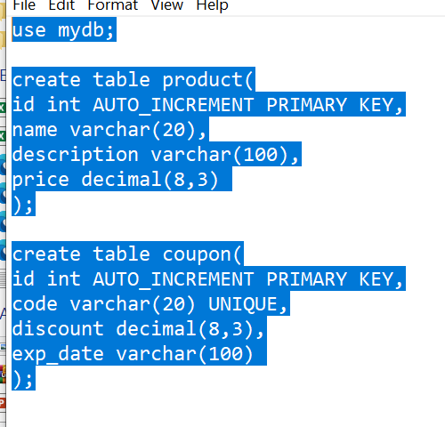

**Steps**

Create the project

Create model and repository

Create the rest controller

Configure the data source

Test

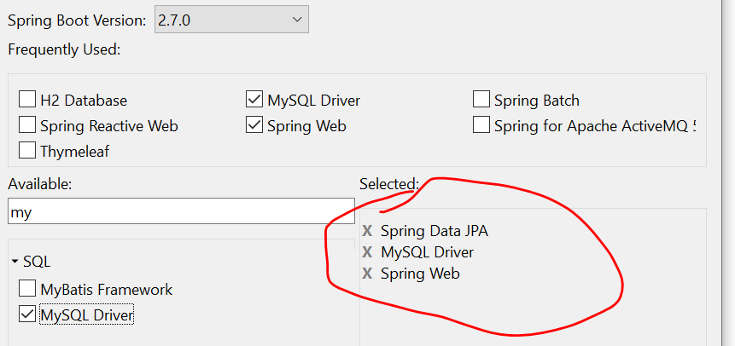

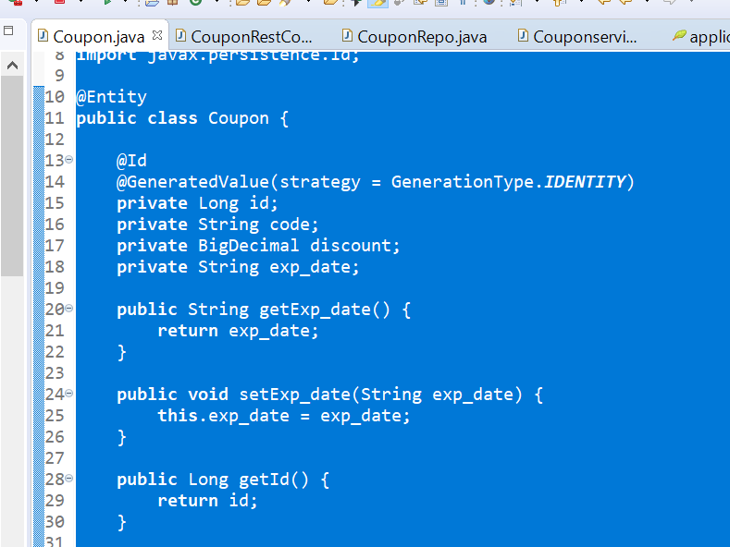

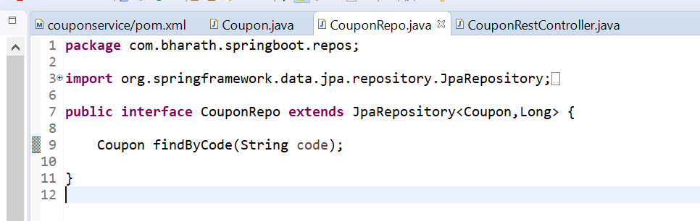

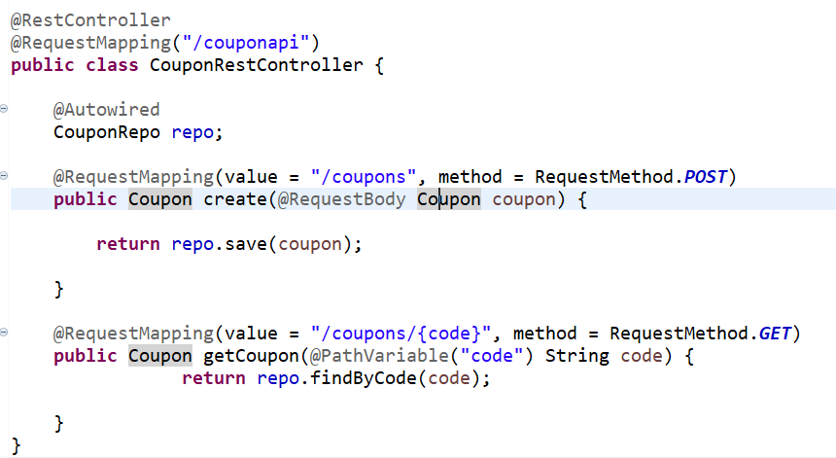

Configure the data source

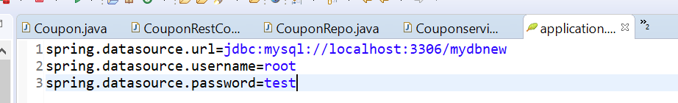

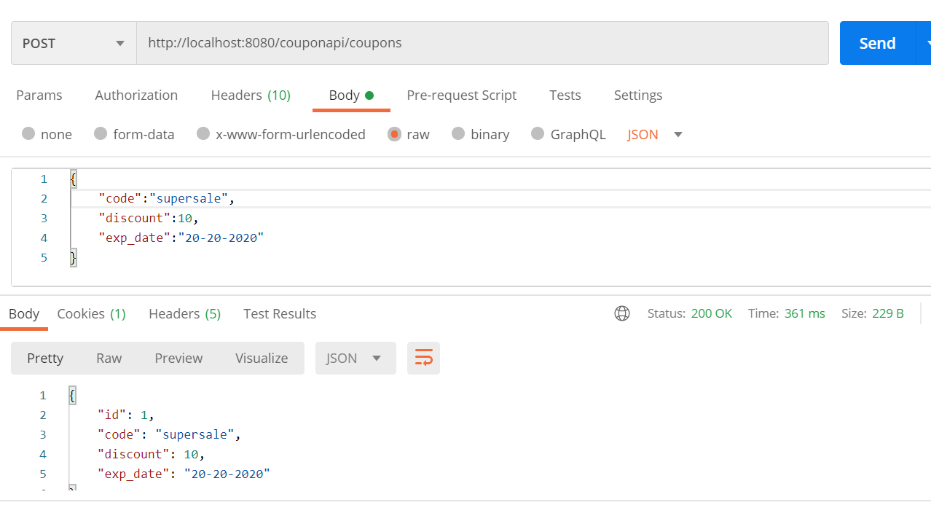

Create Product Microservice

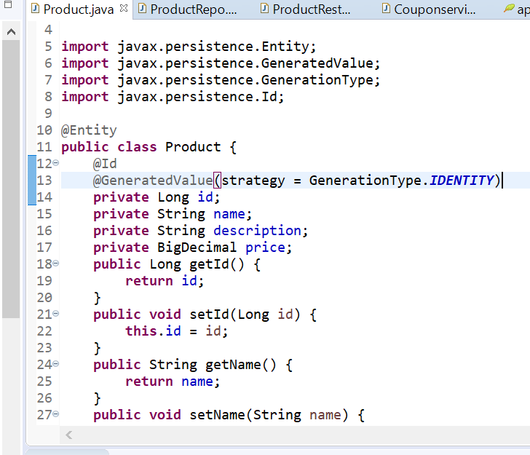

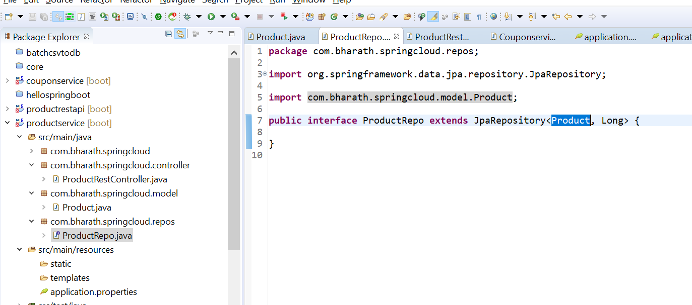

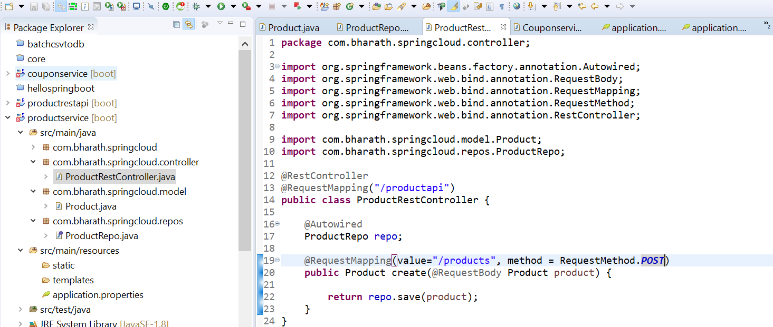

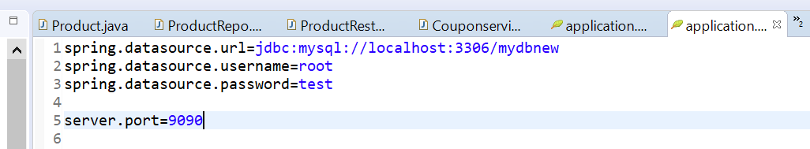

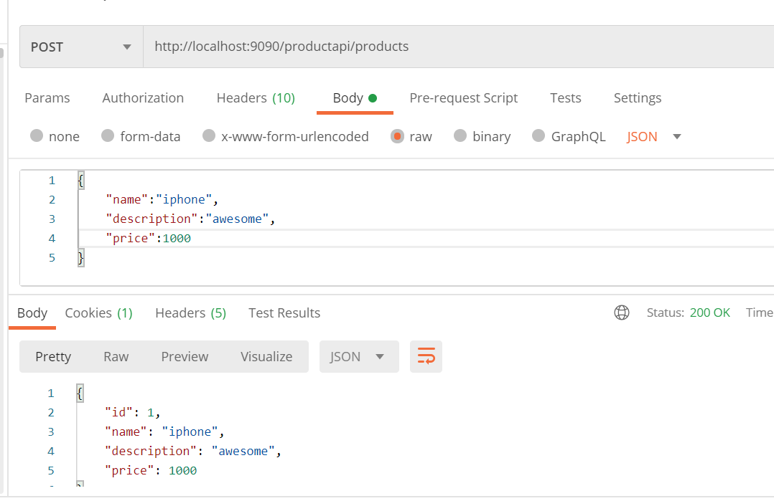

Integrating Microservice

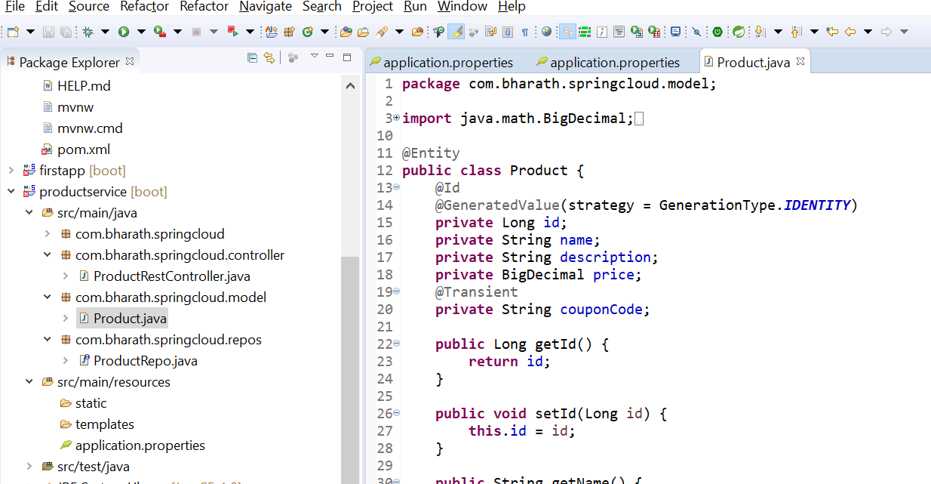

Spring offers RestTemplate to call restful client

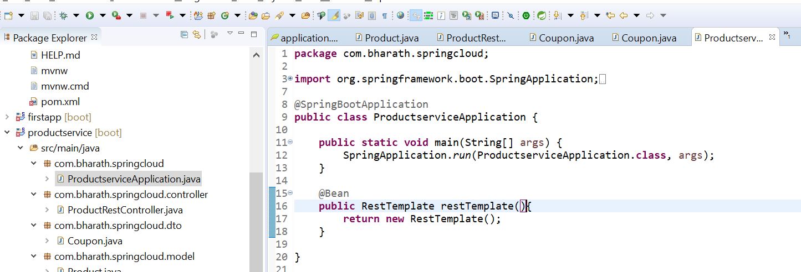

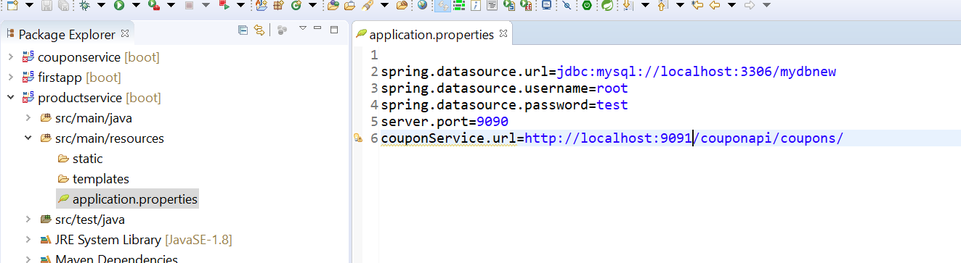

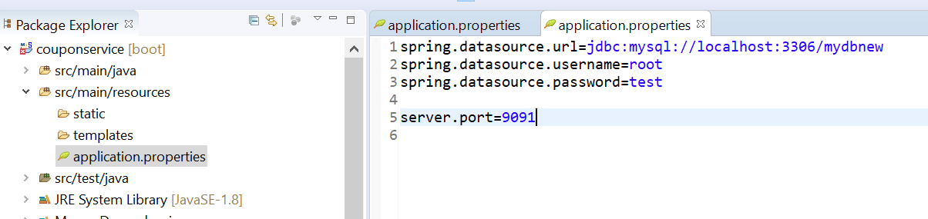

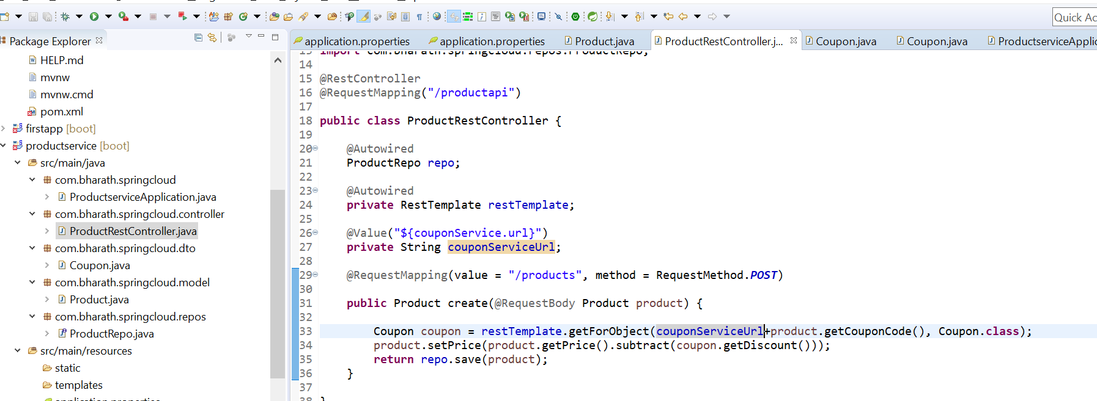

**Integration Testing**

**productService :-- 9090**

**CouponService :9091**

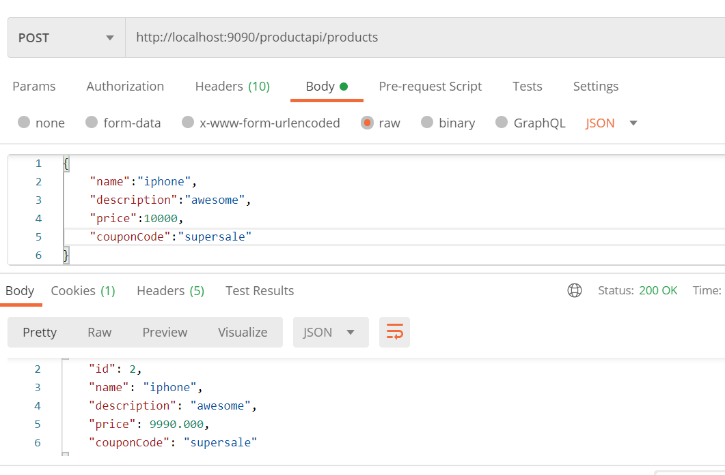

**Refactor**

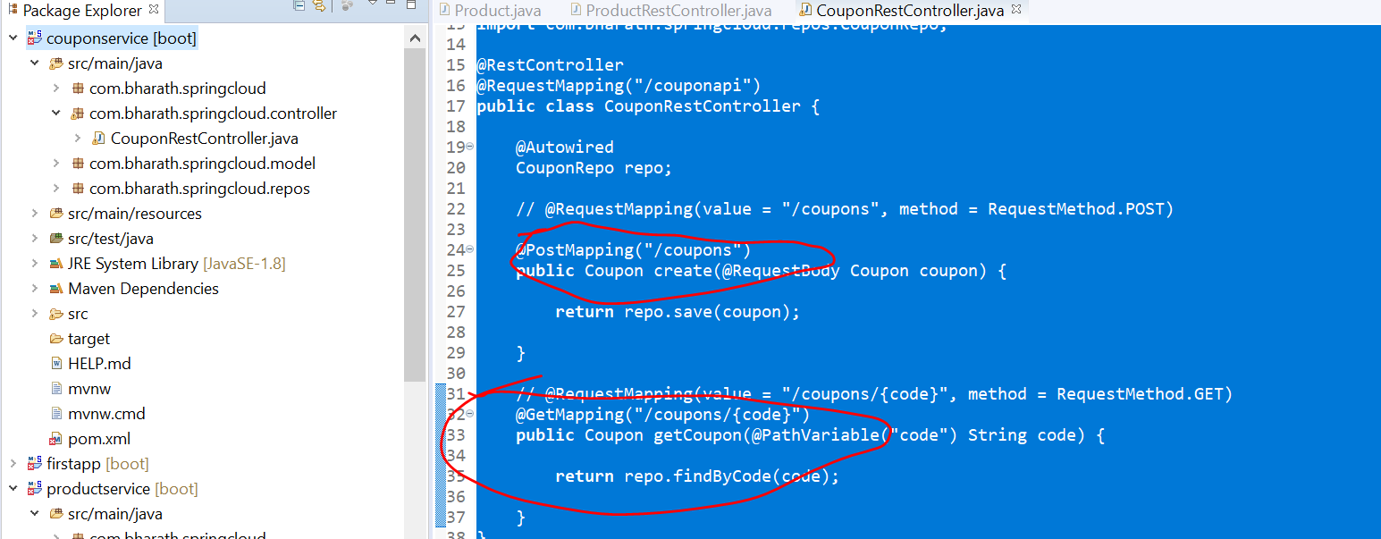

**Section 3 :- Secure Rest api**

**Requirement :---**

configuring authorization and authentication for coupon ms

Step:

Will create UserDetailsService which will fetch user and role info from d/b

Will create user table, role table and mapping table which will map user and role in d/b

Will create two user

User 1:- create coupon and retrieve coupon

User 2- retrieve coupon

Role:-- whether it is admin or regular user

User and role :- define jpa relationship many to many

**Step 1- create tables**

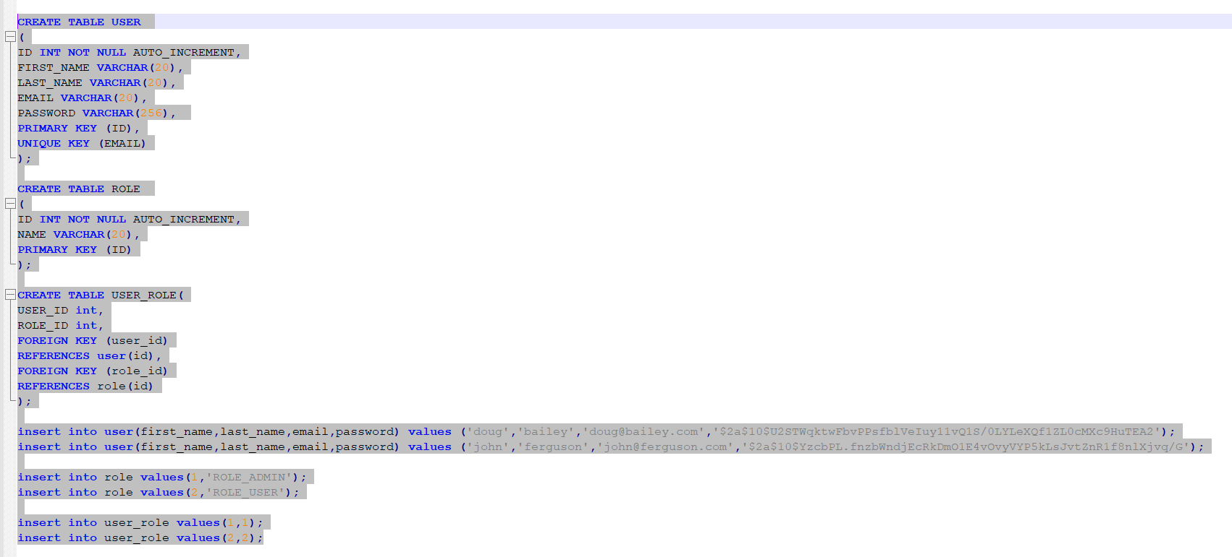

Here we are mapping using user_role table to user with rolle by id

user 1-------Role_admin

User 2 -------Role_user

**Create entities**

**Requirement :-**

Secure the coupon m/s

Step2 :----add security dependency

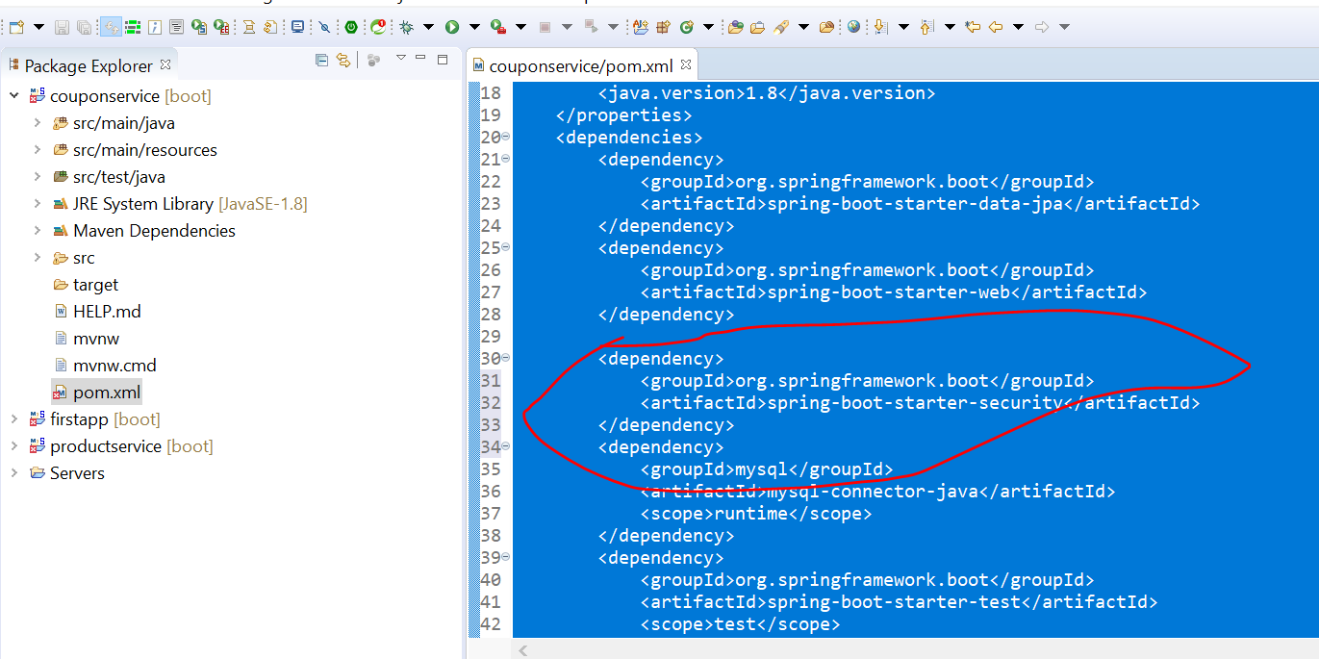

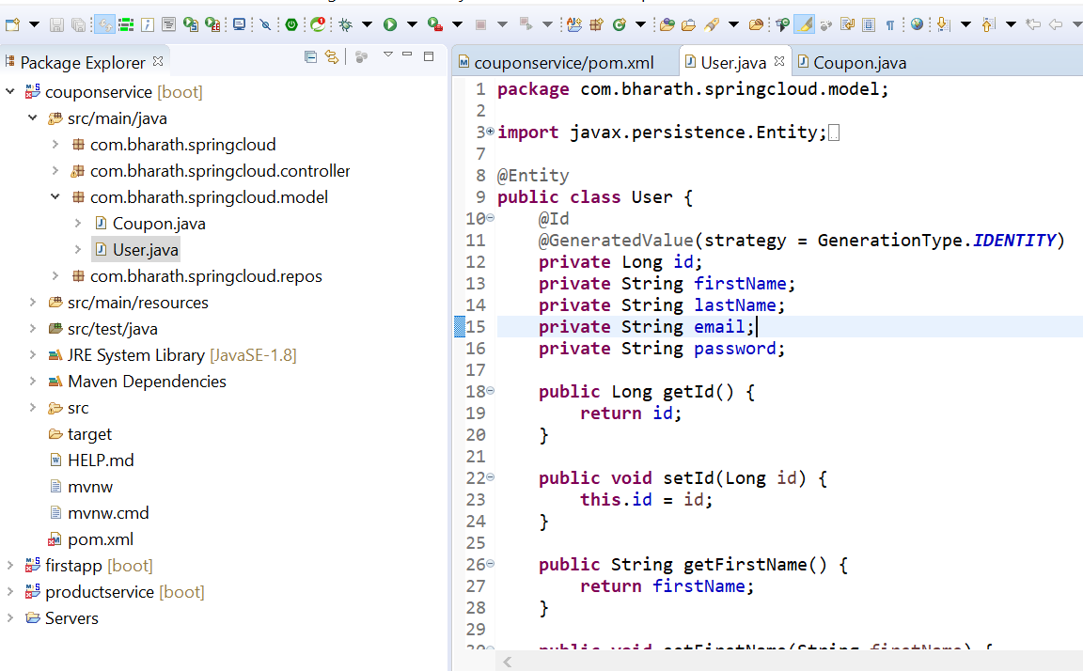

**Note :**

getAuthority will invoke internally by spring security and it should return name of the role

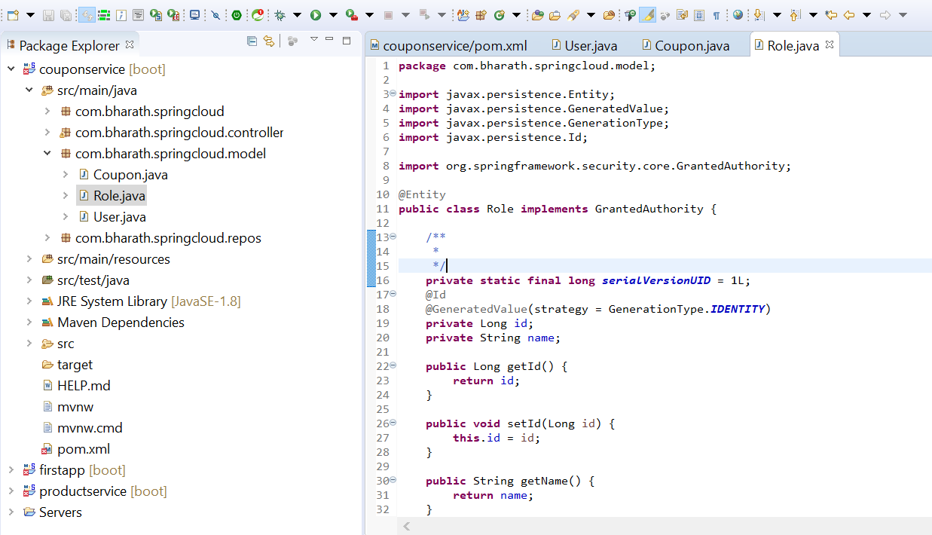

**Define Entity Relationship**

**Objective :---** define r/s between user and role entity

One user can have multiple

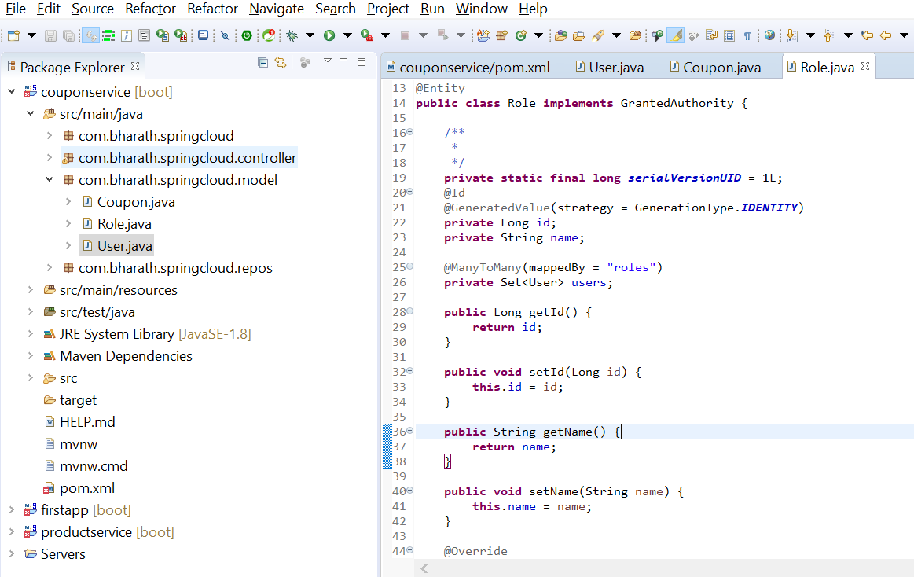

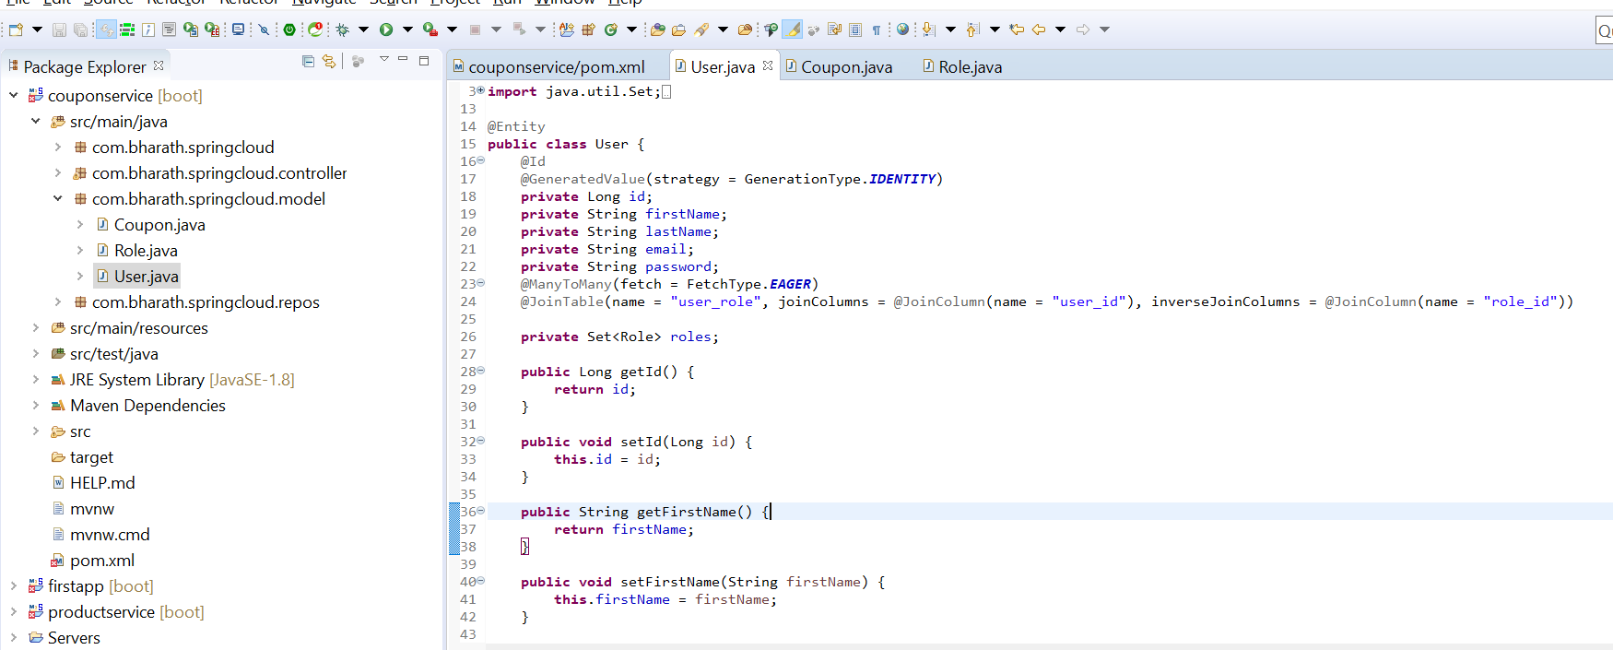

**Create Repos**

**Objective :-**

define repo for user and role

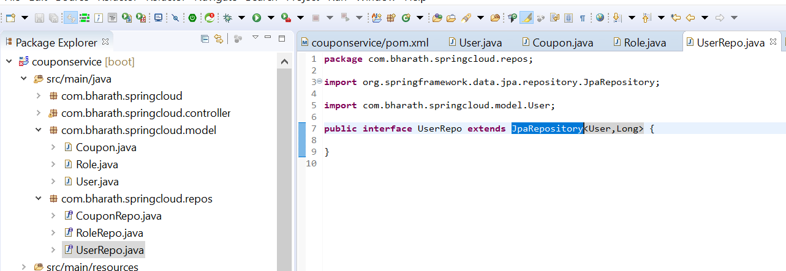

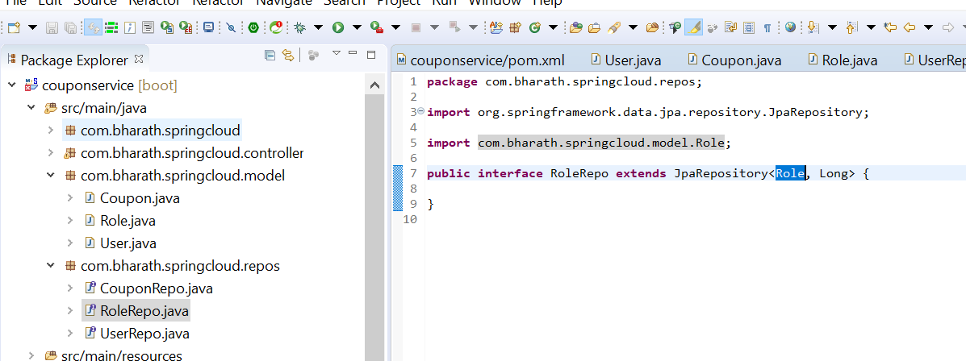

In userRepos we need to get details of user by giving his email

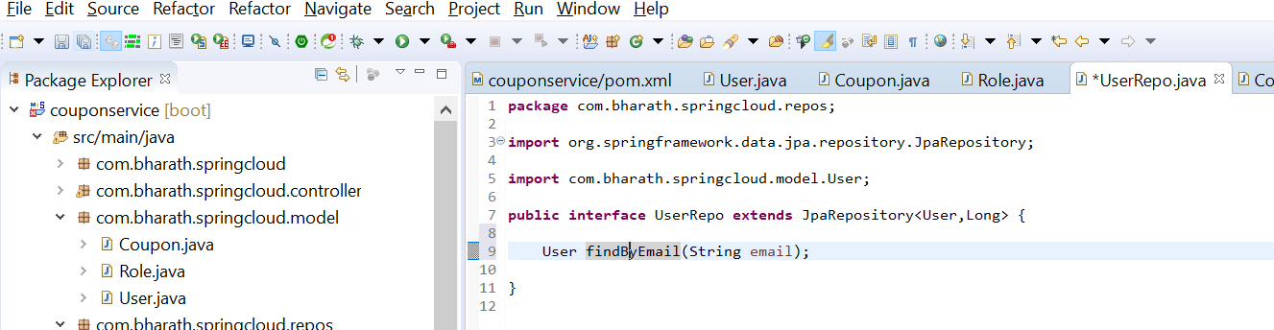

**Implement UserDetailsService**

UserDetails will be use by Authentication Provider in spring security

**Note :-**

it give user object of it own from spring security

Username will send by client in request

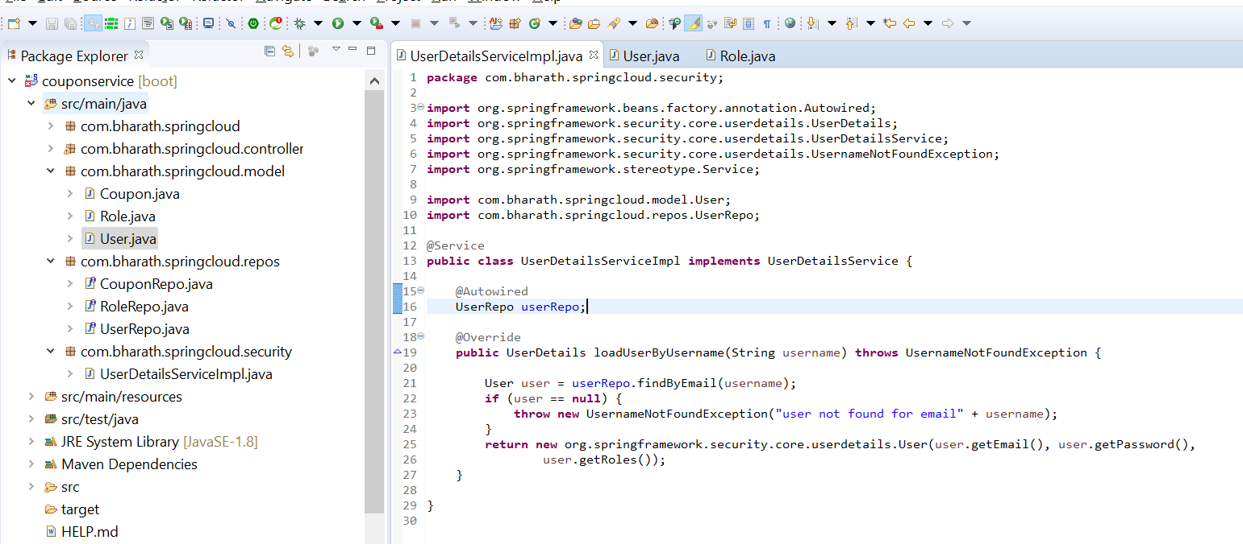

**Create WebSecurityConfig**

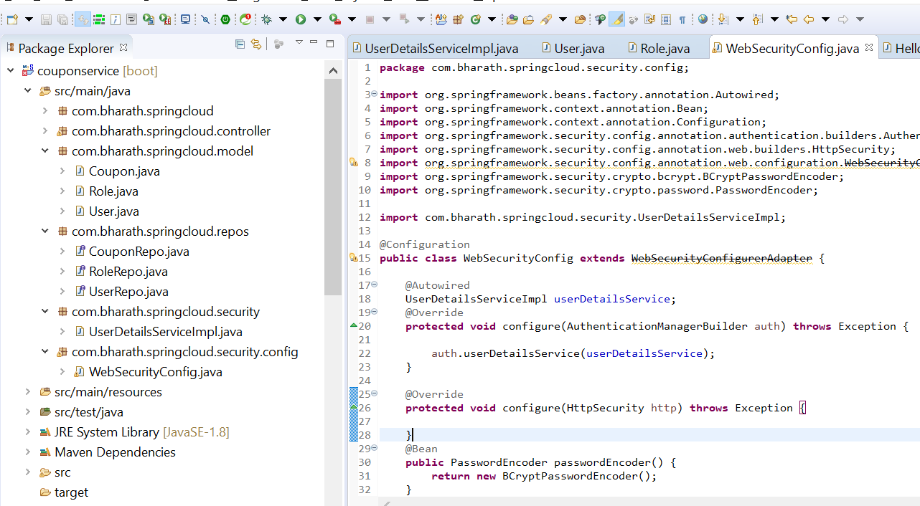

**Secure the URLs and Methods**

What type of authentication we want and how the authorization should happen

**Note :**

by default csrf is enabled in spring security and if it enabled we cant perform post operation in postman

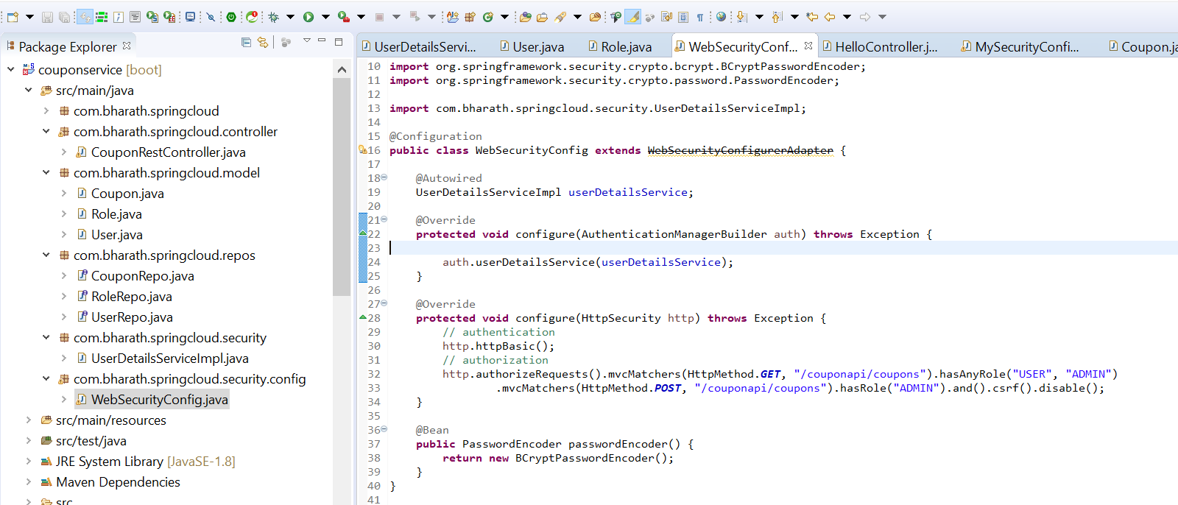

**Test Security**

**Objective :---**

Test the authorization and authentication for our application

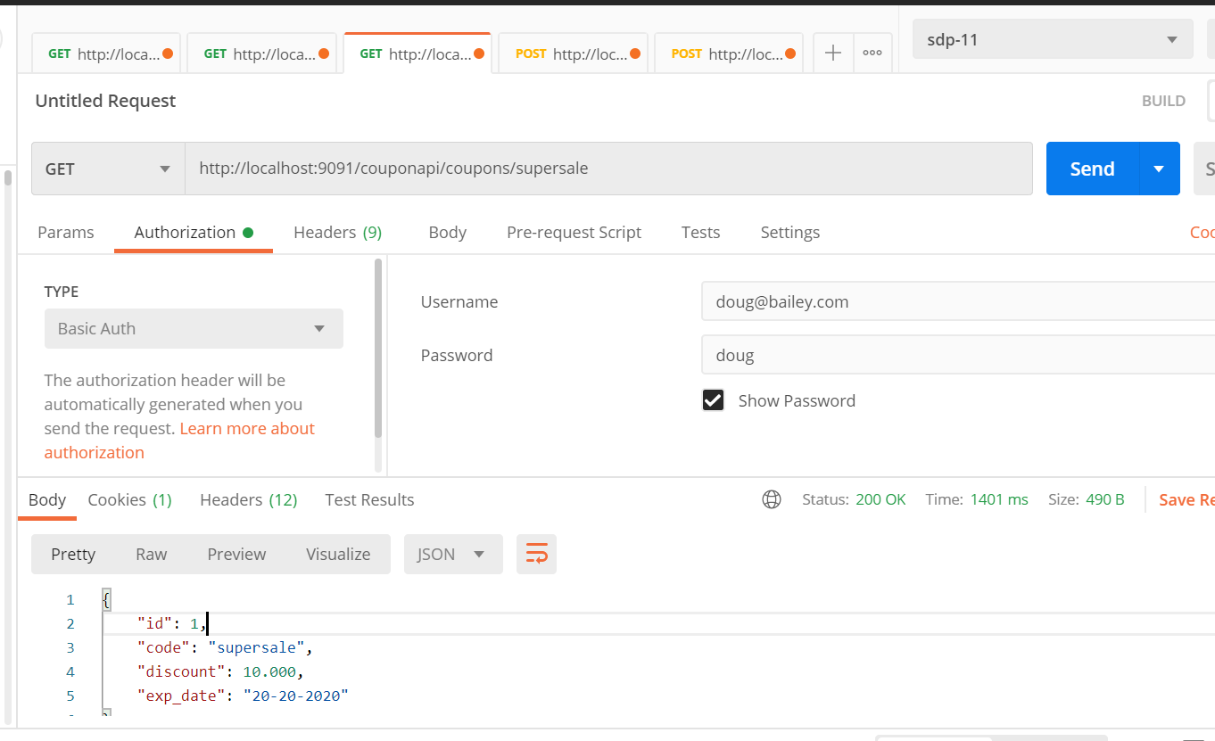

**Note :**

Authentication and authorization is working

Testing post with regular user who don’t have access of post only admin has access role of post

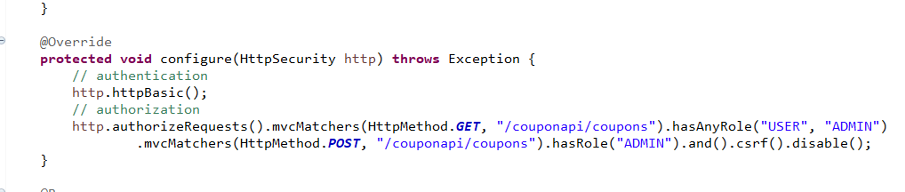

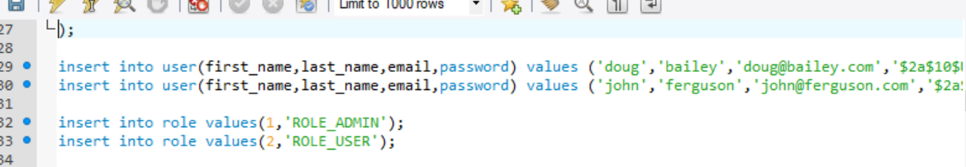

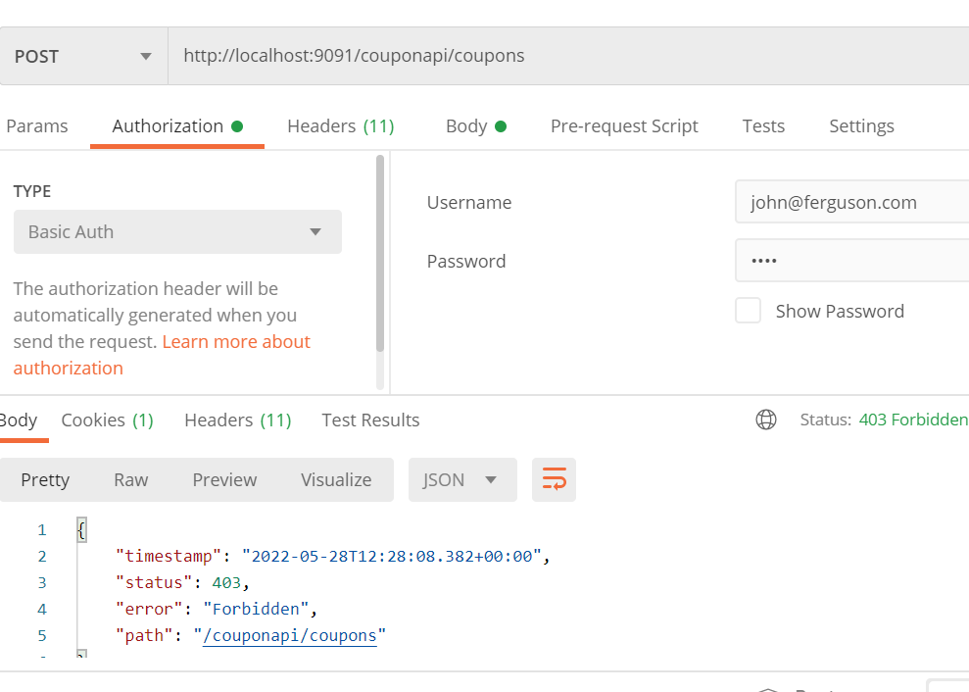

**Now test with admin user**

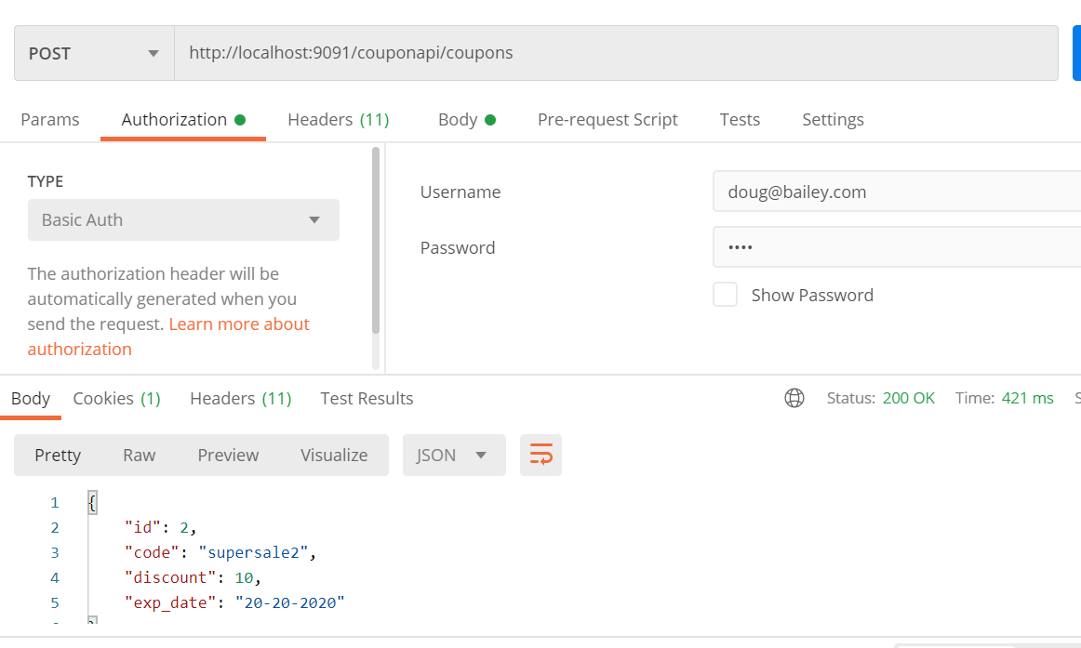

**More about mvcMatchers**

**Note :**

in url we are using supersale still it allowing

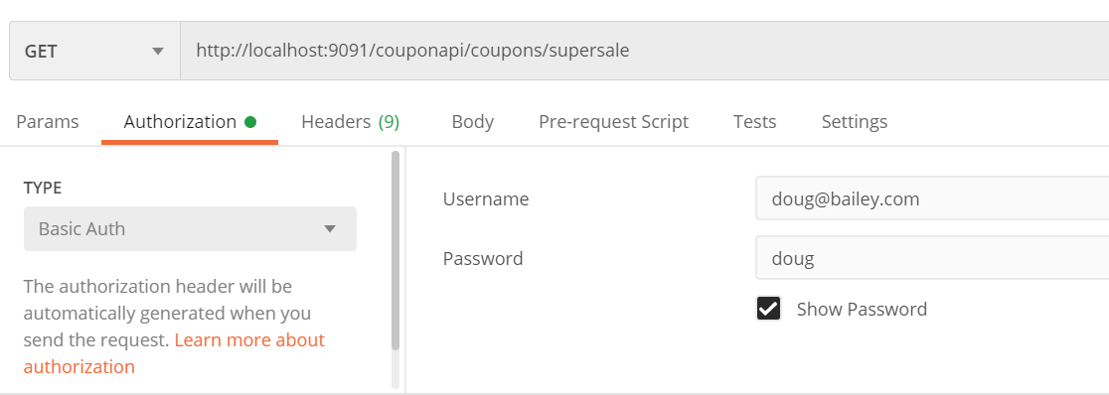

But here we are not using it

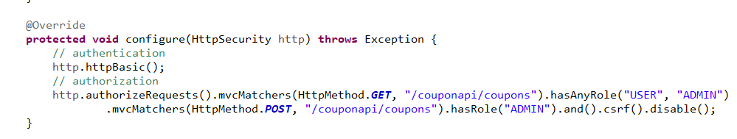

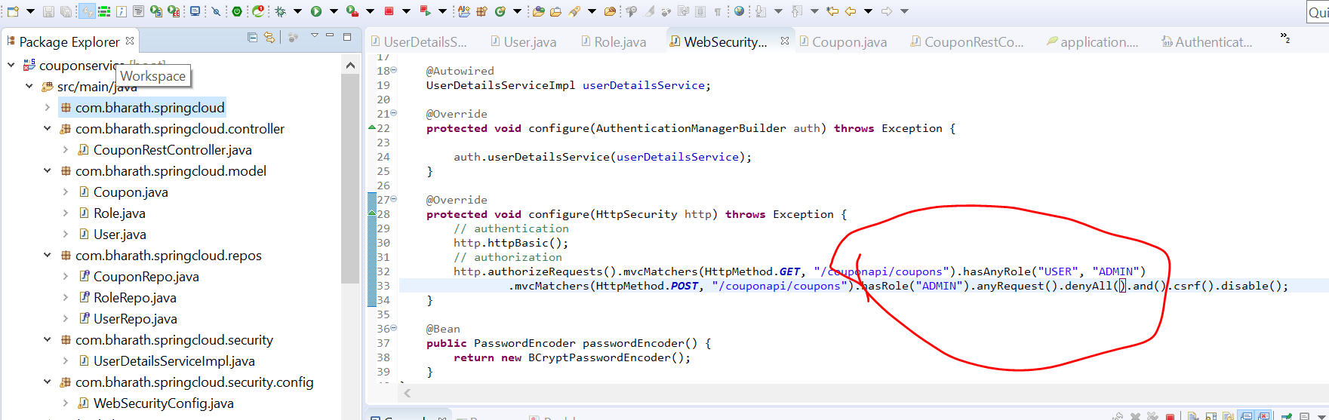

Not it will not allow , it will accept only /couponapi/coupons

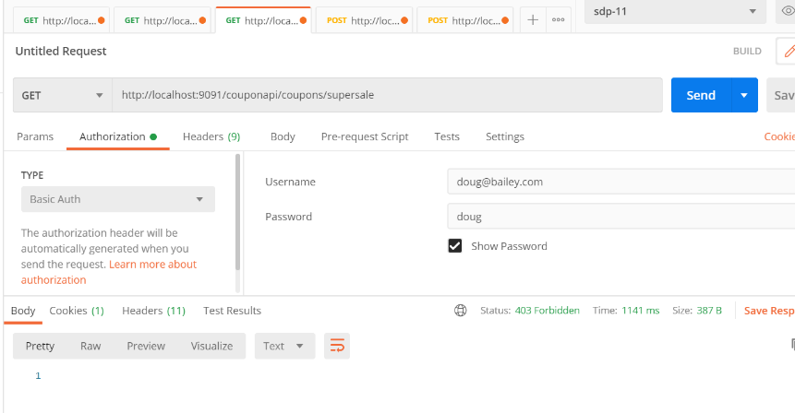

That’s why we are using **

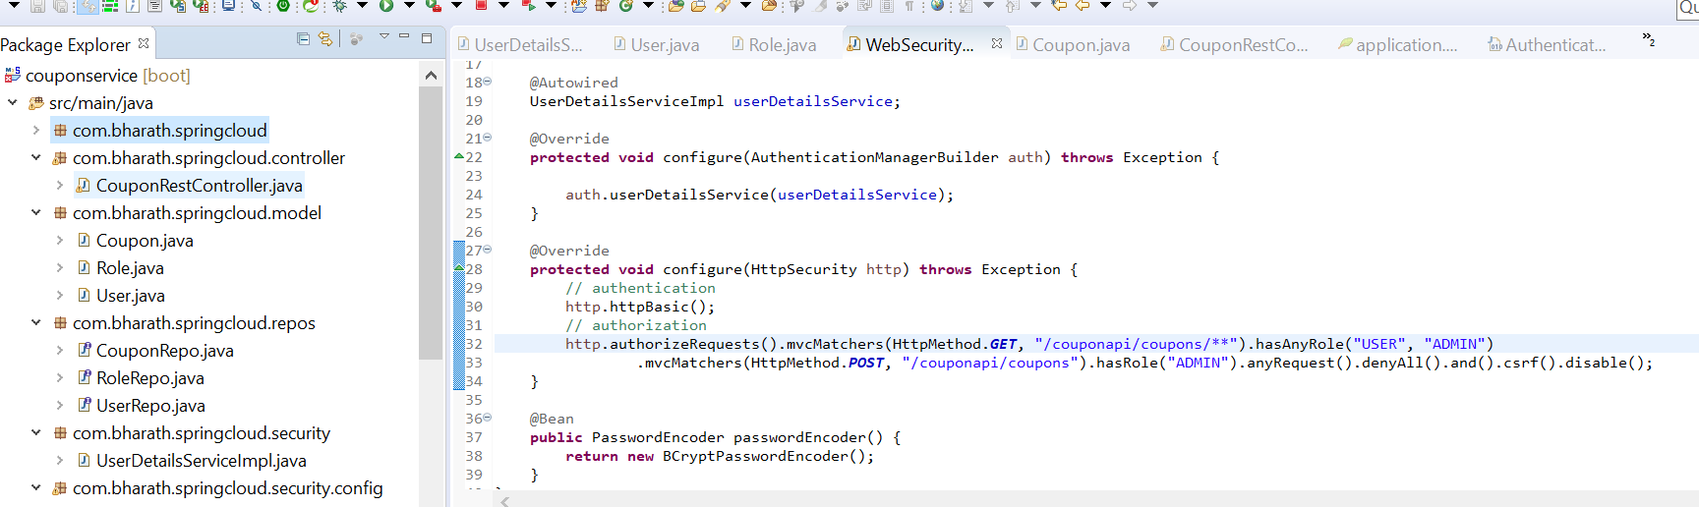

Now we are getting response

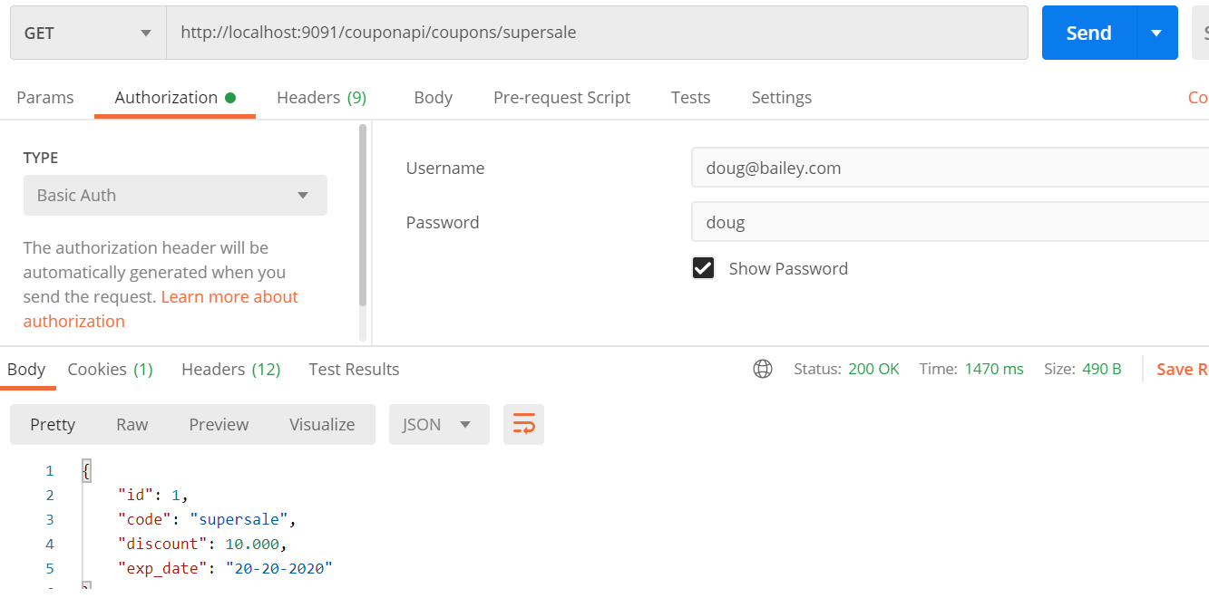

**Opp of denyAll is permitAll**

**mvcMatchers vs antMatchers**

**Note :--**

MvcMatchers intoduced in latest version they are more intelligent :-----

/couponapi/coupons.html-----------if this is url if able to identify by writing this /couponapi/coupons

**Using RegularExpressoin**

**Note :--**

Instead of ** we should use regex in our expression otherwise anything can be pass in url which will damage our system

Using this it will follow a pattern in api

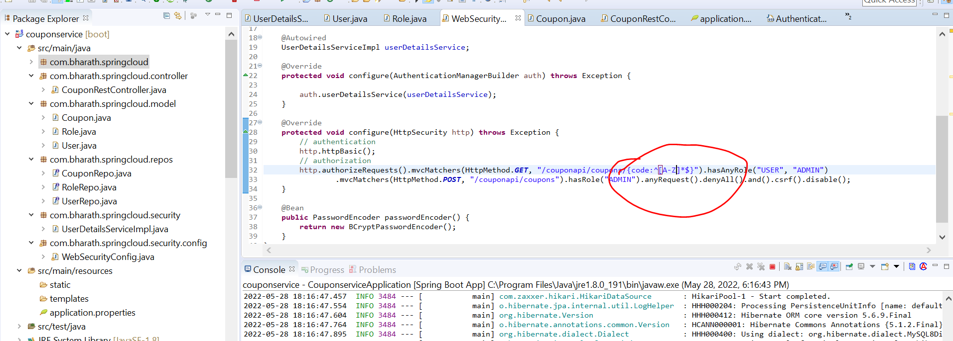

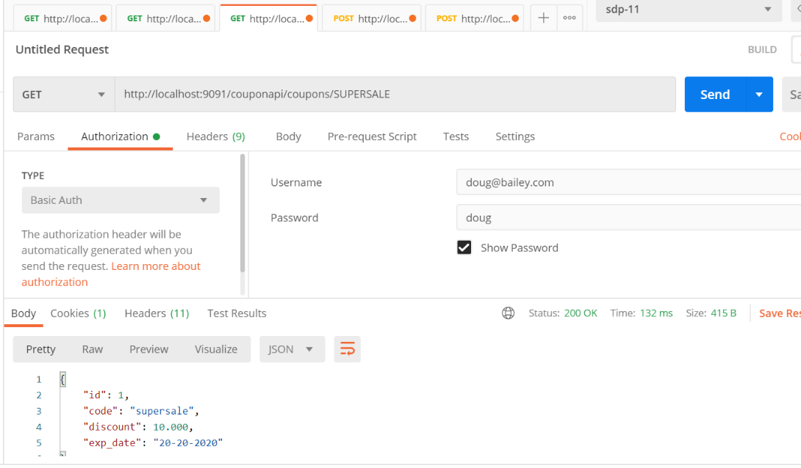

**Secure a web app**

**Steps**

**Objective:**

Create custom login page

**Create Index page**

**Objective :-**

create web layer for coupon service

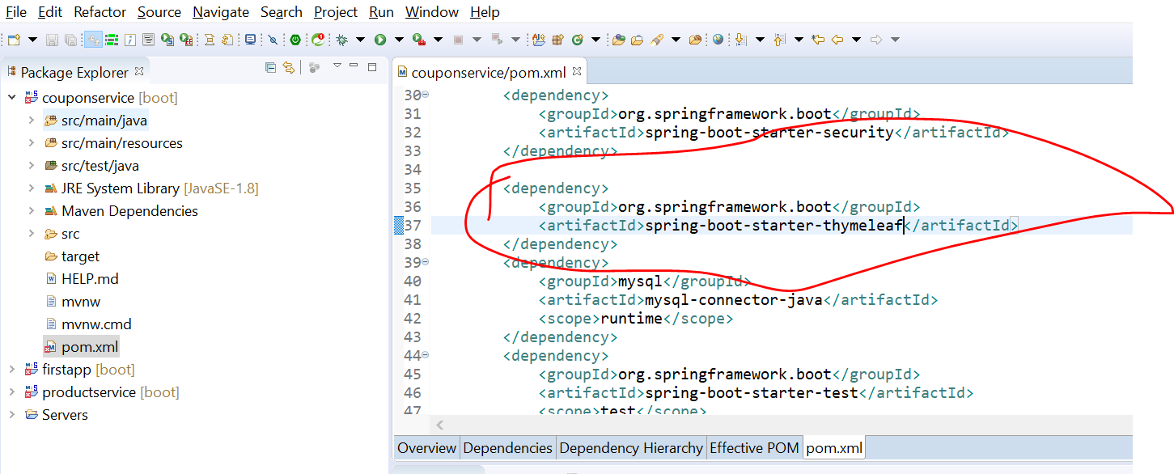

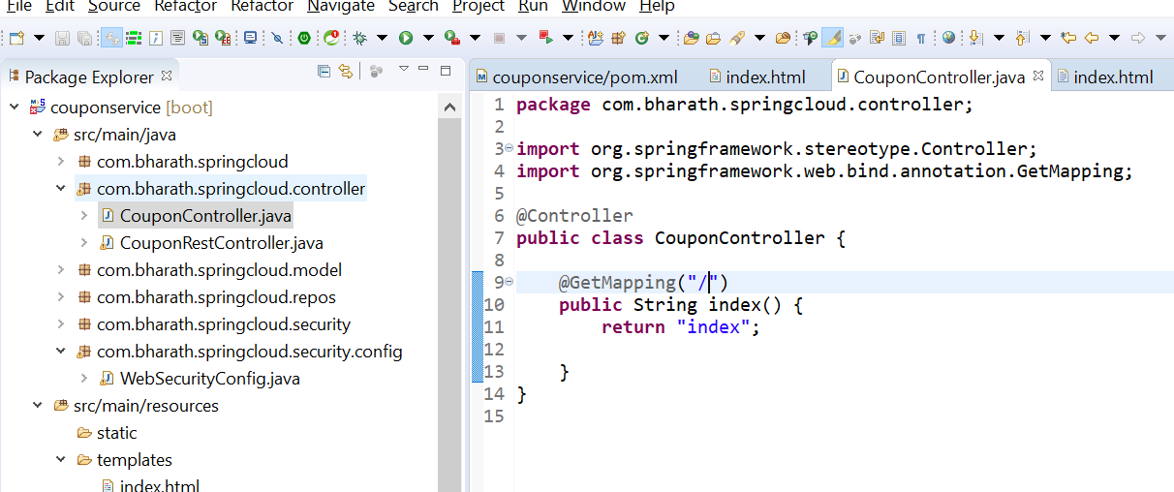

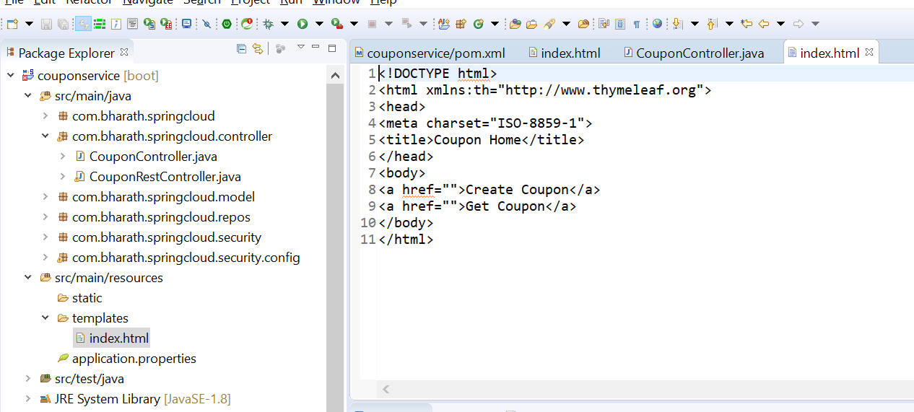

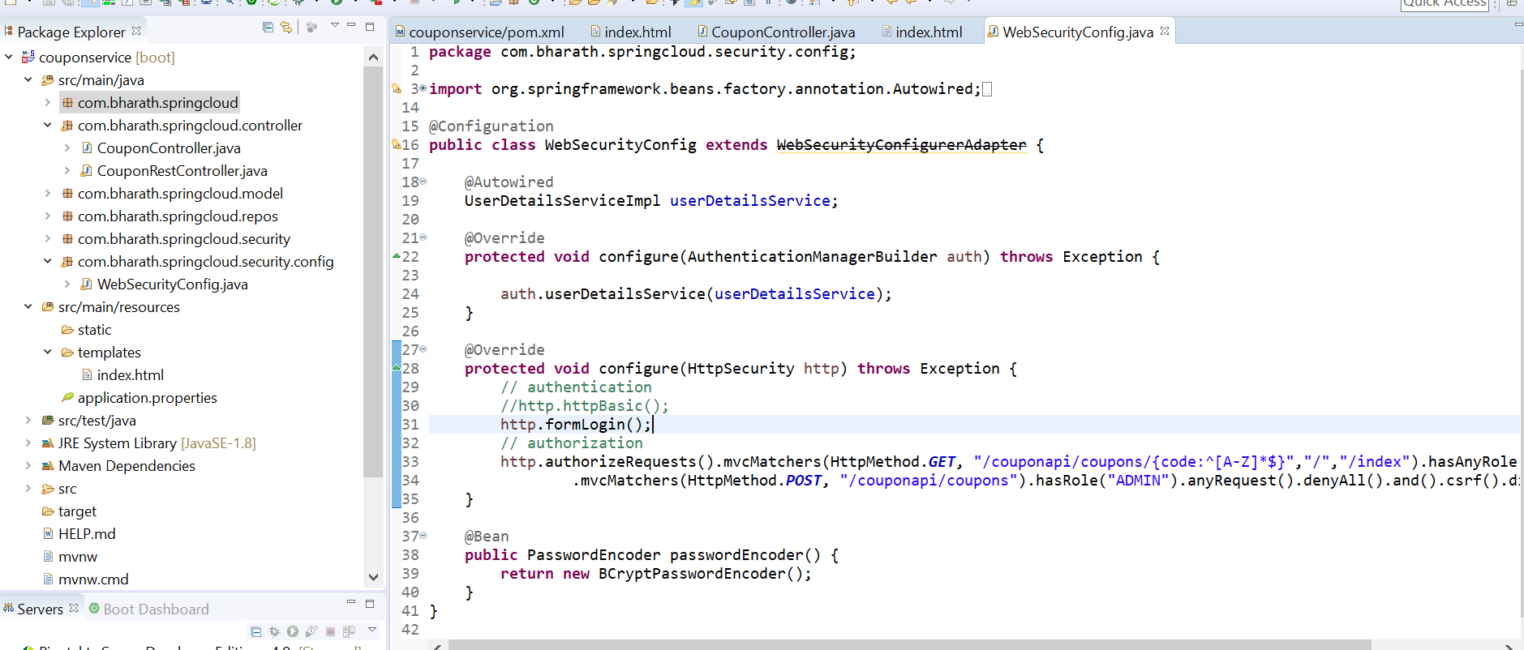

Later on will add our own login

Our security still works in thymeleaf

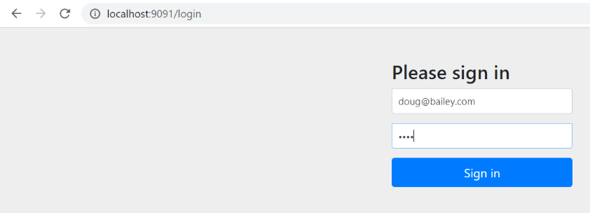

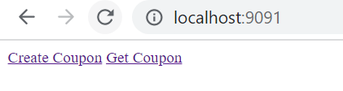

**Render Coupon Form**

**Need to map form with model object**

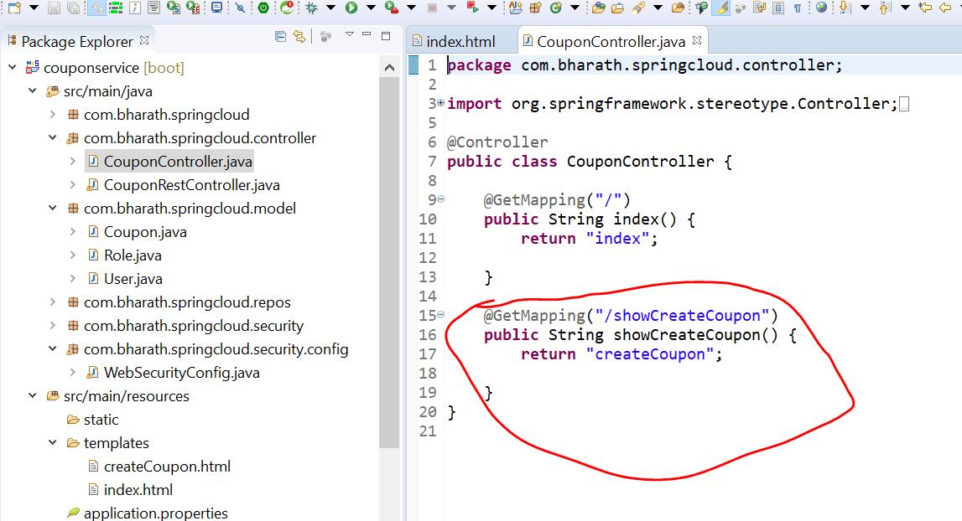

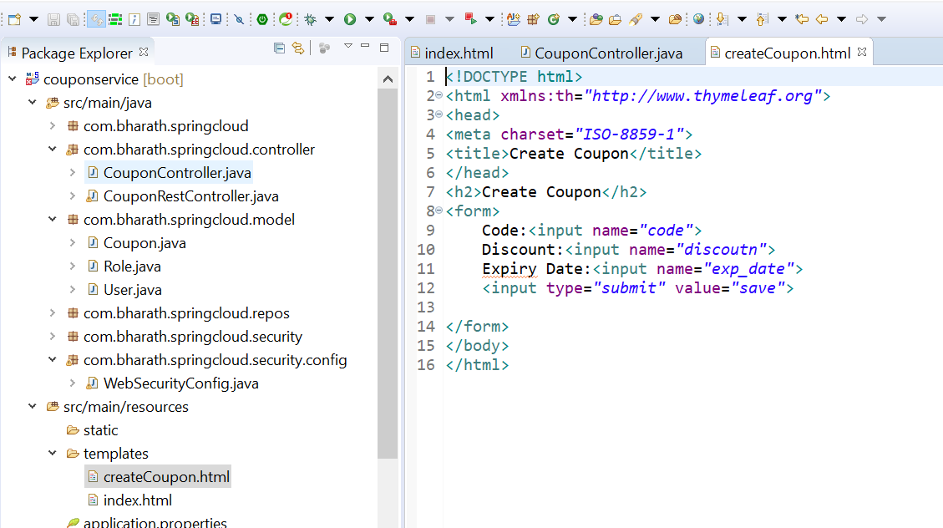

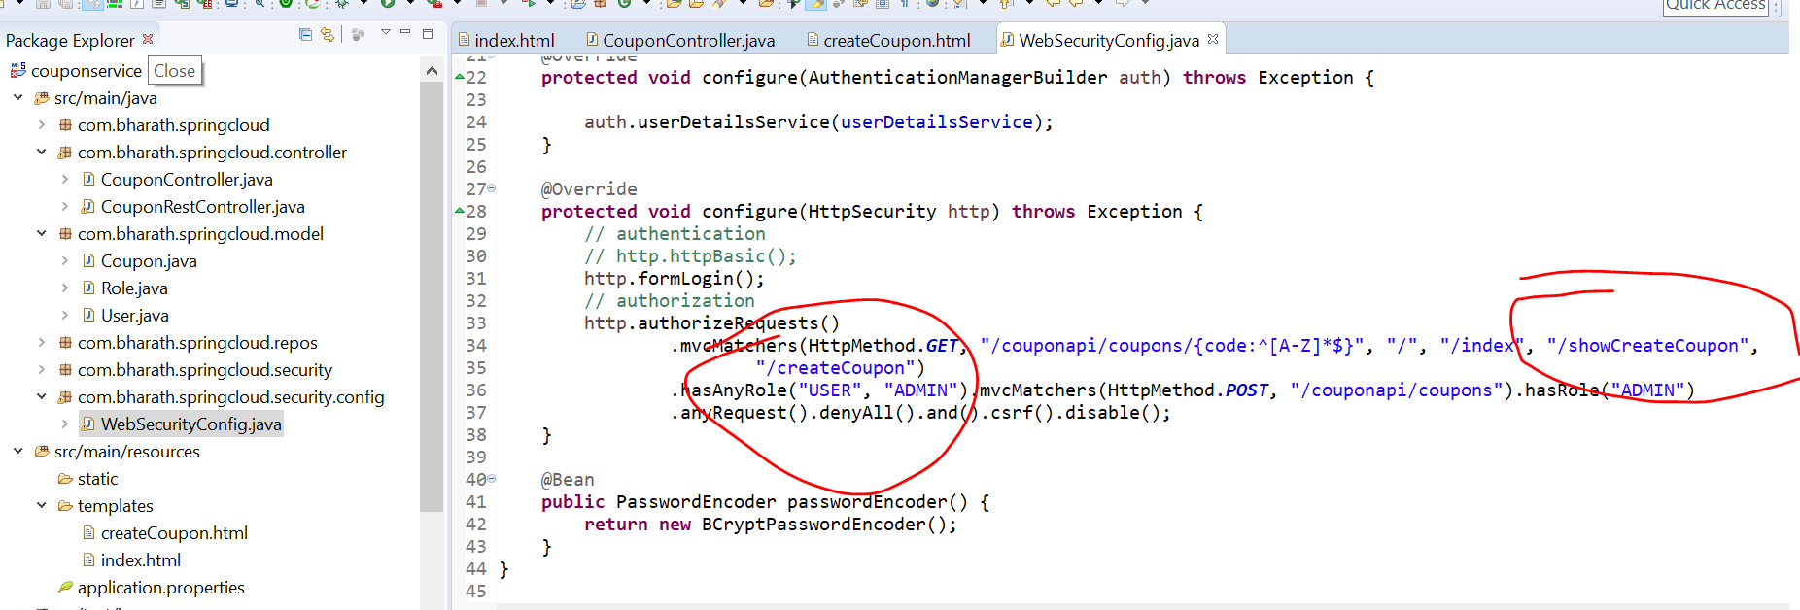

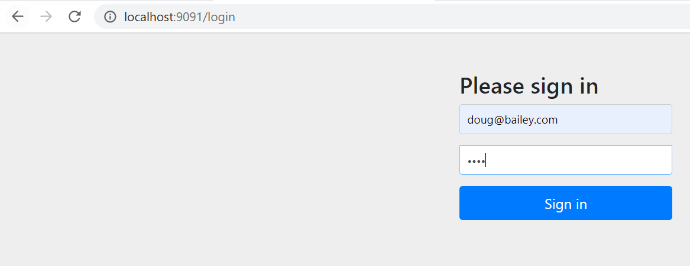

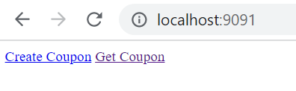

**Click on create coupon**

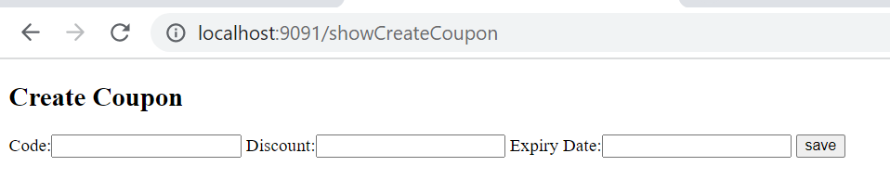

**Create coupon**

**Objective :-**

coupon creation flow

When the form is submitted coupon come in request

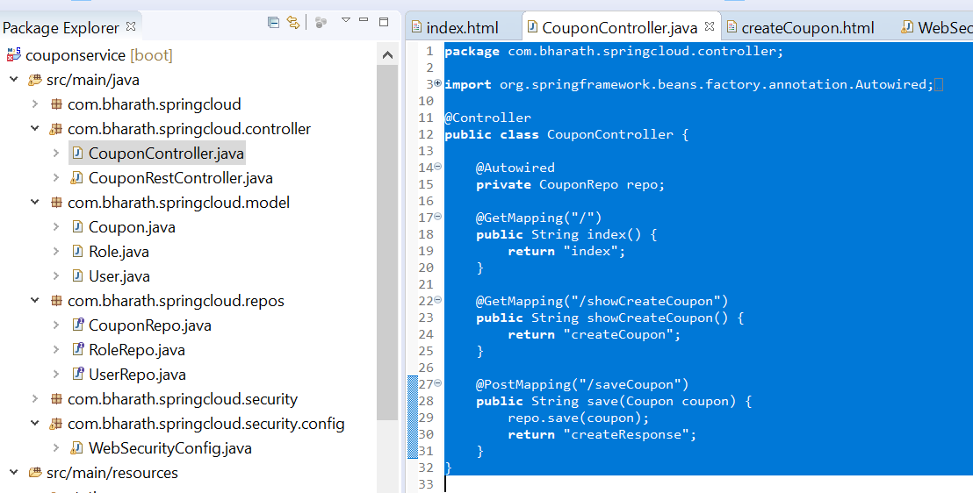

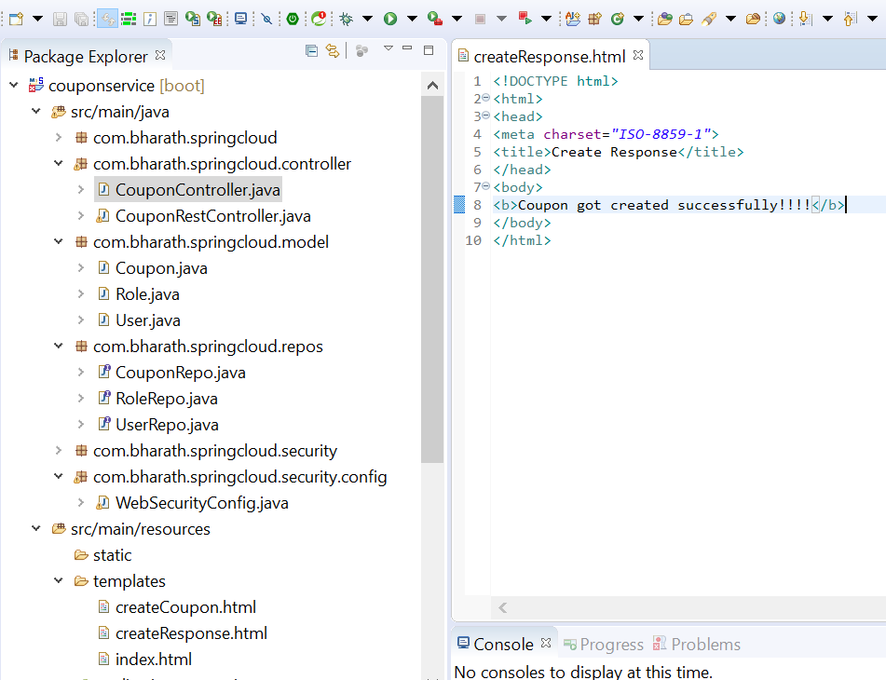

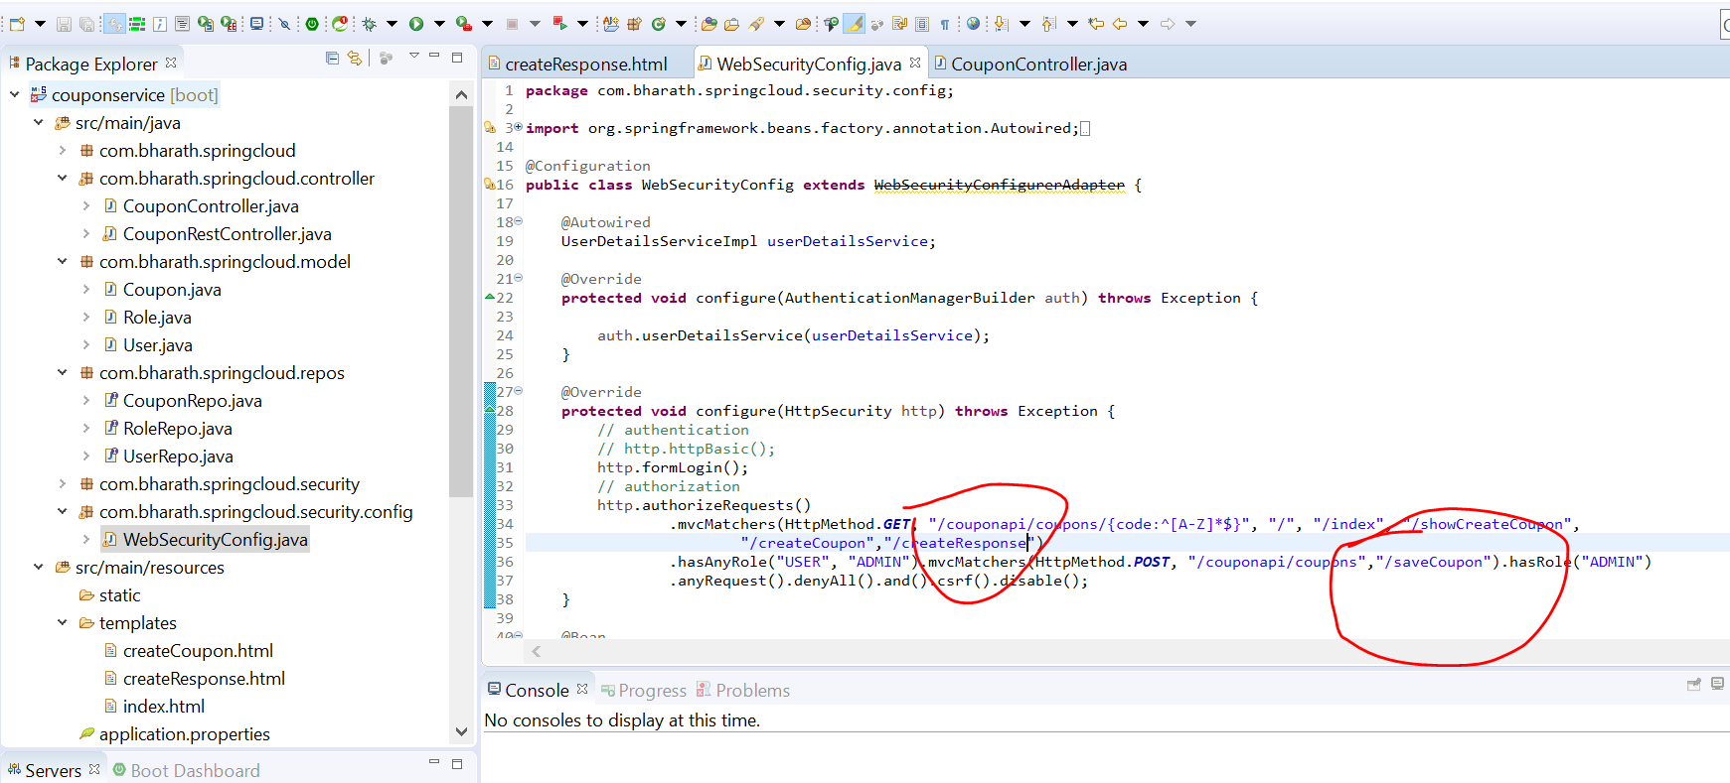

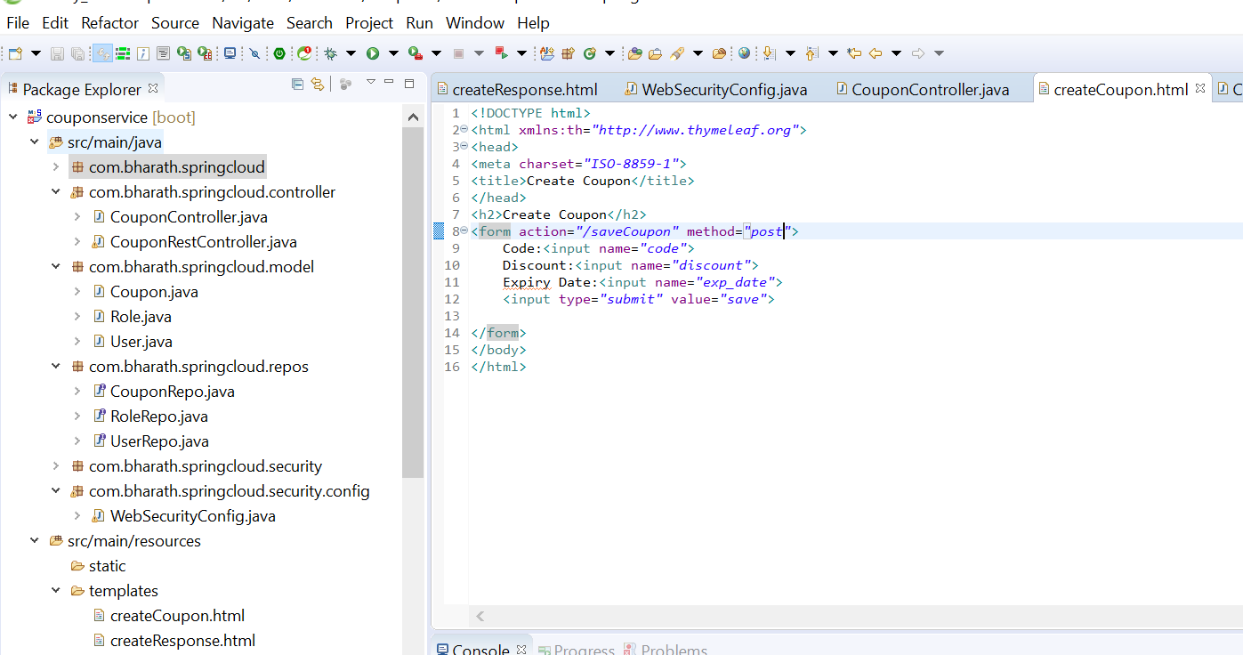

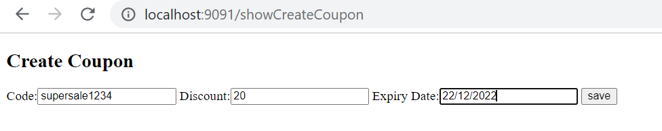

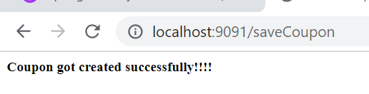

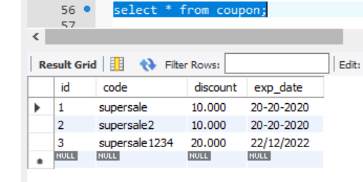

**Render Get Coupon**

**Objective :**

Implement get coupon functionality

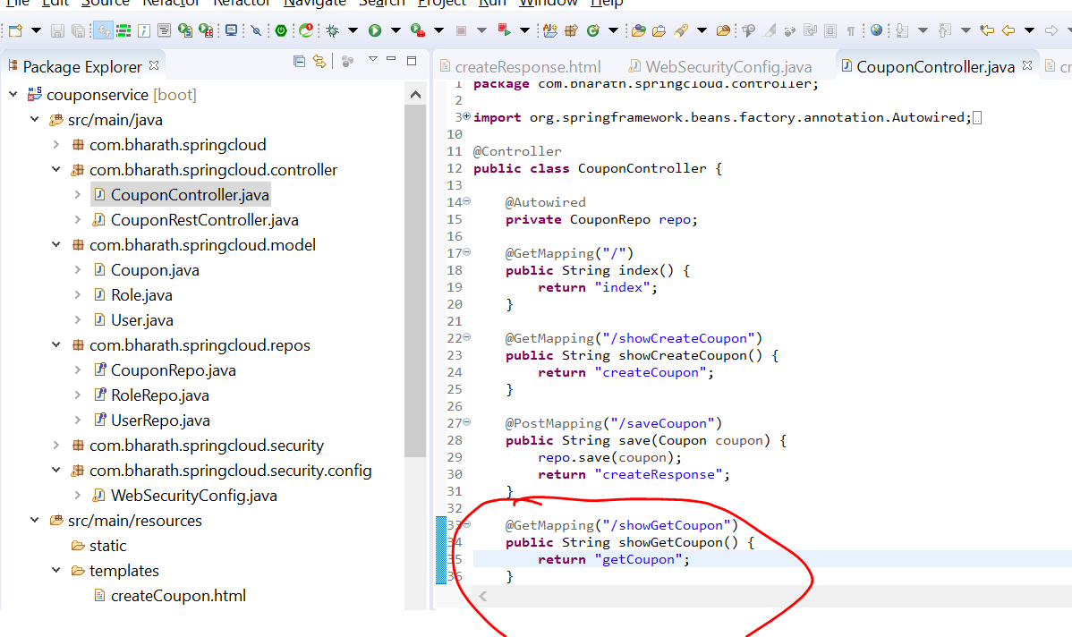

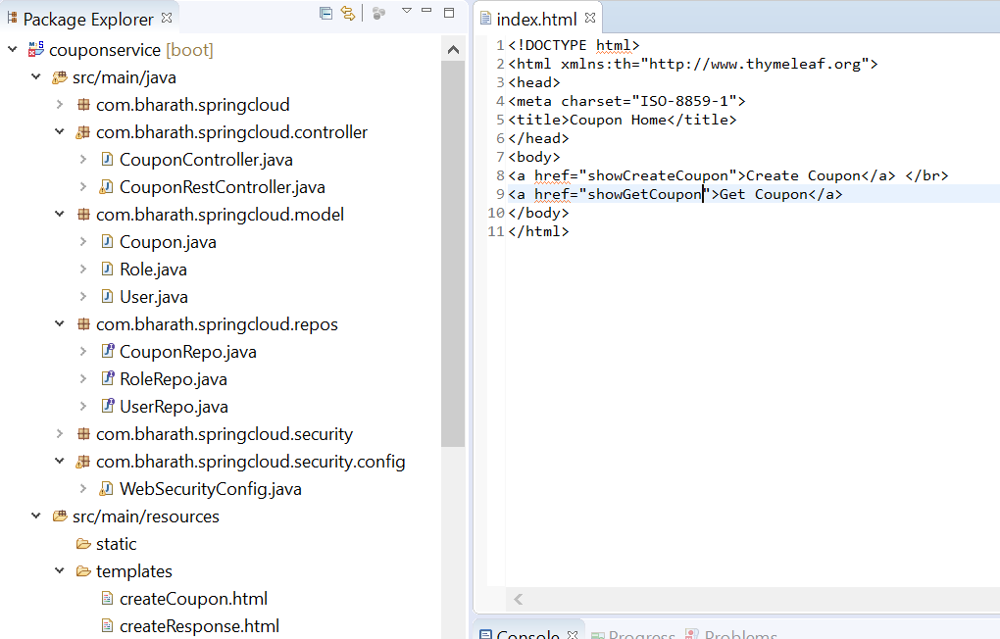

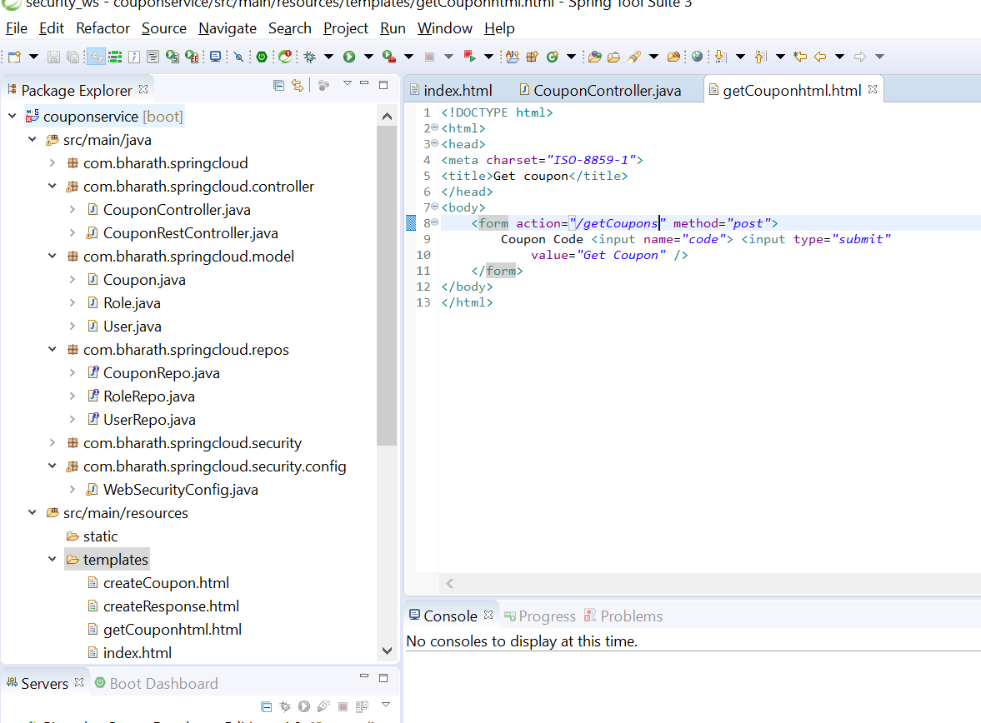

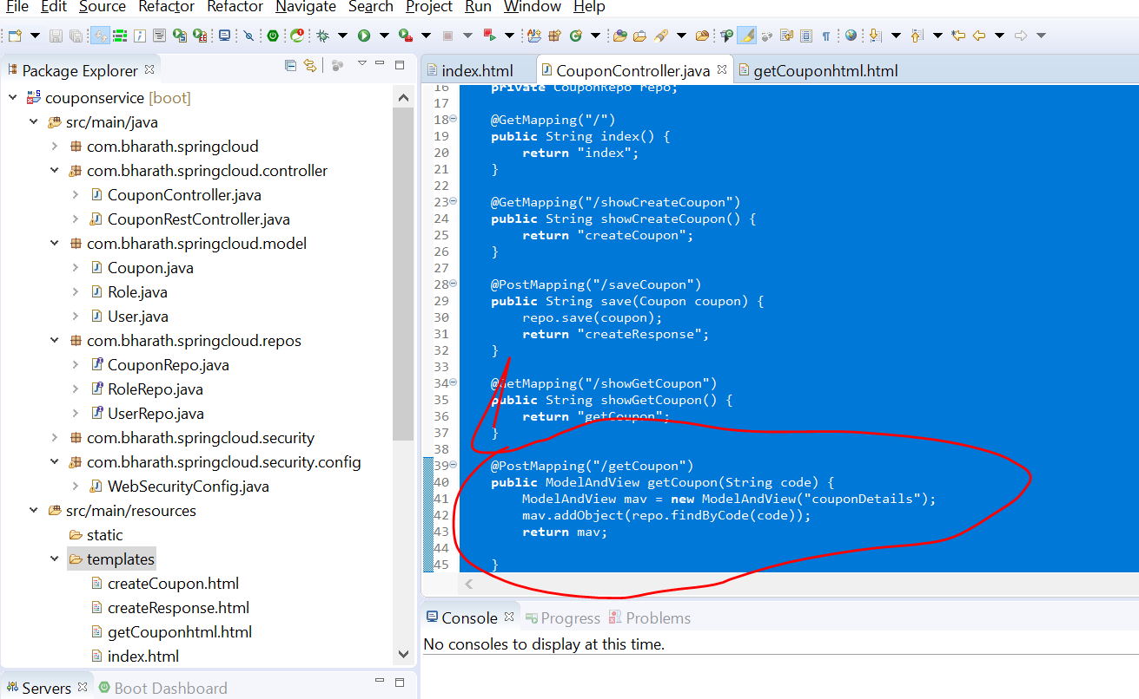

**Test Get Coupon**

**Note :**

We are looking by findByCode so it will automatically use class name in lower case in html

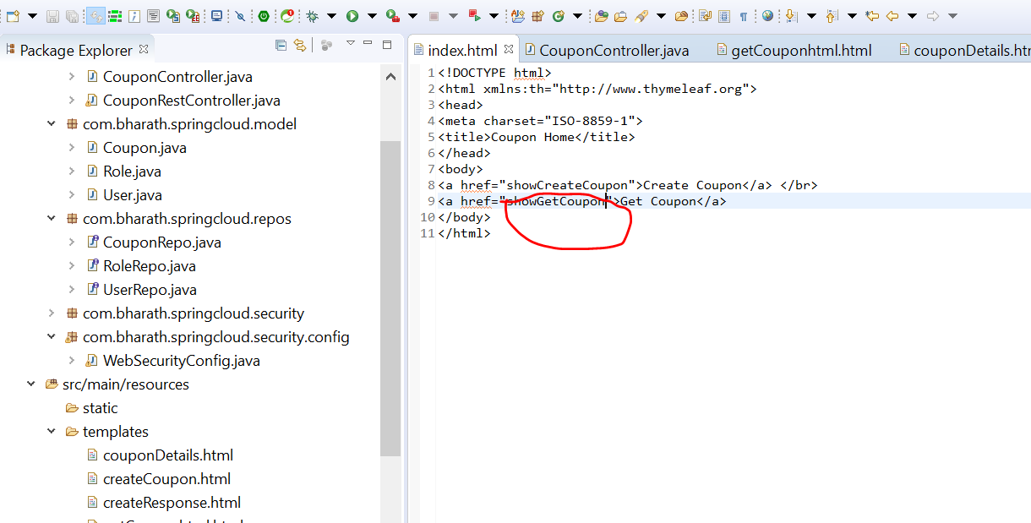

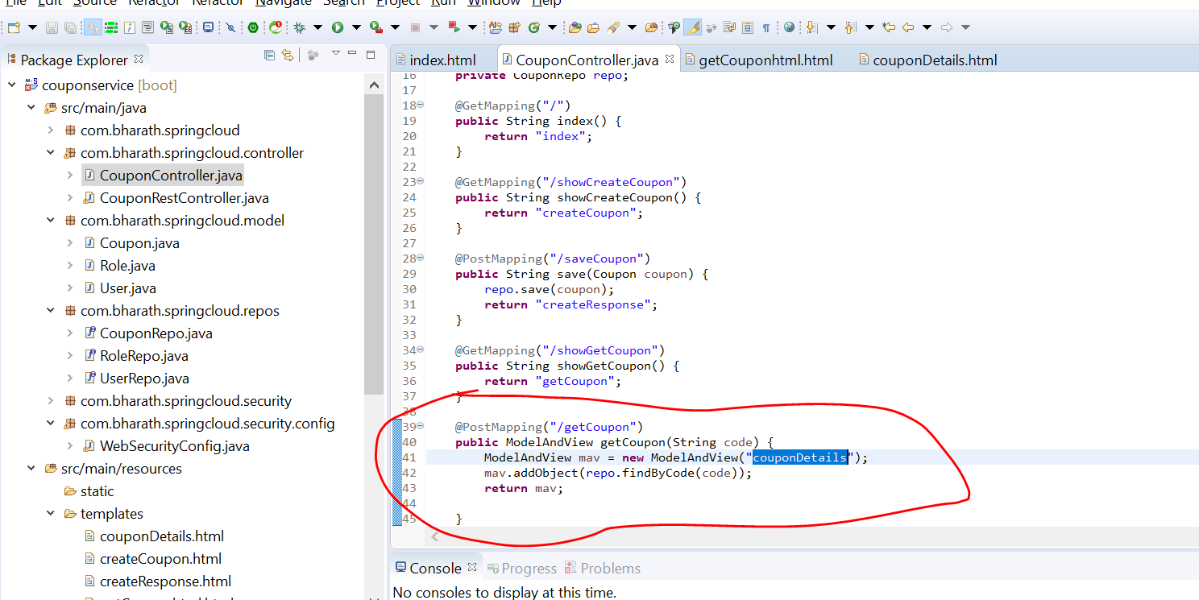

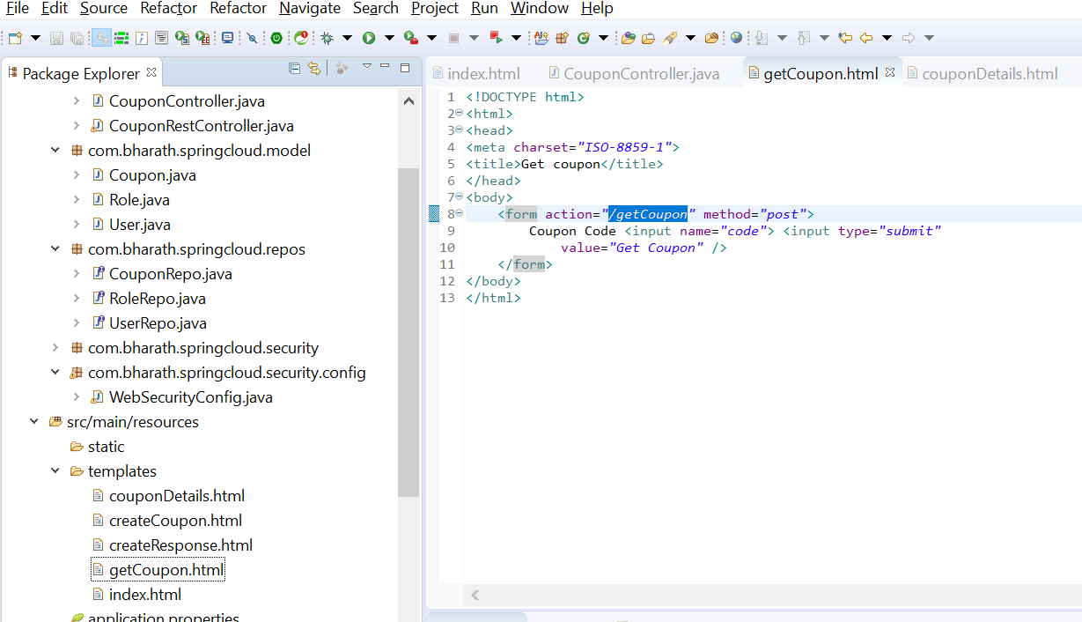

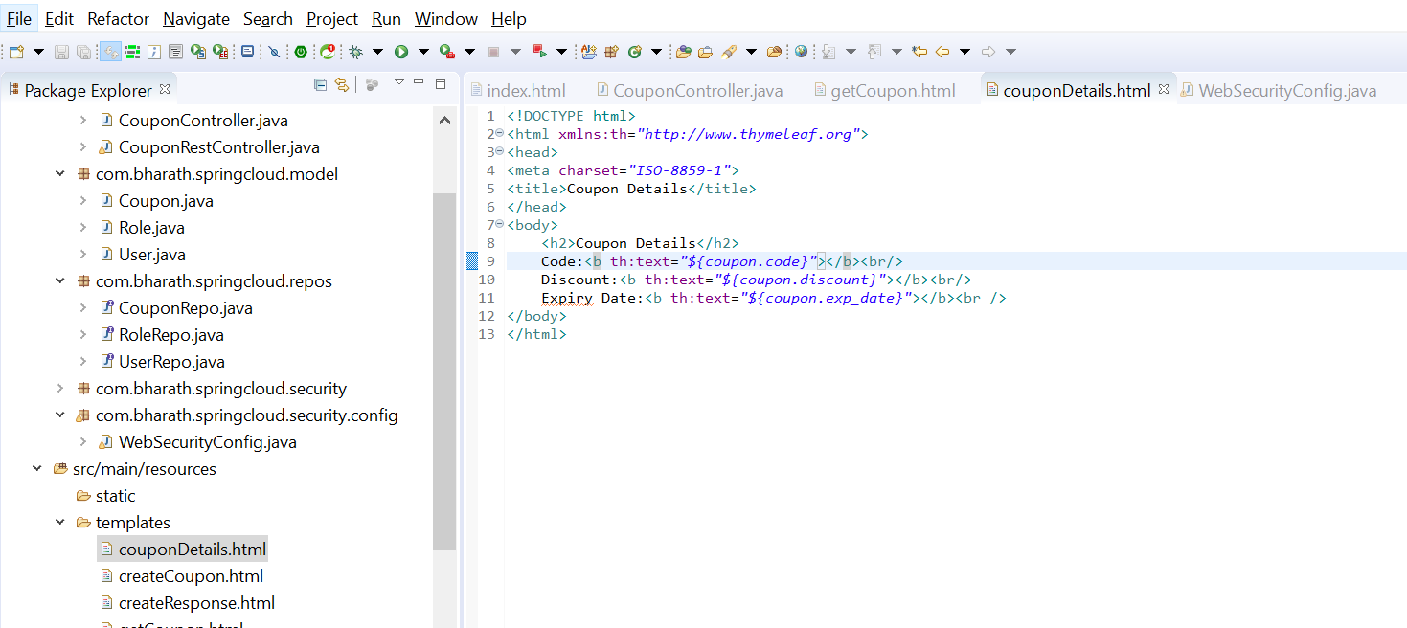

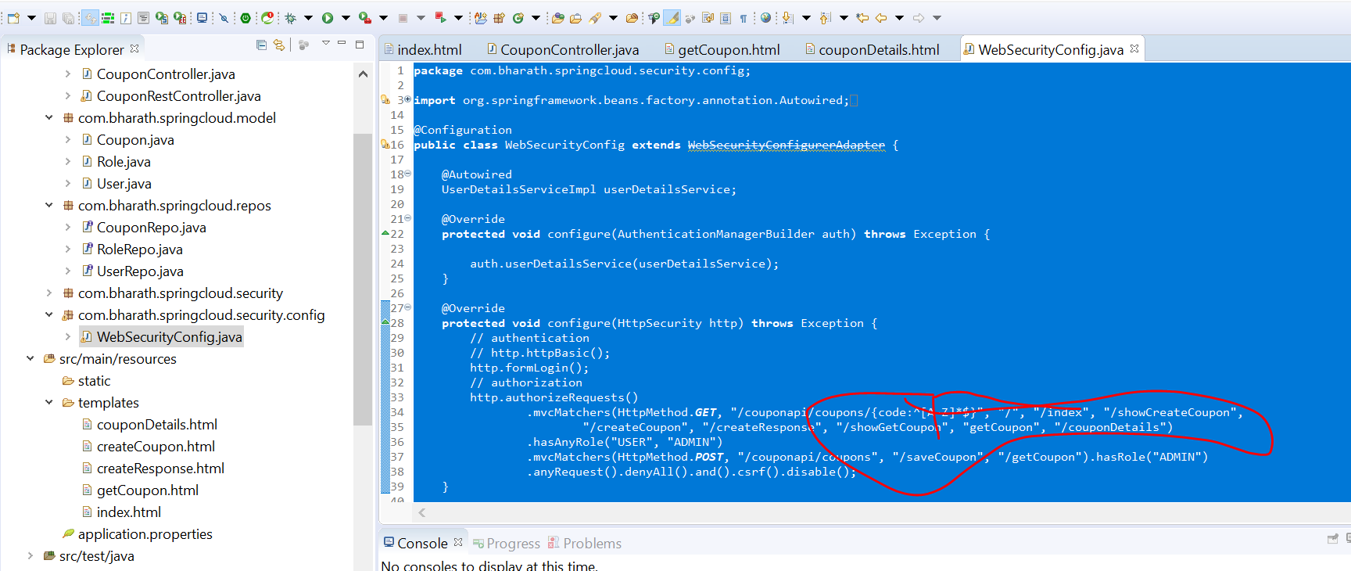

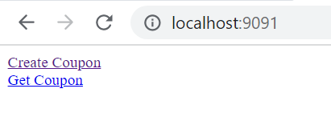

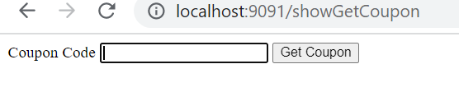

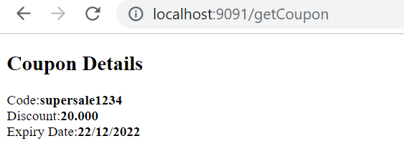

**Refactoring**

**Objective :---**

refactor webSecurityConfig

Create coupon will not be allow by user john

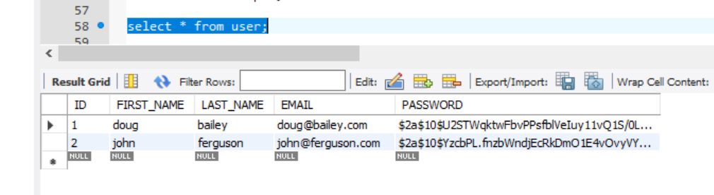

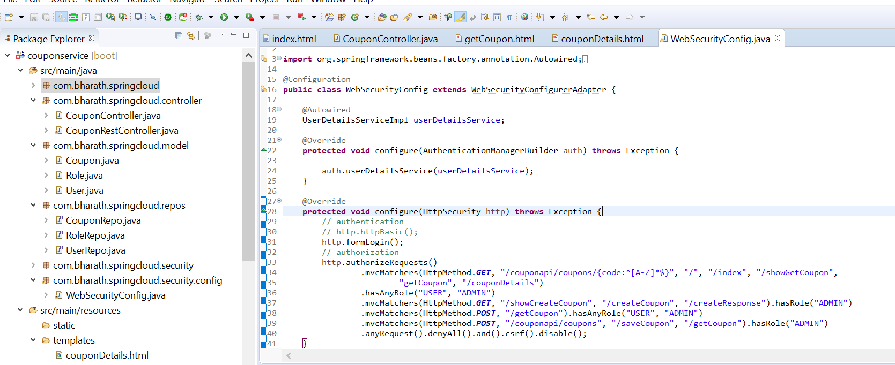

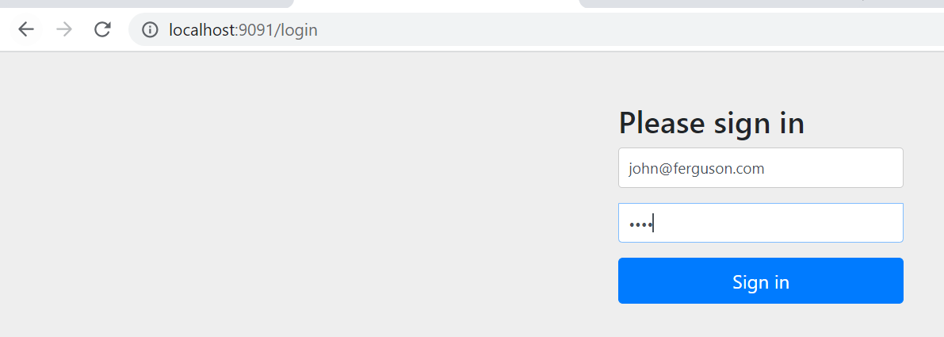

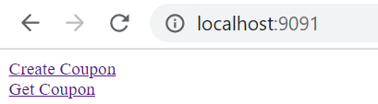

Click create coupon

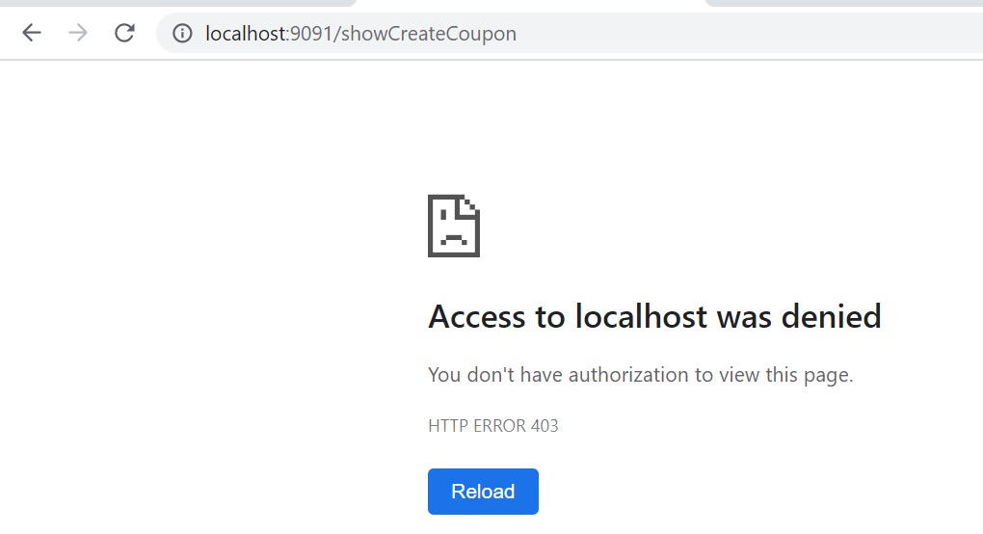

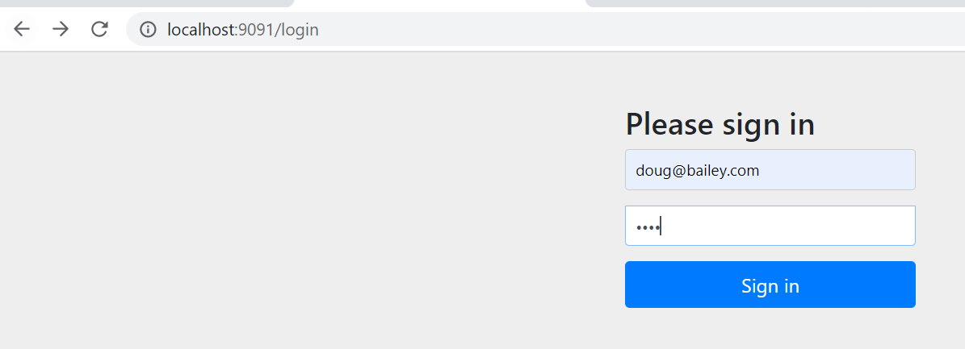

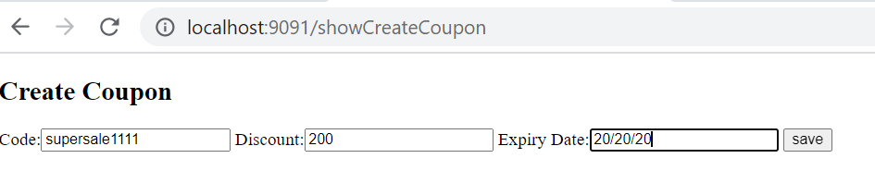

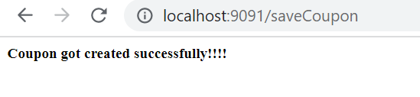

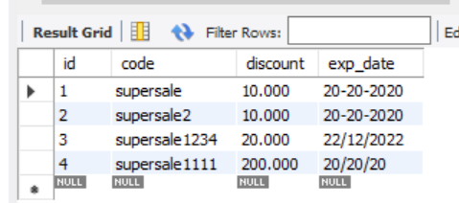

**Implement Custom Login**

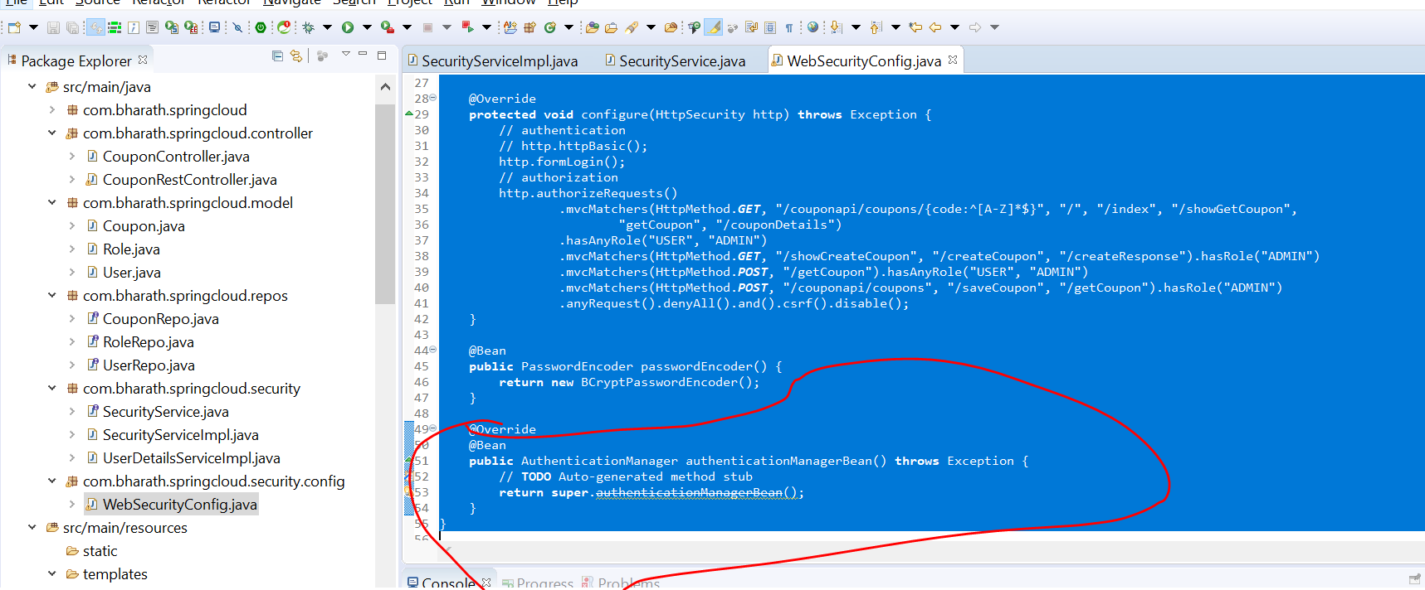

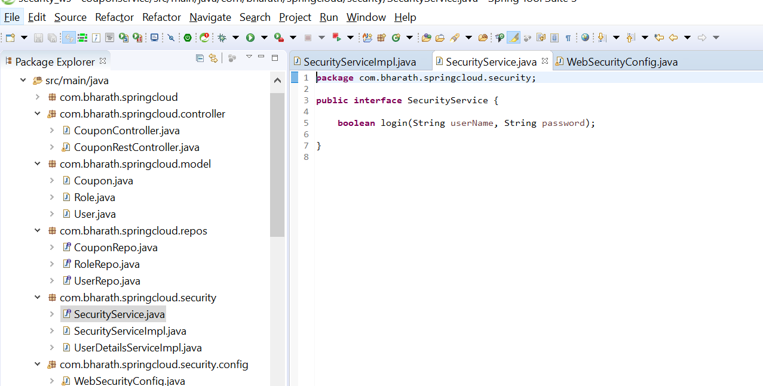

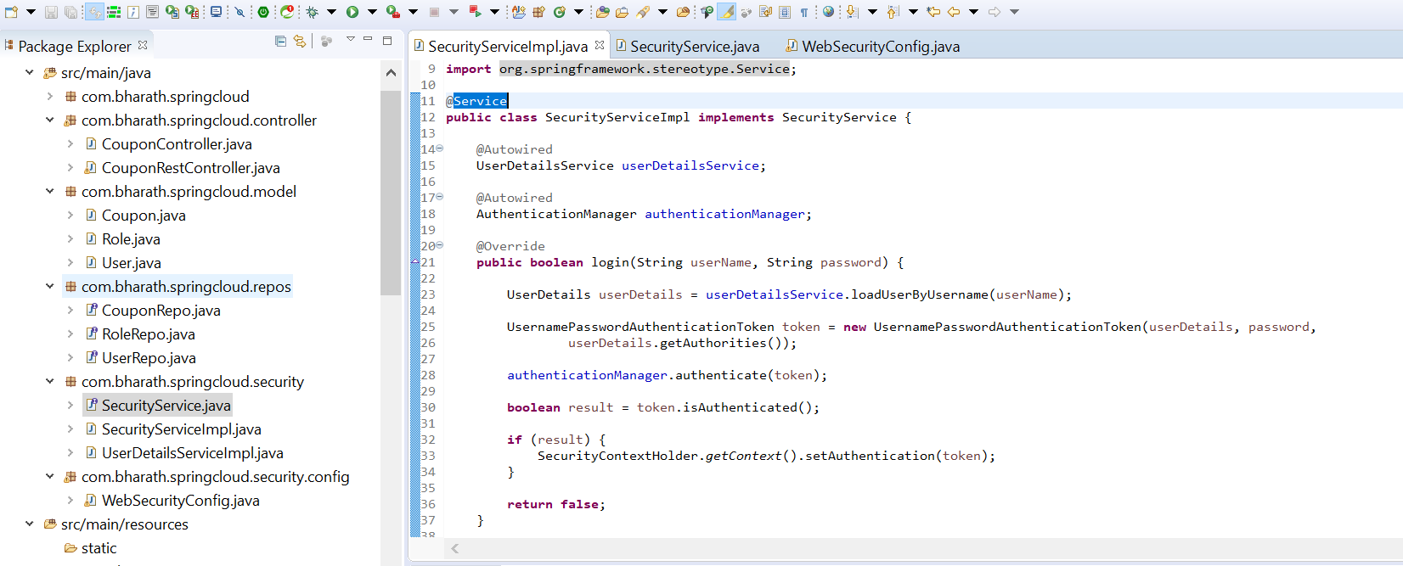

**Create the view and controller**

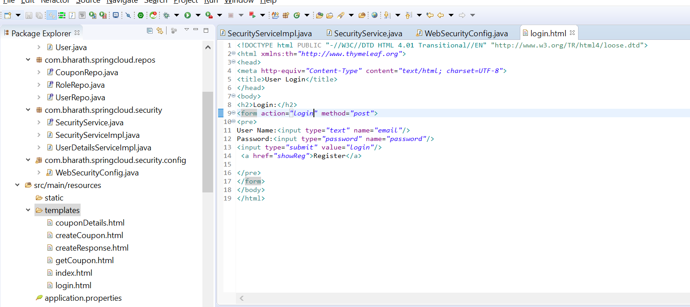

Note :

@RequestParam is spring web annotation

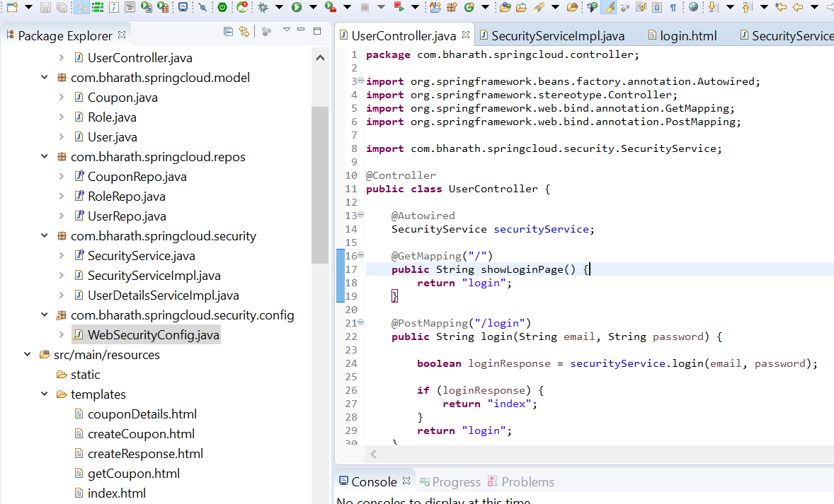

**Configure and test**

We have created our own login page so comment this http.formLogin

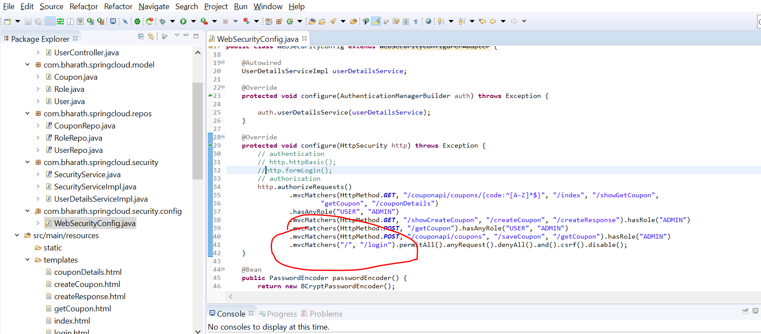

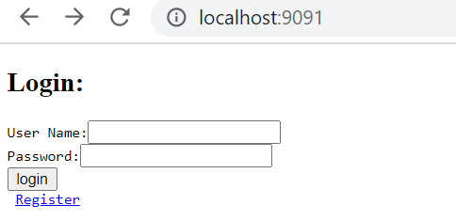

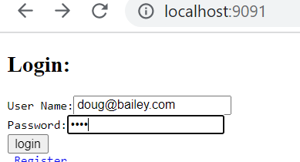

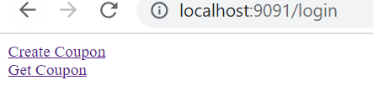

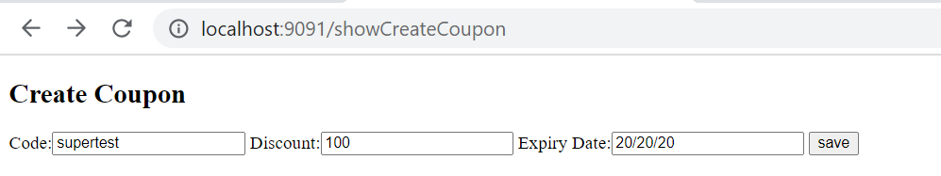

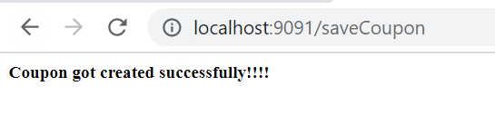

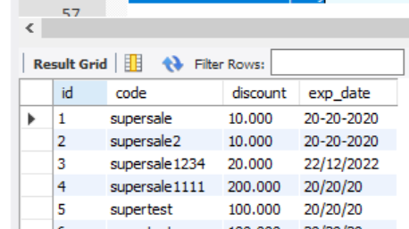

**Logout**

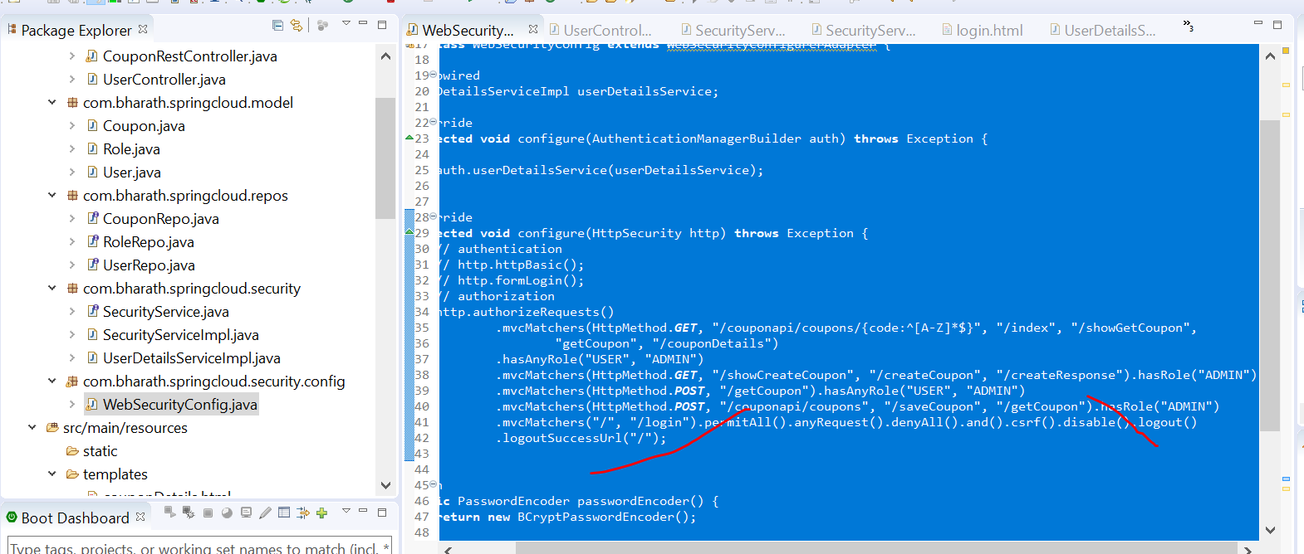

**Note :**

We don’t need to write any mapping for logout in spring

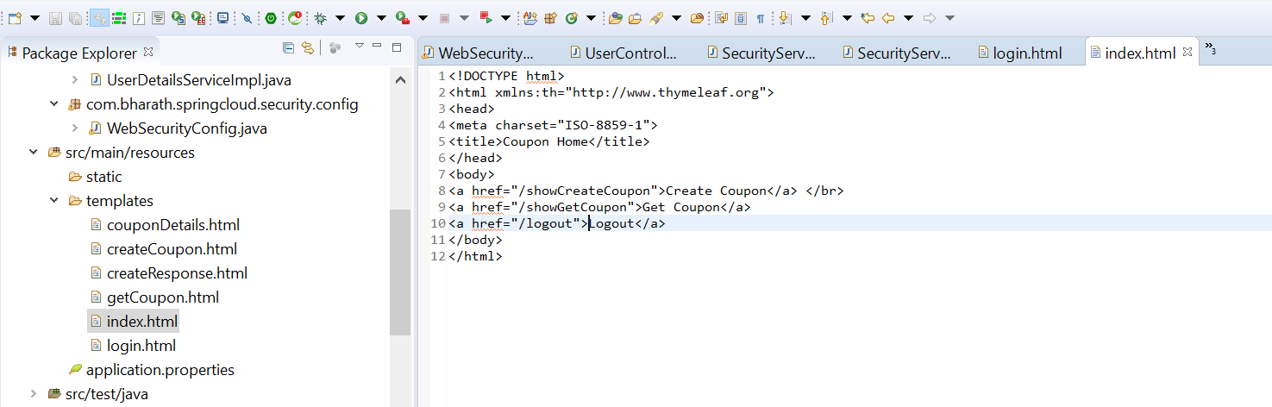

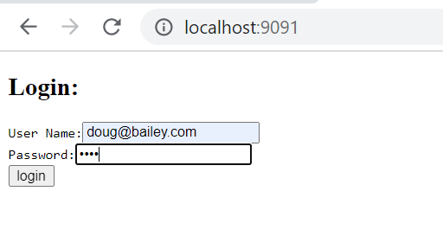

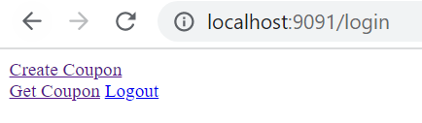

Click on logout , it will come to login page again. At this point session is invalid

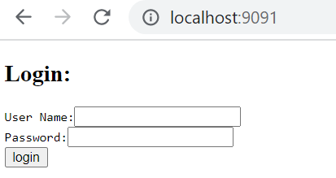

**Implement User Registration**

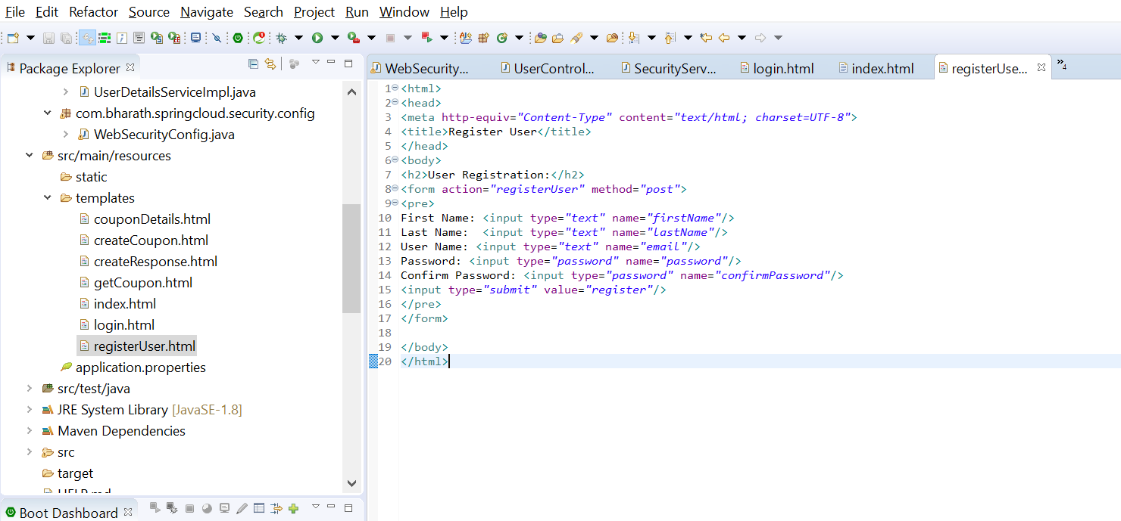

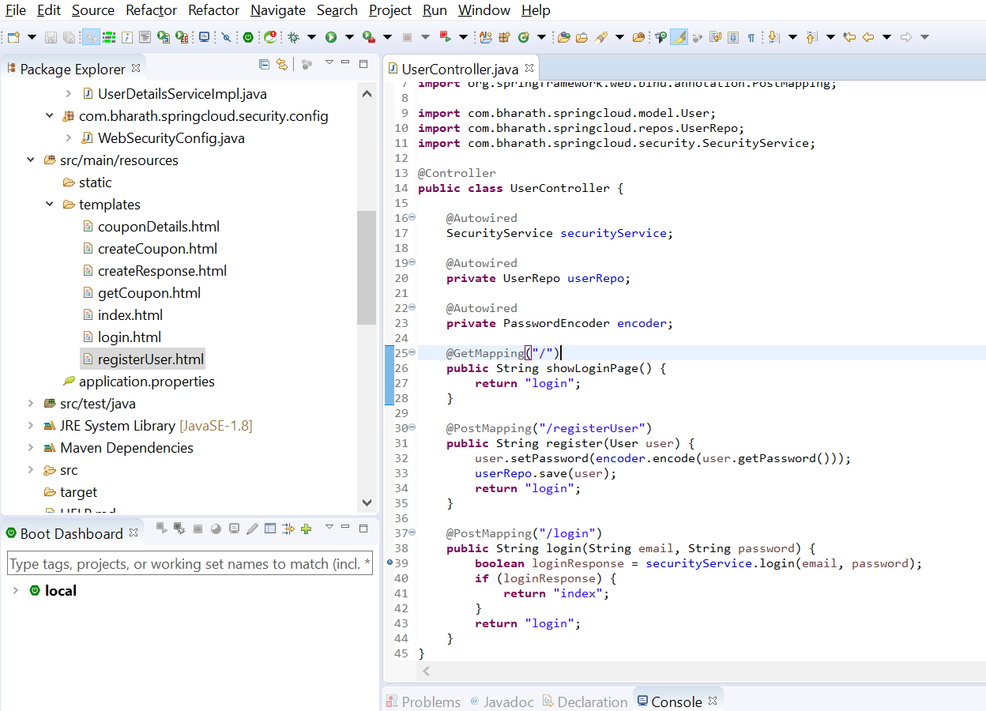

**Test User Registration**

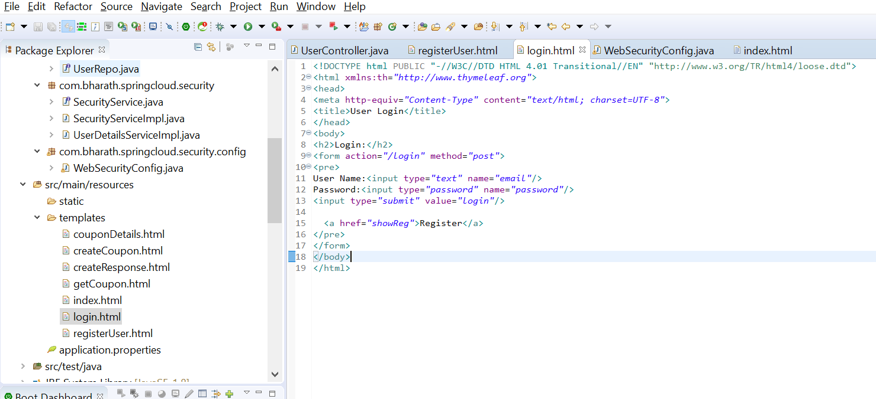

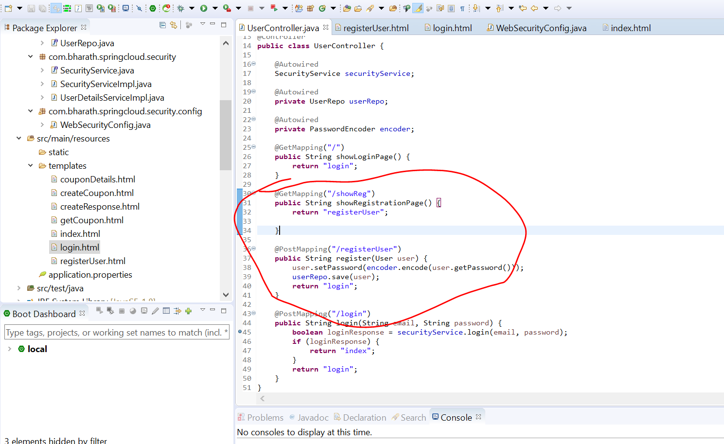

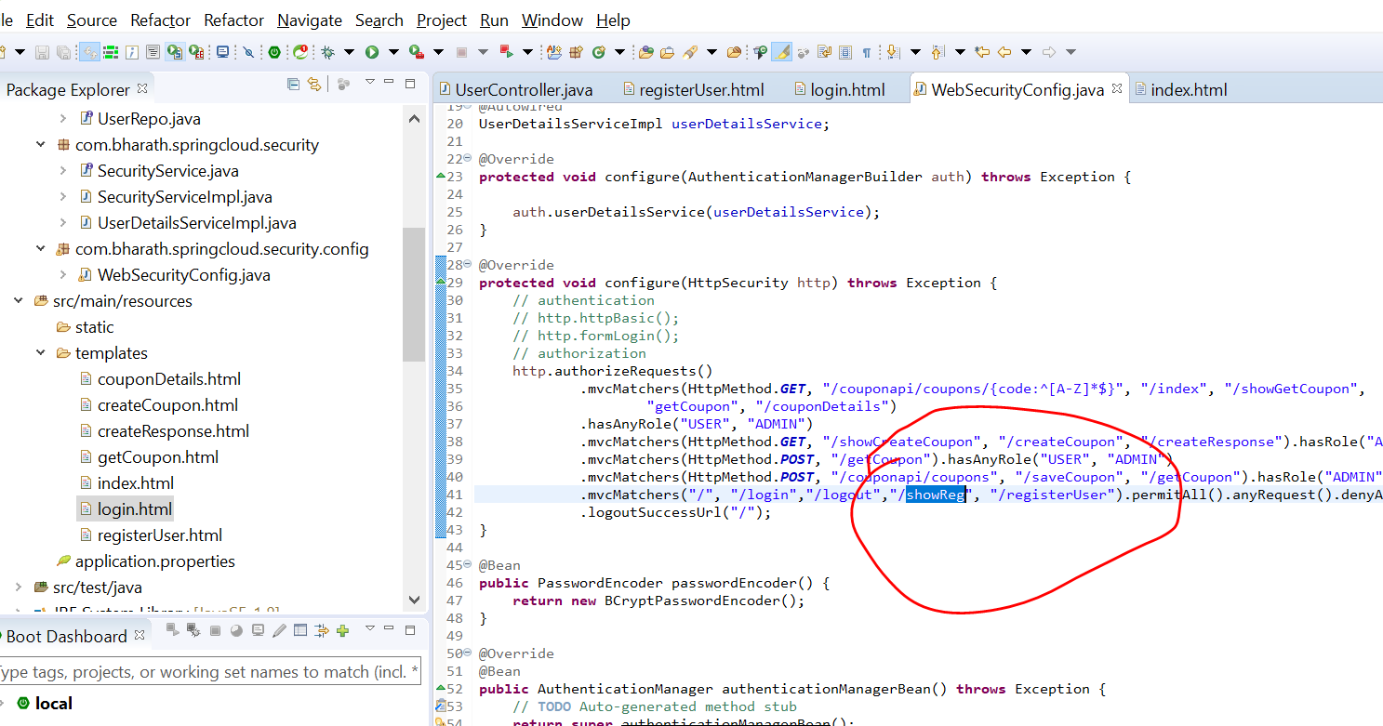

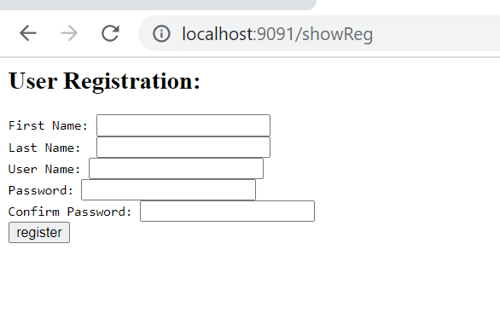

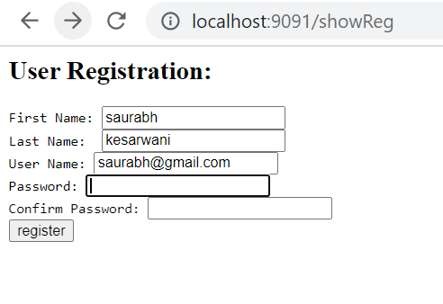

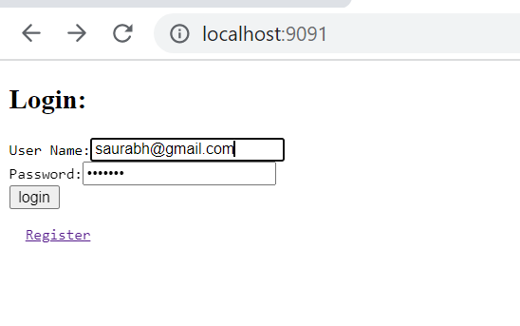

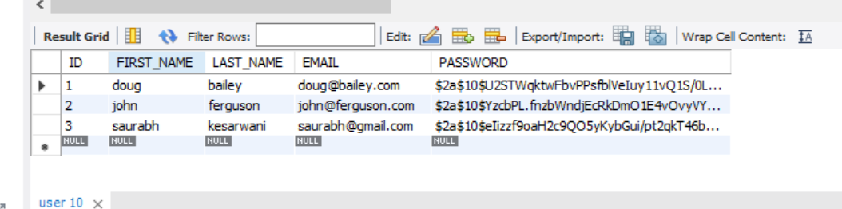

**This user don’t have any roles**

**Oauth Concept**

Open authentication and authorization framework

Example

Tax filing website instead of asking user to register , it will ask to login through facebook.

Once we login tax filing website able to fetch profile info from facebook.

This entire flow is possible through oauth framework

Again tax filing want to upload document of user in google drive it will redirect to google login

This is again possible due to oauth , it will allow only to upload document not to access mail.

Note

Google will decide how much authorization given to tax filing

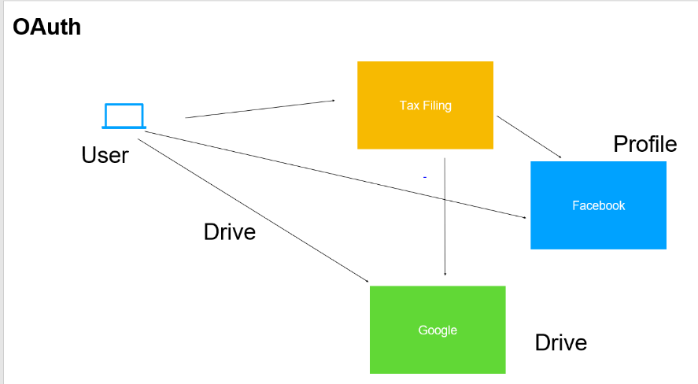

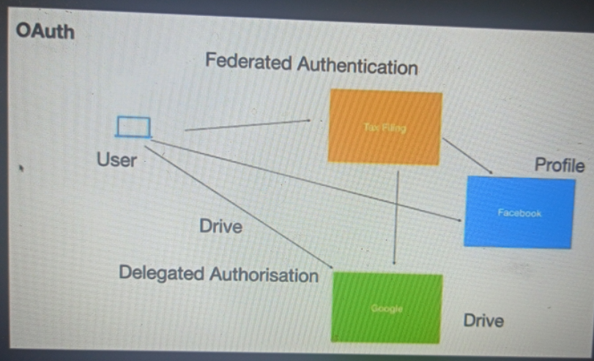

**There are four imp component in oauth**

**Resource server :--**

this is where resources or user data is store .this could be the restful endpoints or web application.

Which a client application want to access . The user or resource owner has permission to access these resource.

So when client application want to access certain data on resource server. It will ask end user to authentication directly with authorization server providing the user name and pw. The authorization server will validate user id and pw and it will generate a token.

This token will use by client to send a request to resource server. The resource server will validate token to authorization server.

If token is valid, it will send required data back to client application

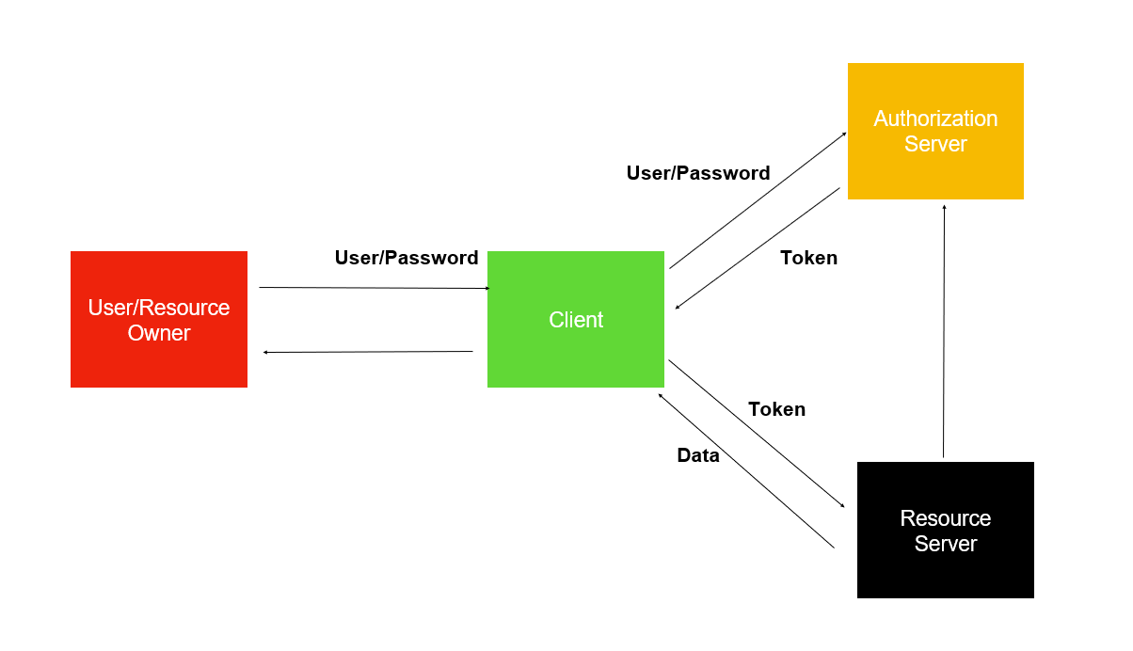

Note :

Once the client application will get a token , it need not to get user id and pw again to access resource server

**Grant Types**

Oauth support multiple work flow

like how user id and pw exchange between resource owner and client and

How user id and pw exchange between resource owner and authorization server

**Grant Types**

Authorization code

Password

Client credentials

Refresh Token

**Note :-**

we can pick appropriate grant type as per our application requirement

**Authorization code grant type**

User trying to file tax returns using a web application. This application want to access google docs of user so that it can use them and file his return. At this point it will ask user to authorize with the google auth server. The user will be redirected to login page.

The user enter user name and pw at which point the auth server tell the client app the user has granted the permission. The client app has not got the token yet. At this point the client apllication need to send has it own user id and pw which register itself to the auth server.once auth server get details of client it will send token to client. Once the token got it can do whatever it want to do with the resource server.

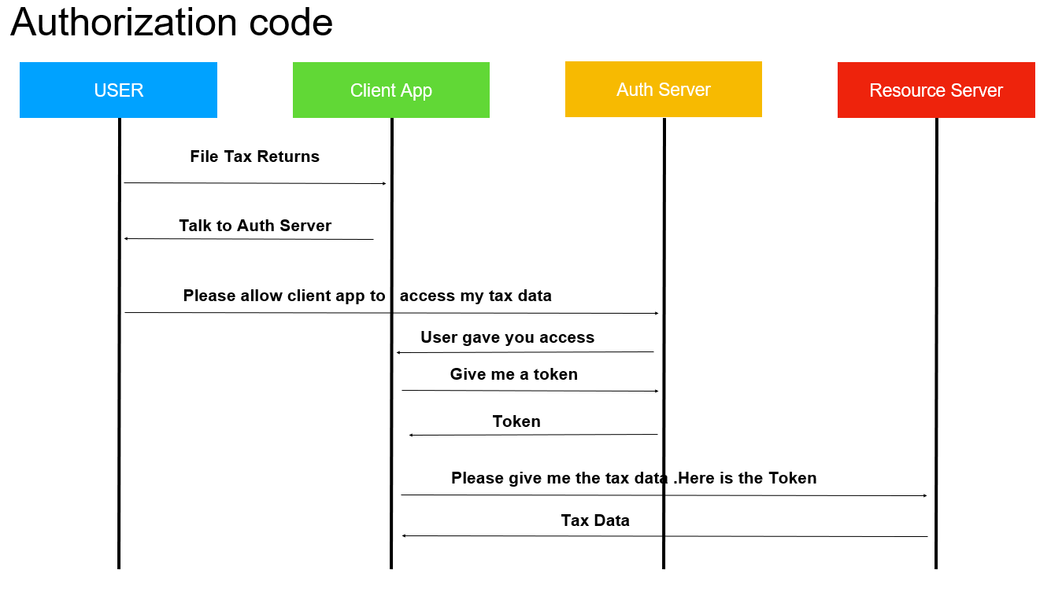

**Note :**

The user details are never known to client application

What does a authentication server do?

An authentication server is an application that facilitates the authentication of an entity that attempts to access a network. Such an entity may be a human user or another server. An authentication server can reside in a dedicated computer, an Ethernet switch, an access point or a network access server.

**Client id and secret given to client by authorization server when it register to the auth server**

**Password Grant type**

**The only difference between Authorization code grant type and Password Grant type**

In authorization code grant type client don’t know about user id and pw but in Password Grant type user giver user name and password to Password Grant type and it will send it own credential and also user name and pw to auth server

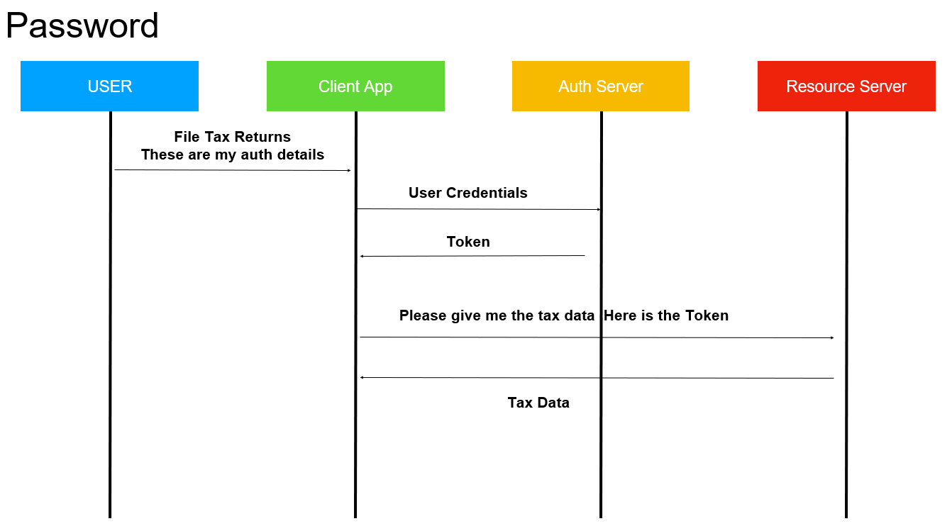

**Note :--**

**Auth server :-- google or fb account where client app are already registered it**

User details will directly given to client app

**Login using fb account uses :- Authorization code**

**Resource Server** – store user's data and http services which can return user data to authenticated clients.

What is a resource server in OAuth?

The resource server is **the OAuth 2.0 term for your API server**. The resource server handles authenticated requests after the application has obtained an access token. Large scale deployments may have more than one resource server.

**Client credential grant type**

**Here don’t have user in picture**

Think like an application accessing another application like in m/s

Very typical in single sign on application

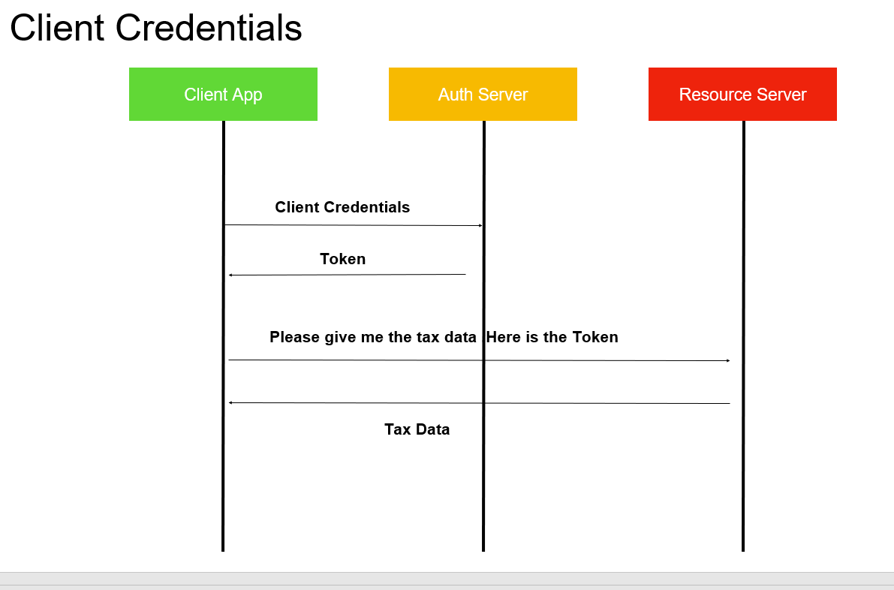

**Refresh Token**

Along with the token auth server also handsover refresh token. Suppose token expire then to repeat again entire flow again it will send refresh token to resource server and it will validate token to auth server.

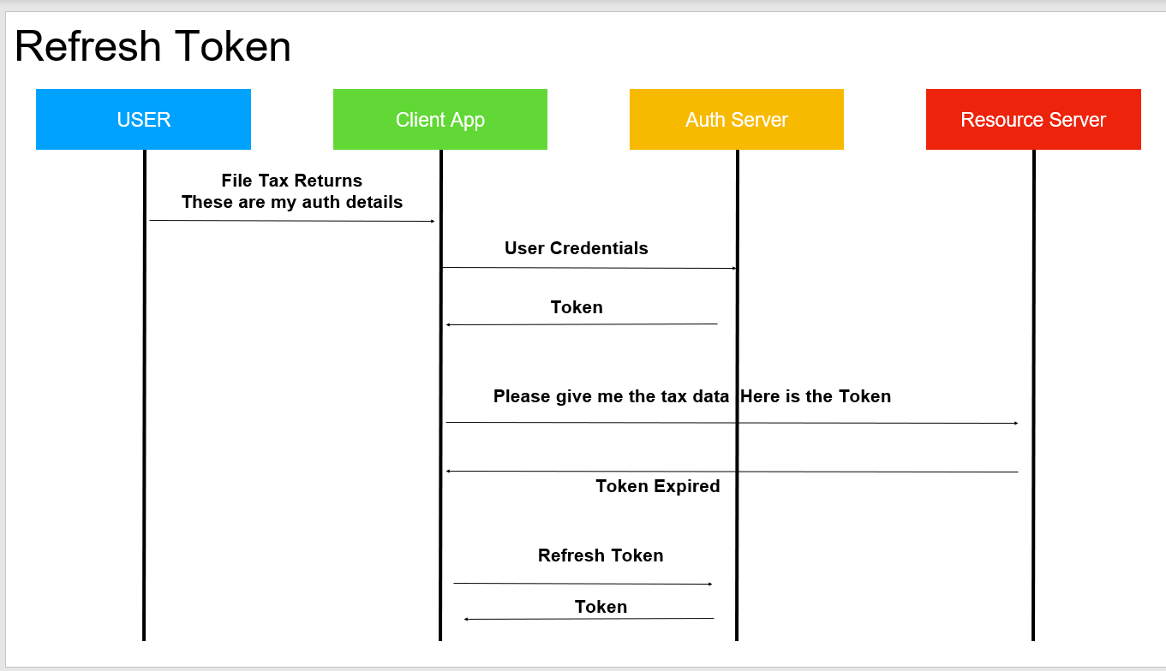

**Note:---**

We can create our own grant type also if required

**Google Oauth Playground**

**Client app :--**

**google playground**

**Search contact :----click it , and ask for authorize with google credential once will authorize it will get token and**

**That token we can use in resource server to get contact details**

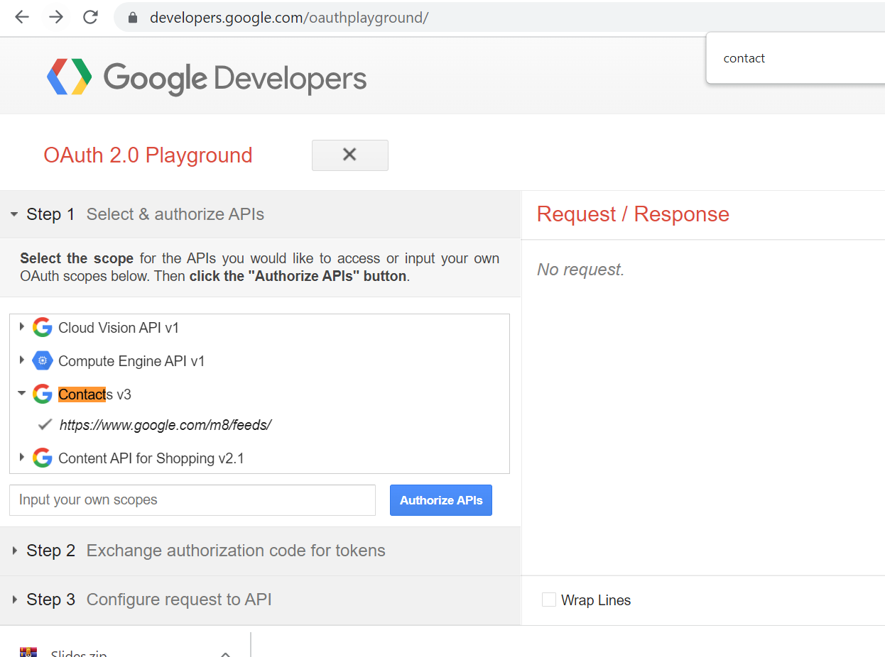

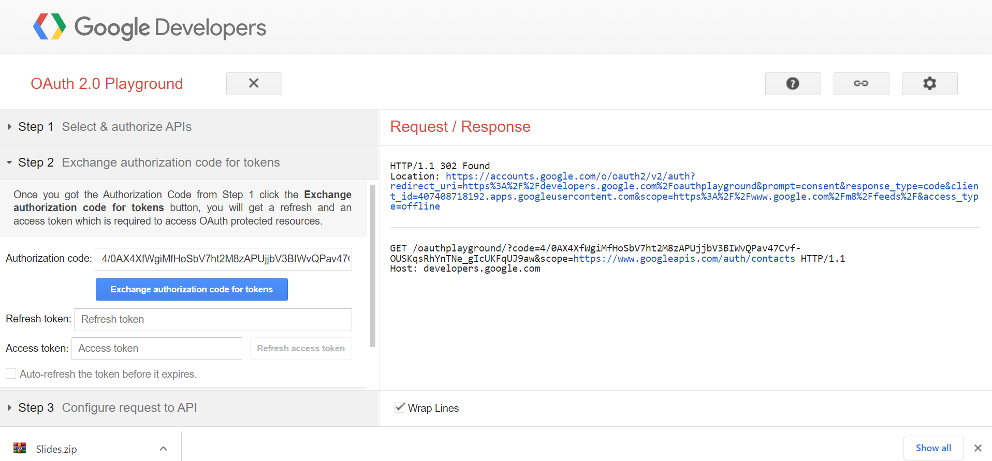

**Oauth in action**

**Steps**

Authentication server will authenticate user details and client details, generate a token and store token in tokenstore

**AuthenticationServer :**---- responsible for authenticating and generate a token

**ResourceServer :-**-- responsible for receiving a token and verifying whether token is valid and grant permission to appropriate url

**Step 1:----Add maven dependency**

Will add in CouponService project

For oauth we are using version below 2.4 release

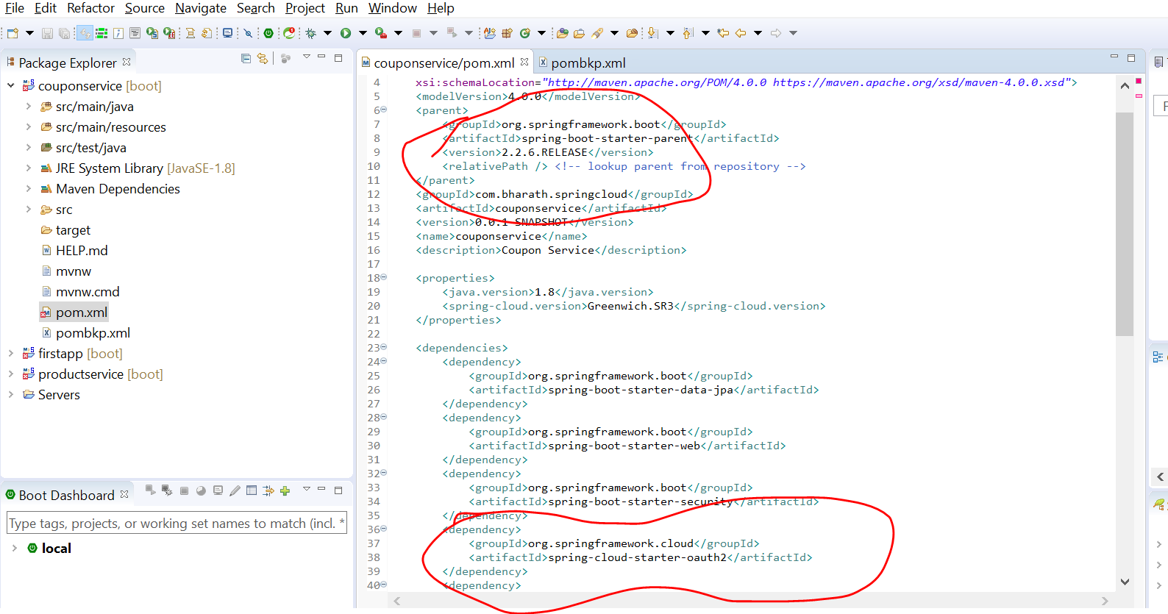

**Step 2:----Create WebSecurityConfig**

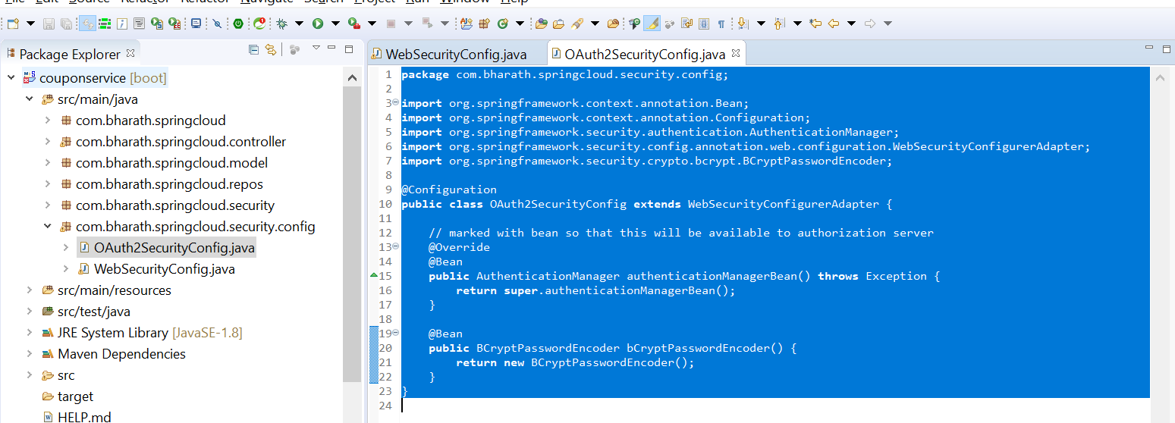

**Create AuthorizationServer Part1**

**We need to tell authorizationServer about token store**

It will retrieve userdetails from database

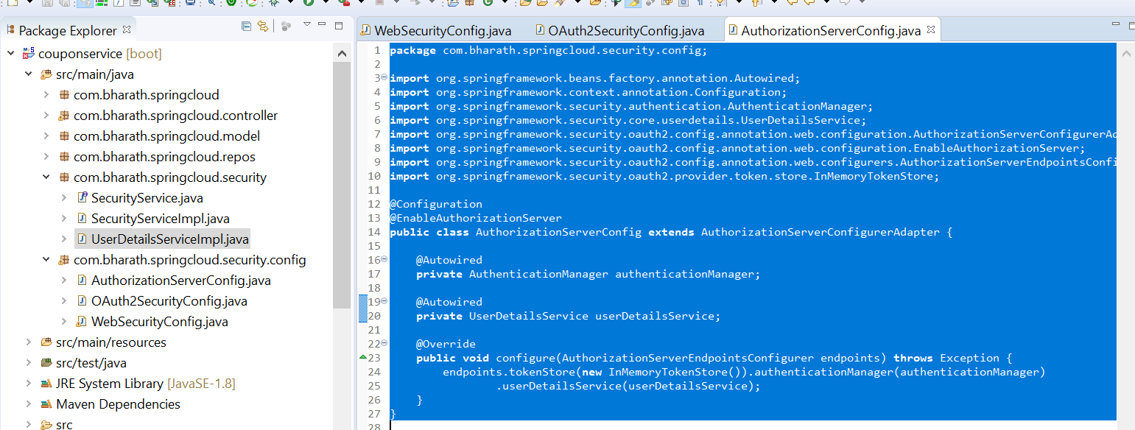

**Create AuthorizationServer Part2**

Will configure client details in Authorization Server

**Note:**

Will using resource id again in resource server that will be link like authorization server and resource server

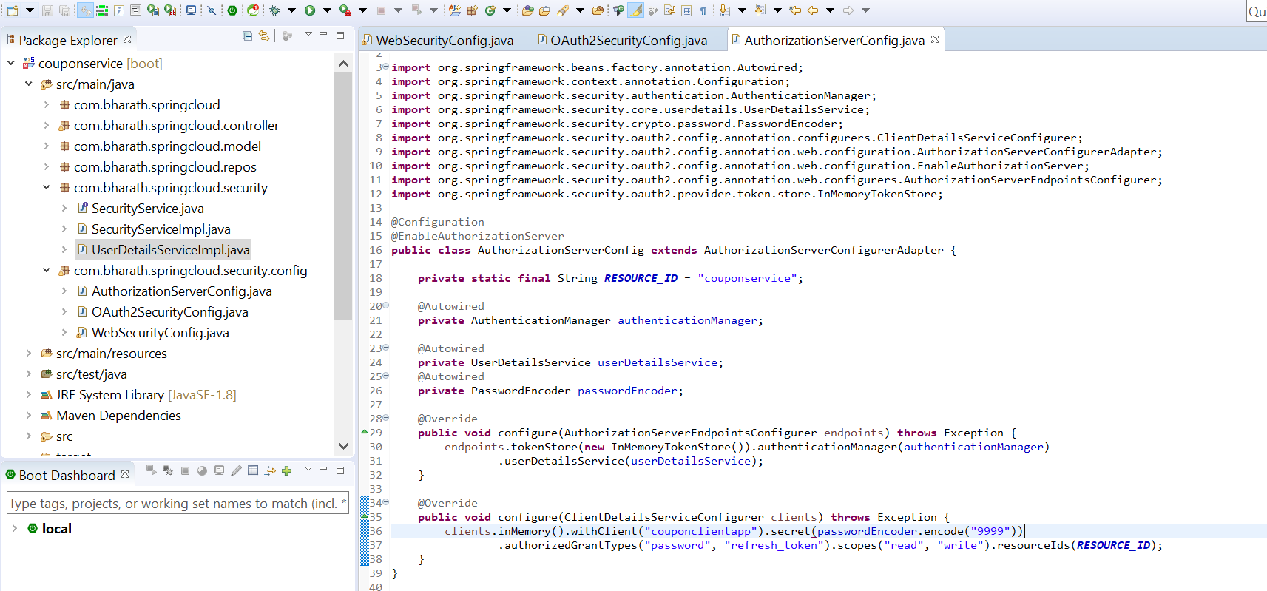

**Create Resource Server part -1**

**Note :--**

ResourceServerConfigurerAdapter is very similar to webSecurityConfigurerAdapte

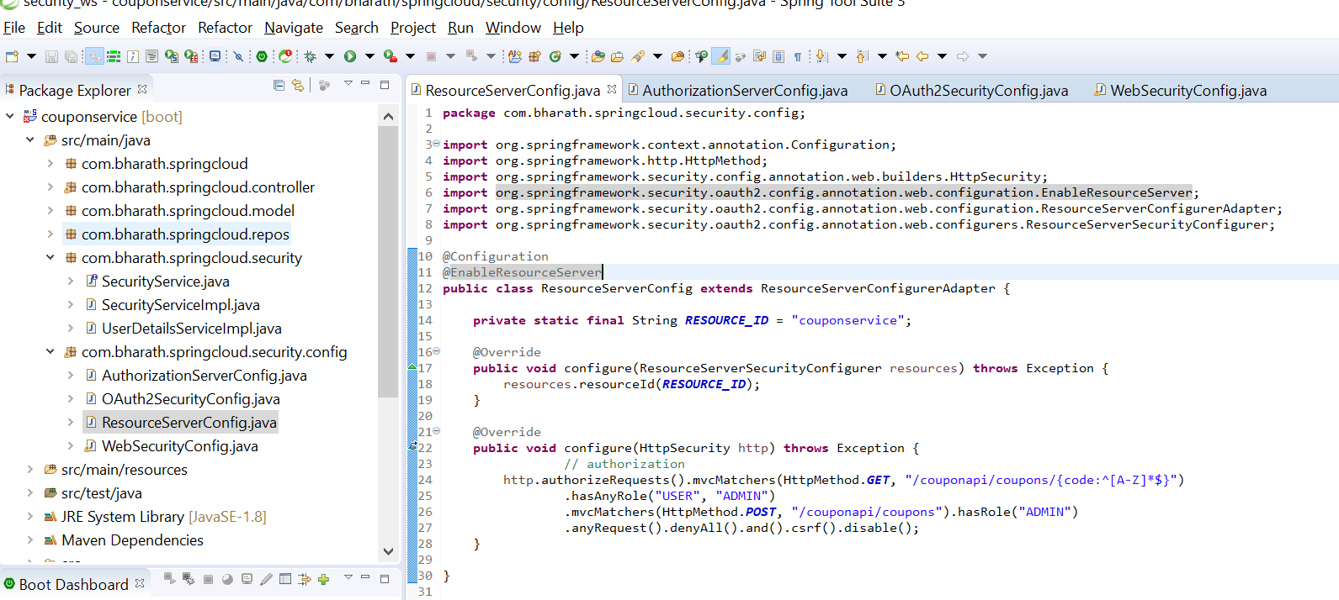

**Testing**

**Step 1:---**

**retrieve a token by hitting authorization server**

**Default is :----**/oauth/token

We need to provide client details and also user details in password grant types to authorization server

This is what we configured in memory . These are client details

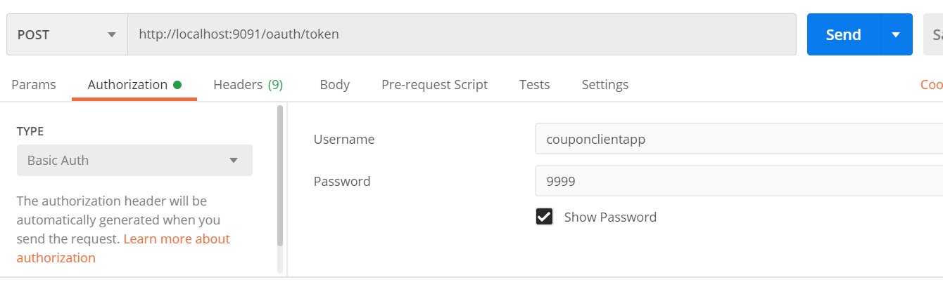

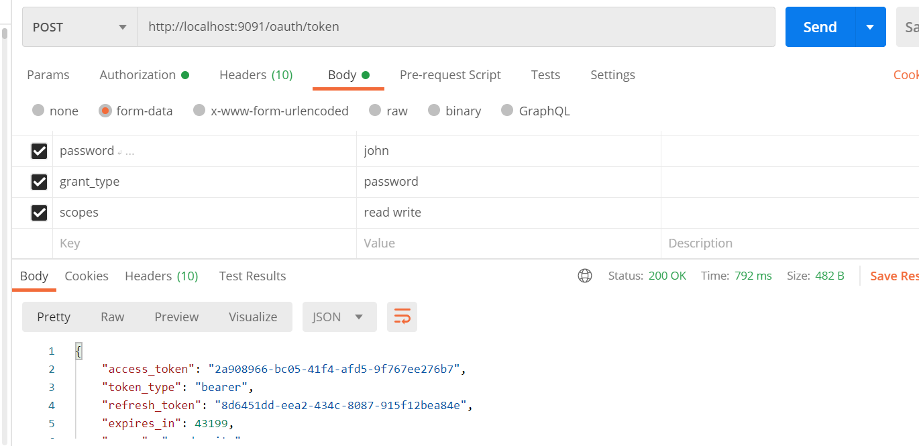

This request hit the authorization server . It will go all regular spring security flow.

Once the authentication is successful it will generate a token for us.

It will use token_store in memory

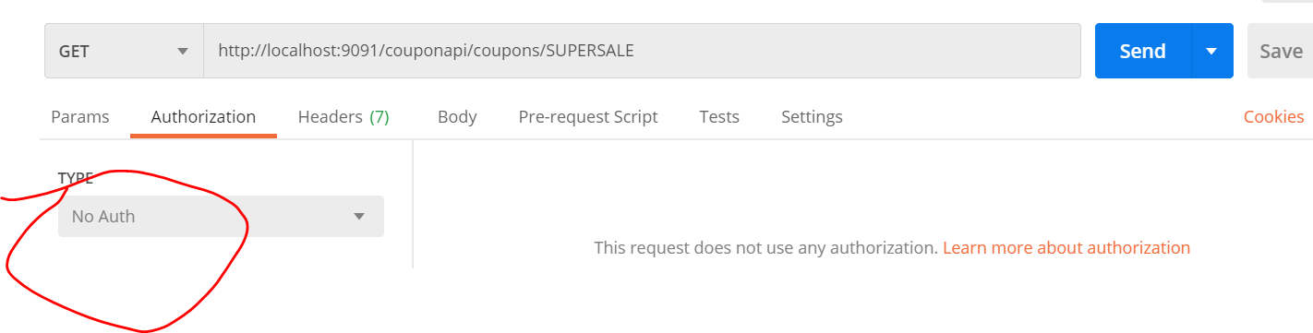

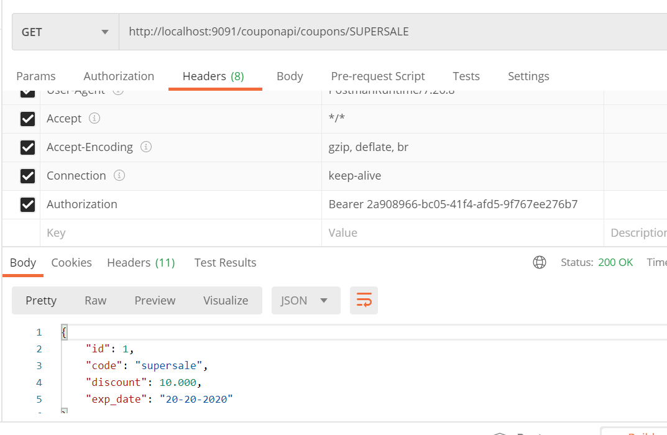

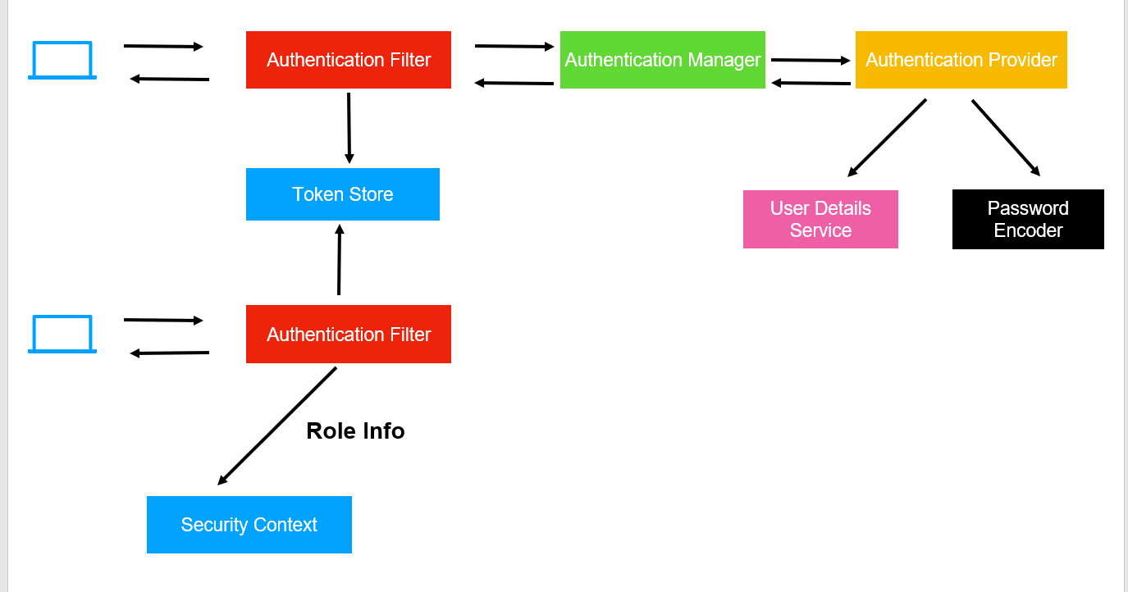

Resource server will take the token ,communicate with authorization server if this token is valid. It will look token_store to do the validation then it will fetch user details will store info in security context because it need to know which user has access of which resource

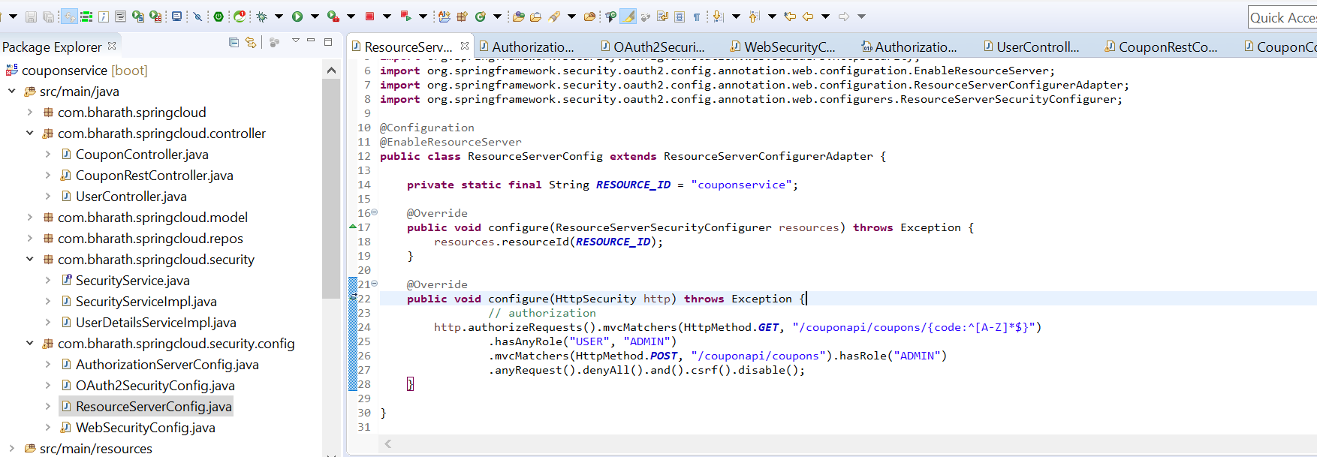

Authorization server doesn’t care of storing the details but resource server does

John does have admin access to create coupon

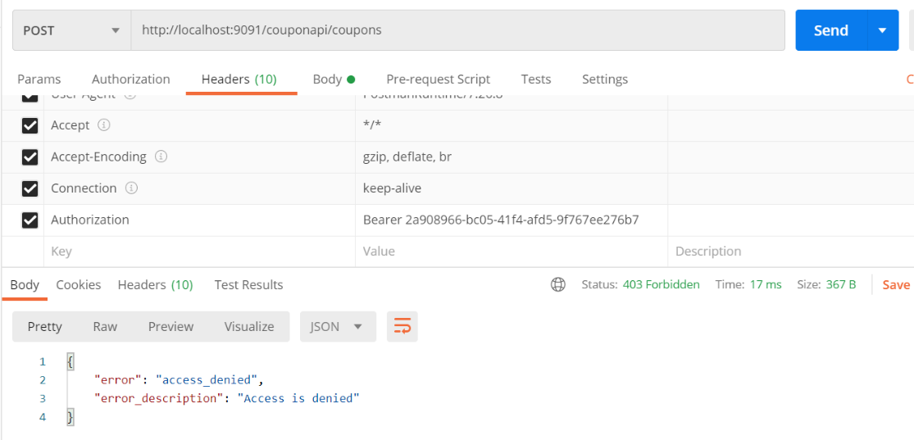

With doug

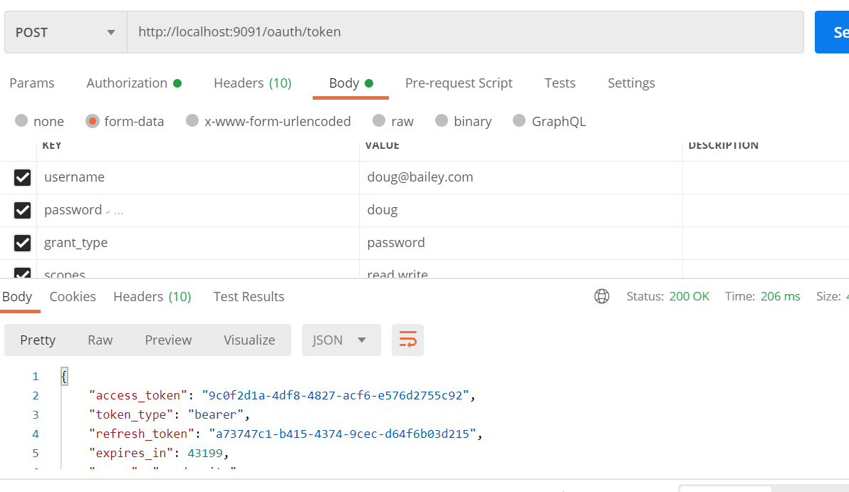

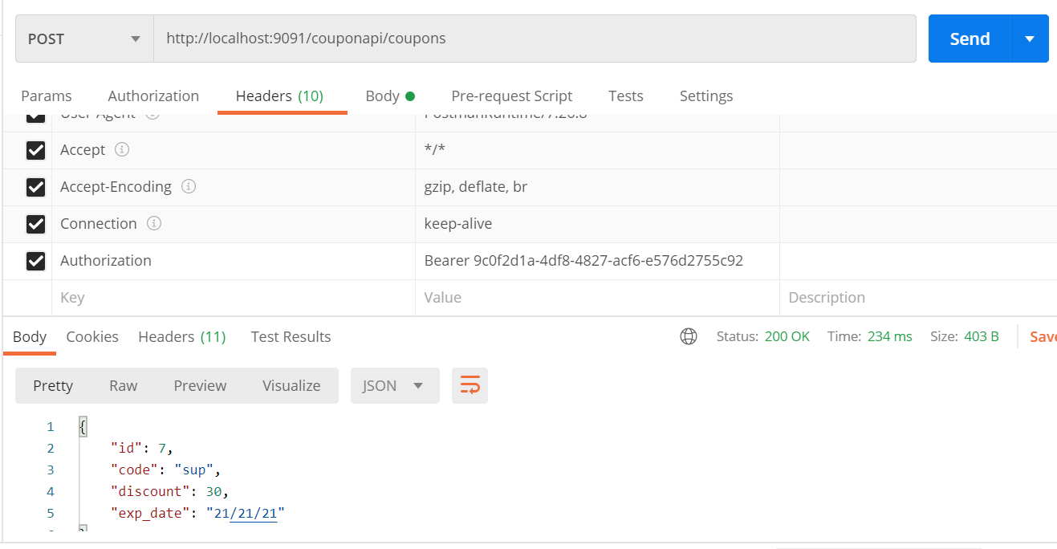

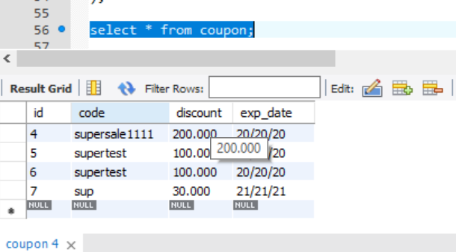

We got token by authorization server and once the token is used by resource server it validate against token store and retrieve user info from userdetails service and check access of admin .

**Store token in db**

**Note :**

So far we use in memory token store so once the application is down it no longer valid

We can permanently store token in d/b

Spring security will use this table by default to store token

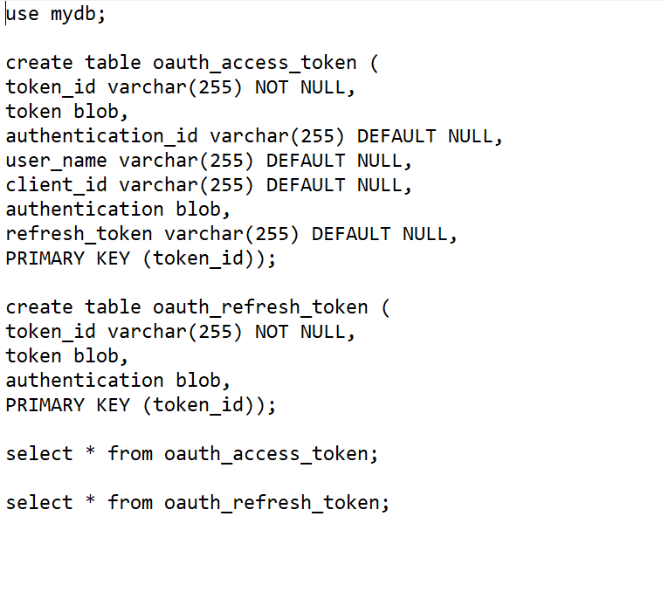

**Note :**

**Spring will inject a data source**

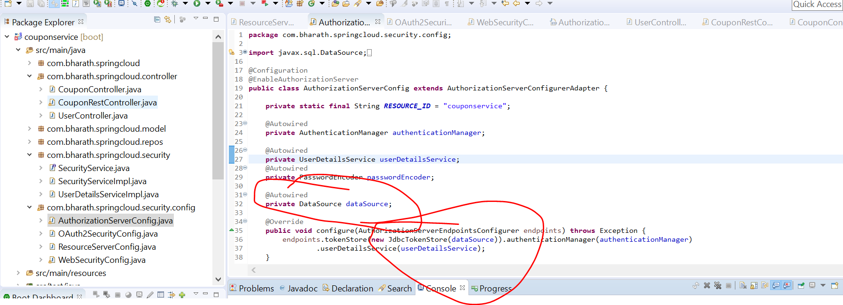

We don’t need to write any sql, JdbcTokenStore know how to store token in table.

**Imp point:---**

resource server will directly go into database to validate token instead of going in memory authorization server to validate

Token

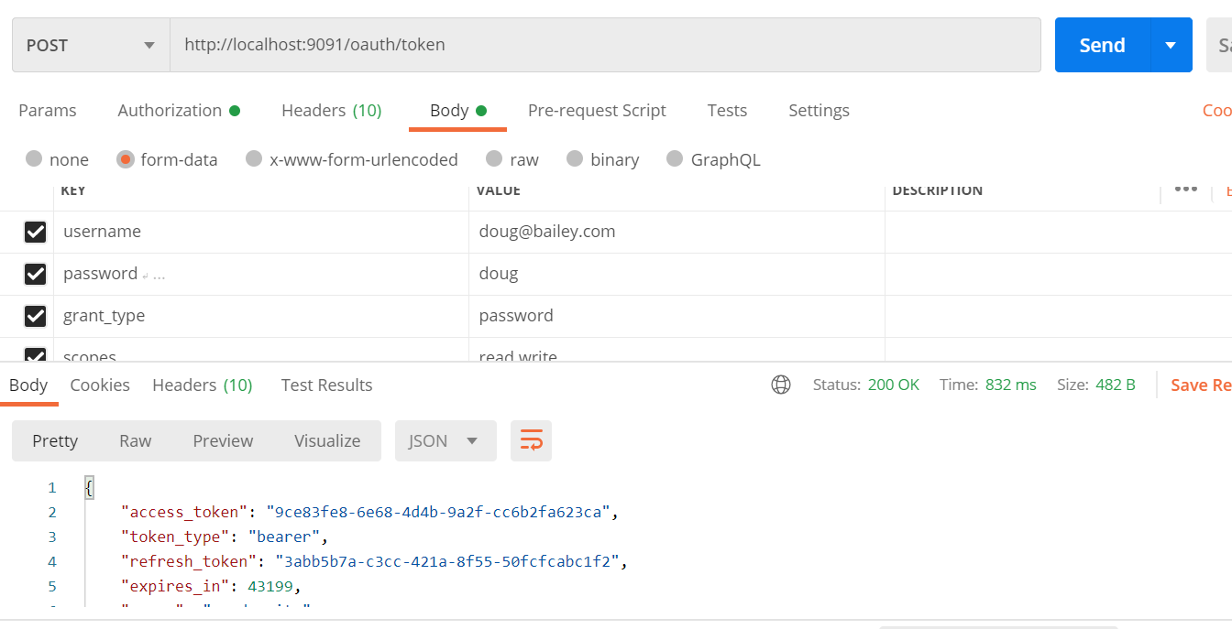

Note: this time token generated from d/b

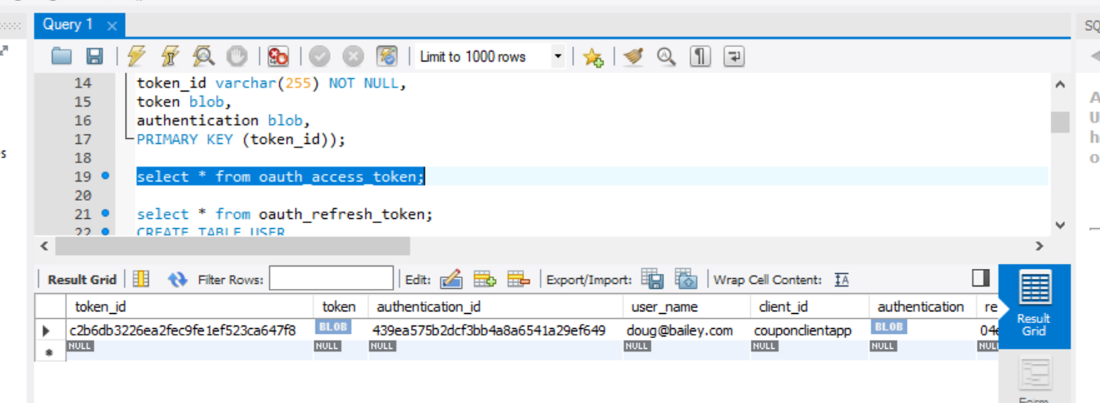

JWT

Note :

Postman is acting as client from where we are passing user name and pw and also client username and password

Will create a private key and store in authorization server, using private key it will generate a token and expose to public key .

When we hit rest endpoint url and will pass token that will be validate by resource server using public key and it will check grant type

**Json Web Token :-**

it is token format or standard to create token

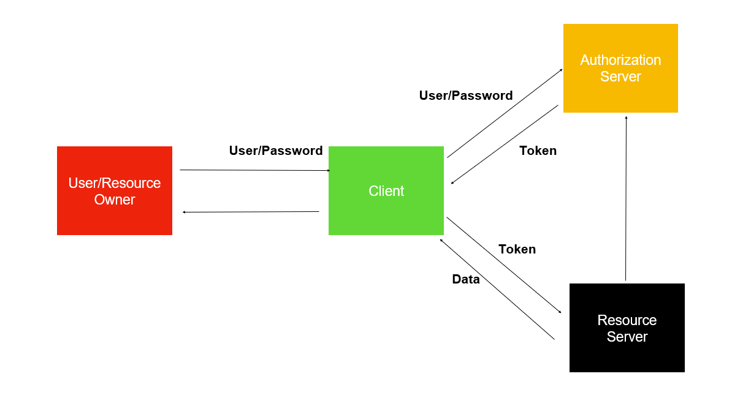

Disadvantage in oauth :---

resource server need to fetch user details like user authority again from authorization server to check how much access user have

And also need to validate token so all this is overhead again i.e communication between authorization server and resource server that is

Where jwt come in

**JWT:----- is json based token syntax**

**Jwt token is three parts:---**

1. **Header :---** algo and type(jwt)
2. Payload :-- it will contain all user info and authority and in this way resource server need not required to communicate again with authorization server but how does resource server knows this is valid token there come third portion of jwt token
3. Verify signature

Every jwt token has a signature . Signature is calculated based in algorithm which is given in header.

It is like hash value on this payload

Based on payload it will create a signature and authorization server will use private key to sign a token and authorization server

Will share public key to all the resource server. The resource server will use public key to verify the signature that come is token so resource server need not make additional network call to authorization server again to get user details and to verify token

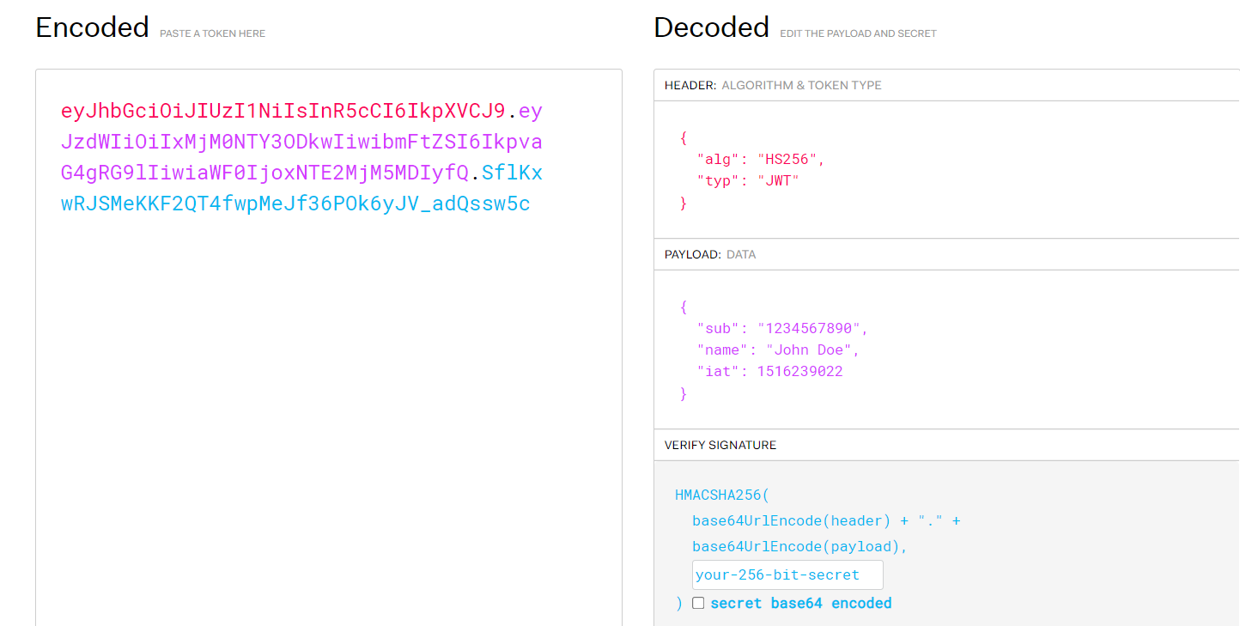

What is asymmetric key cryptography?

[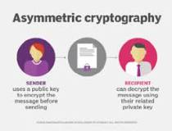](https://www.google.com/search?rlz=1C1GCEA_enIN806IN806&sxsrf=ALiCzsY9a9yjpbnAITM7mdRHIHNrUUECRg:1653984534440&q=What+is+asymmetric+key+cryptography?&tbm=isch&source=iu&ictx=1&vet=1&fir=sS-yIqDey_5pLM%252CbGluE_9_za4xqM%252C_&usg=AI4_-kR3QEyPFf6VQP01MlK3b1FsHeX1rQ&sa=X&ved=2ahUKEwjLo47FpIn4AhUw4TgGHdYaAE0Q9QF6BAgYEAE#imgrc=sS-yIqDey_5pLM)

Asymmetric cryptography, also known as public-key cryptography, is a process that uses a pair of related keys -- one public key and one private key -- to encrypt and decrypt a message and protect it from unauthorized access or use.

**Steps**

Will create a jks file which will having both private key and public key. The private key will use by authorization server to sign token

And resource server will receive the token and it will use public key to verify the signature

**Jwtaccesstokenconverter** :- know how to convert into jwt token and sign them.

**Imp point**

So communication between authorization server and resource server will happen through private and public key

Authorization server will separate from project and it will expose public key in resturl

**Keytool:**

Key and certificate management utililty

Allow us to generate a pair of public and private key that we can use for encryption and decryption as well as signature

When we generated a pair of public and private key the very first file is generated

Keystore : this is where private and public key are stored. This file is password protected and also for each private key we give alias like username and also pw later on when we want to use private key will give alias and also pw.

This public key can be exported into certificate using a keytool and then we can distribute certificate across our client information.

So that they can use public key and do the encryption

**Generate Private and public keys**

Will run this command and generate jwtiscool.jks and paste in resource folder of couponservice

The second command will list out public key which is stored in jwtiscool.jks



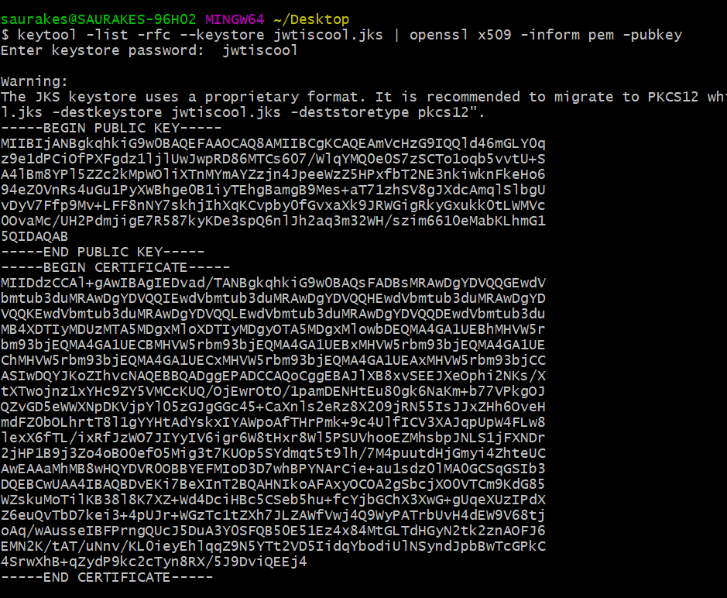

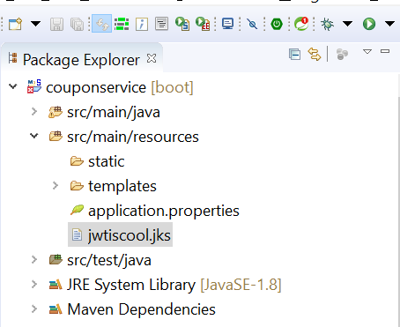

**Configure JWT**

**JwtAccessTokenConverter :**

**i**t will create token and signature that key will give

**keyStoreFactory** :--- will able to read key pair for us

Created three field:

keyFile

Password :-- to access keyFile

Alias name :--- to access private key

**Will use private key and convert into jwt access token**

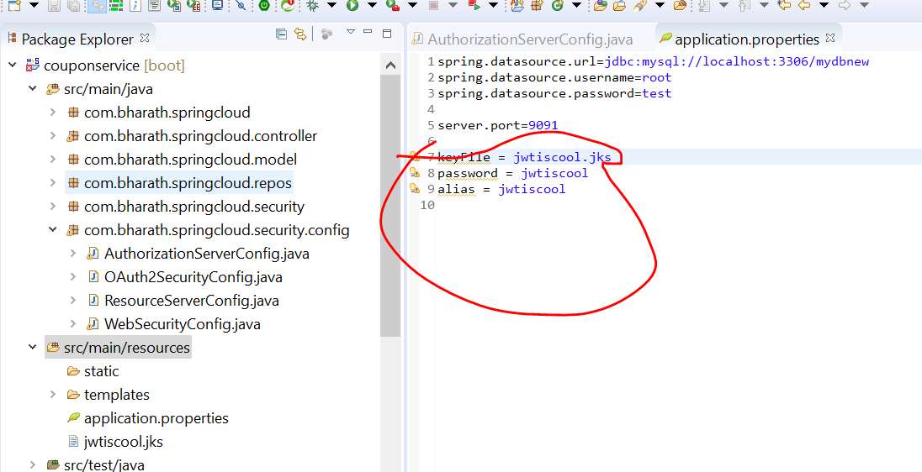

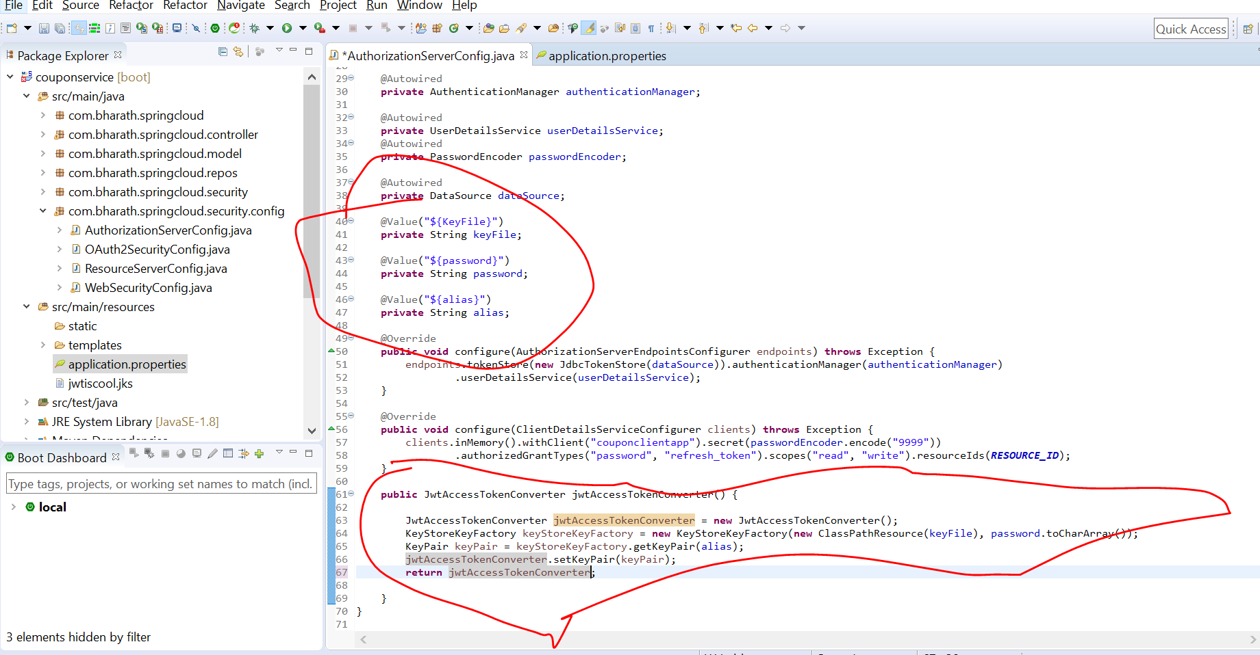

So far we have configured jwtAccesstTokenConverter next we need to create token store itself that will use this converter

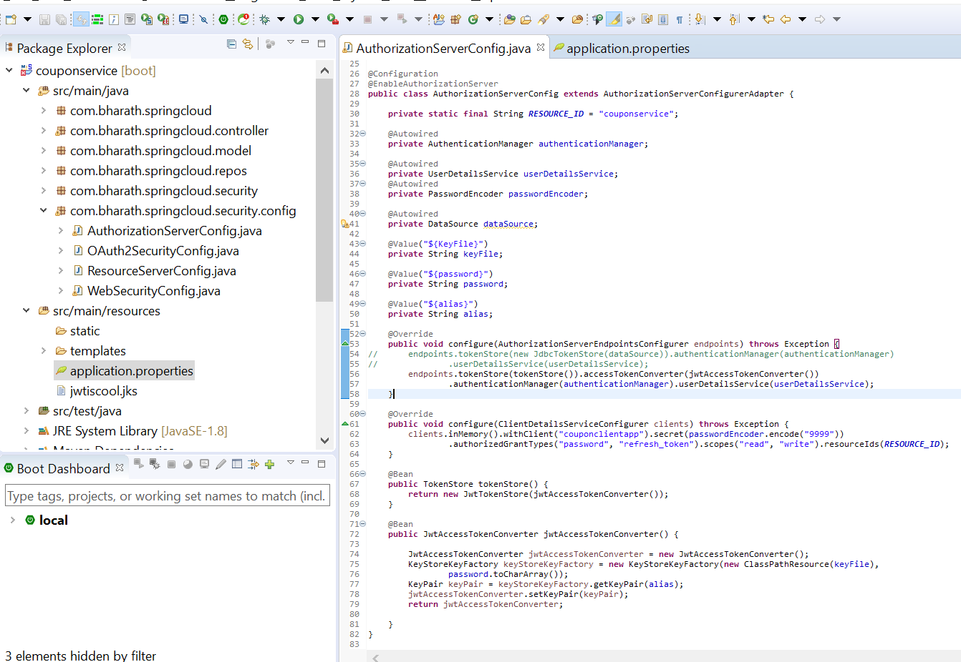

tokenStore knows what type of key is stored

**Test**

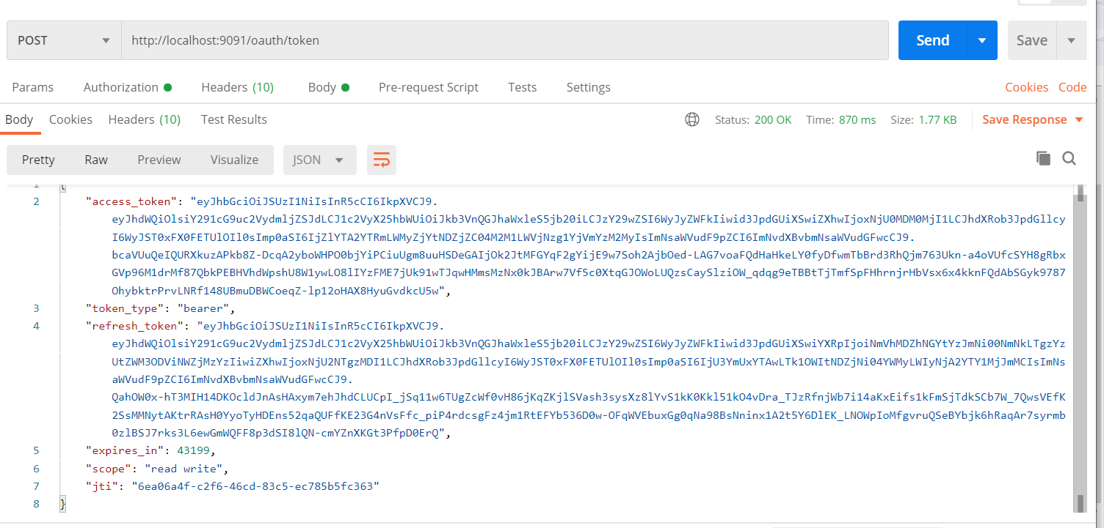

Note :

Using jwt token we are getting response

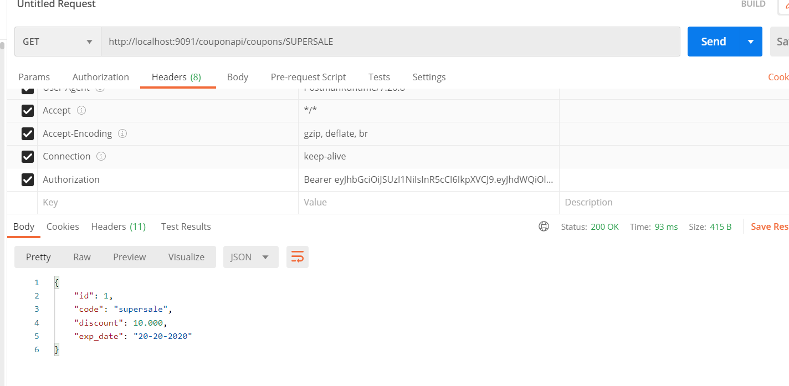

Copy access token only in Bearer

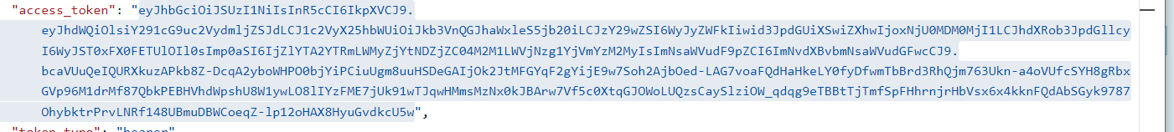

**JWT decoder**

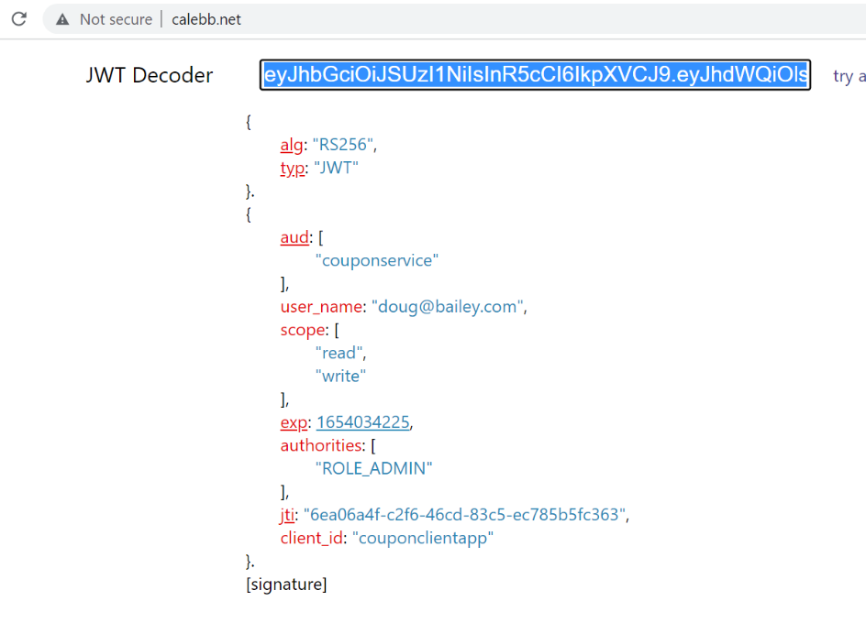

**Note**

Only resource server using the public key can decode this signature

As of now keyPair in same place so it will use by resource server by default to verify signature

**Now requirment :--**

**-** to separate out authorization server in separate project and resource server in separate project then authorization server , jwtAccessTokenConverter will expose a restendpoint where public key is present

**Create AuthorizatoinServerProject**

**Requirement :**

Will create auth server project and move all configuration related to auth configuration

Resource server and authorization server will talk with each other

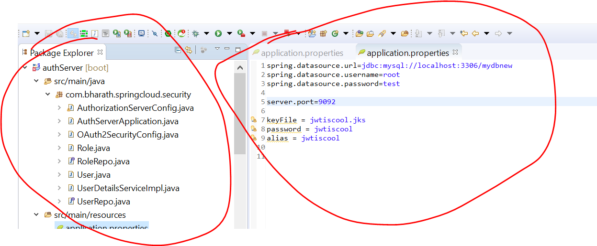

**Configure Resource Server to use public key**

**Note :-**

Auth server is completely detached from resource server

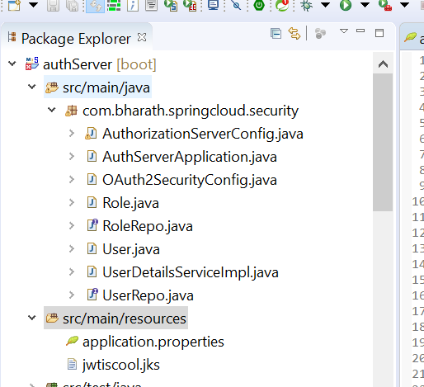

Will use public key in application.properties of coupon service which will be injected into resource server configuration

**Note**

ResourceServer in couponService and authorizationServer we create separate project

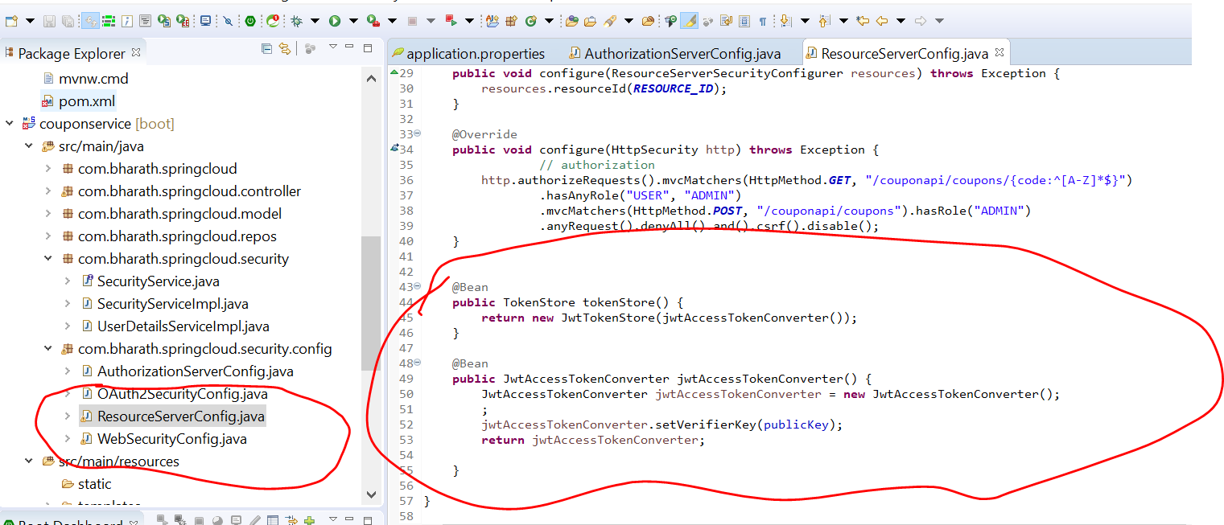

Note :

Write publicKey at one line using \n

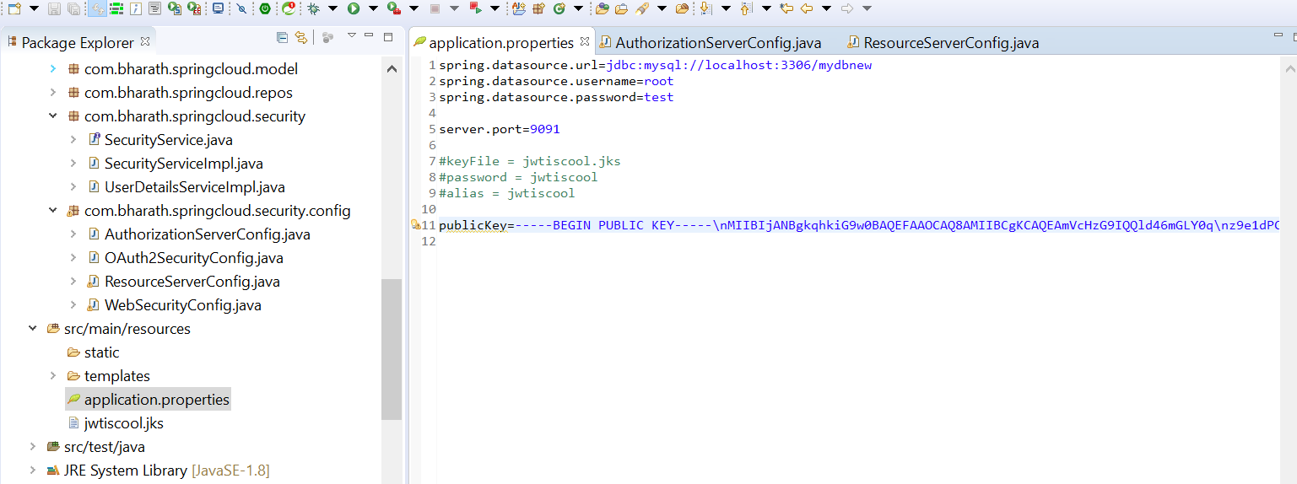

This is the public key that will be use by resource server to validate the token

Using public key resource server knows how to validate authorization server

**Run Auth server :---9092 and resource server --9091**

**We get the token back:**

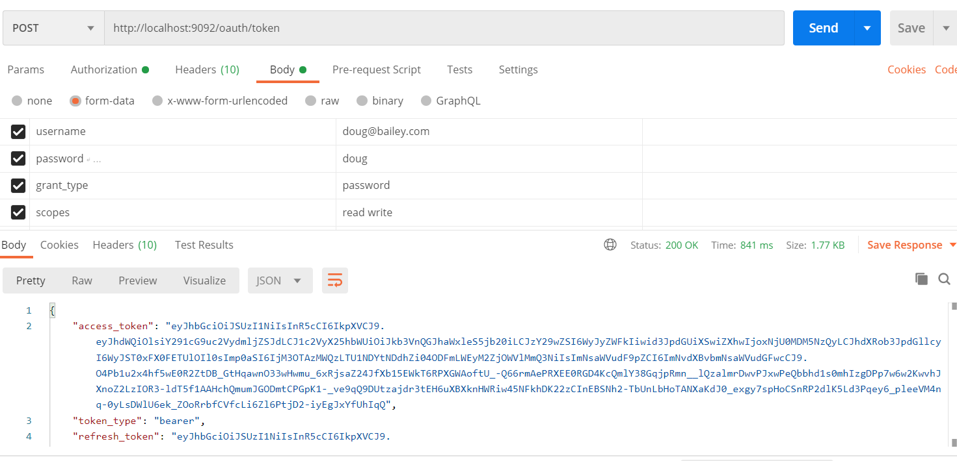

**Note:** we are still getting response

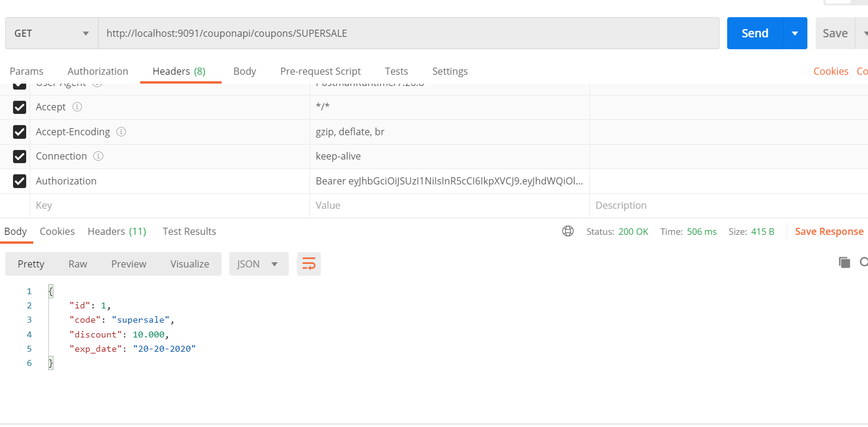

We are sending token in request and resource server validate the token using public key. If token is valid it allows to access resource

**Use Public key dynamically**

**Will addressed two issue here**

**First:---** public key is long in properties file

**Second:-**

if keyfile is change in authorization server we need to make change public key in resource server. Since authorization server expose public key in url, we need to use that in properties file just for demonstration we hardcoded public key there

Note :--

To access end points of public key we need to configure little security in AuthorizationServerConfig

**tokenKeyAccess**:--- anybody can access public key

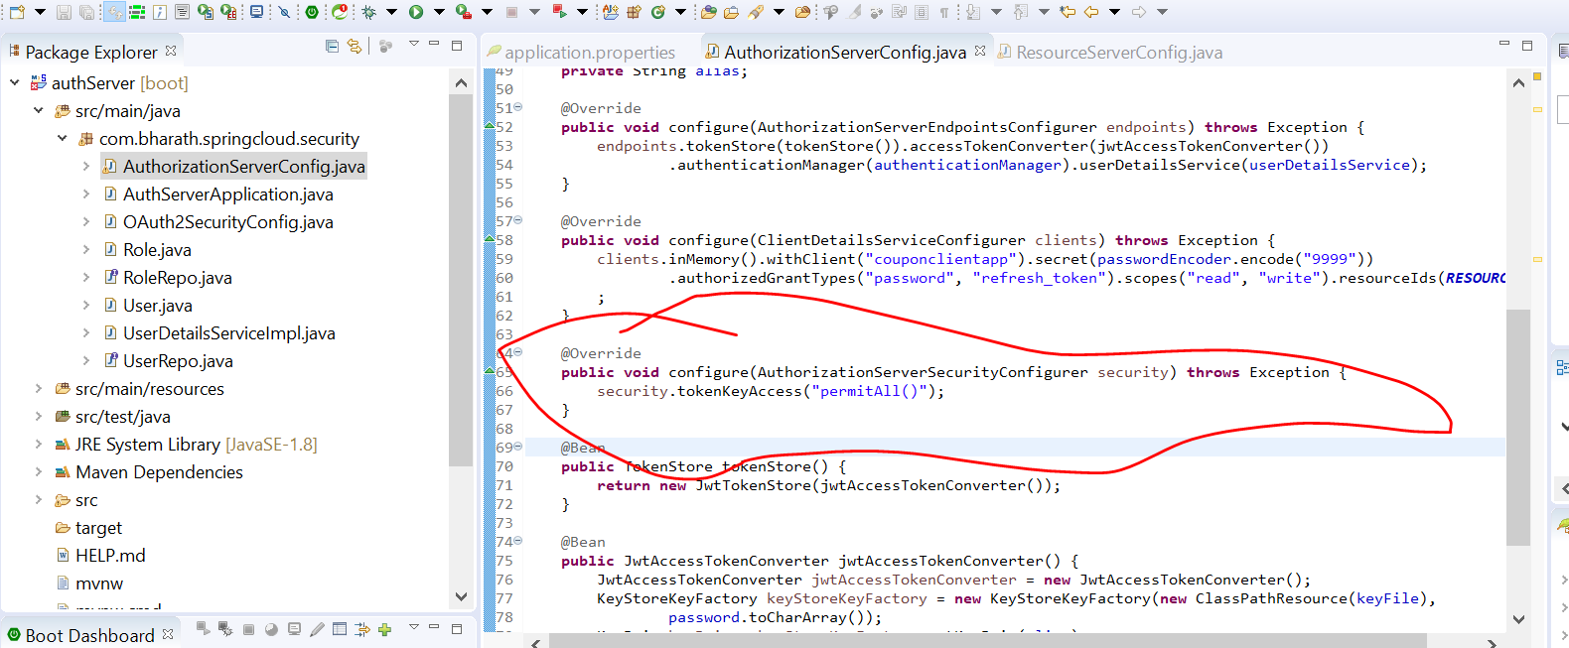

This is the url where public key will present

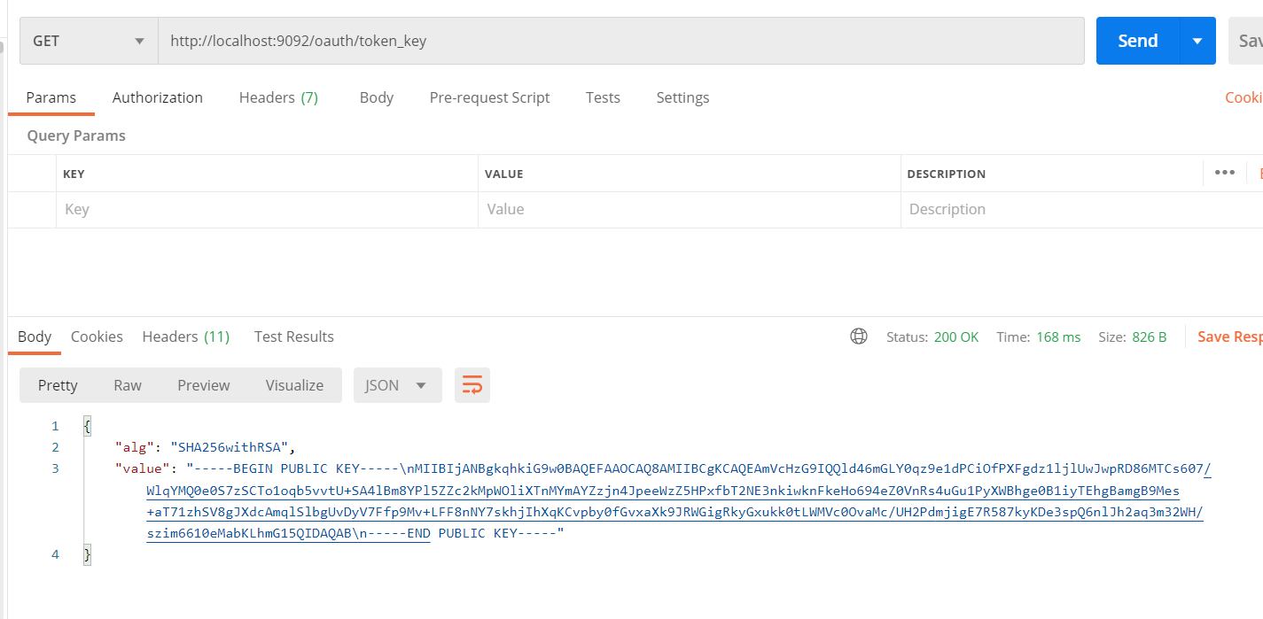

Remove publicKey from properties file

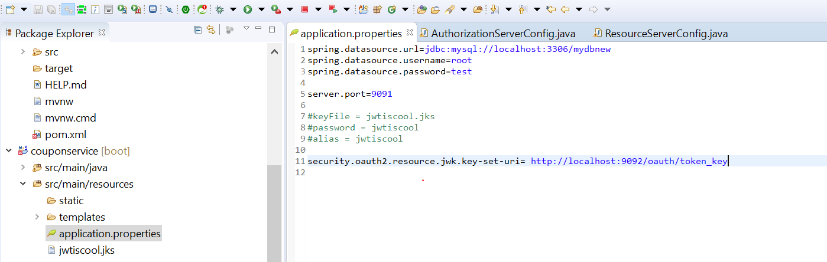

As soon as we configure this line , spring oauth enable default token converter which know how to pull this key , use that key and validate the token

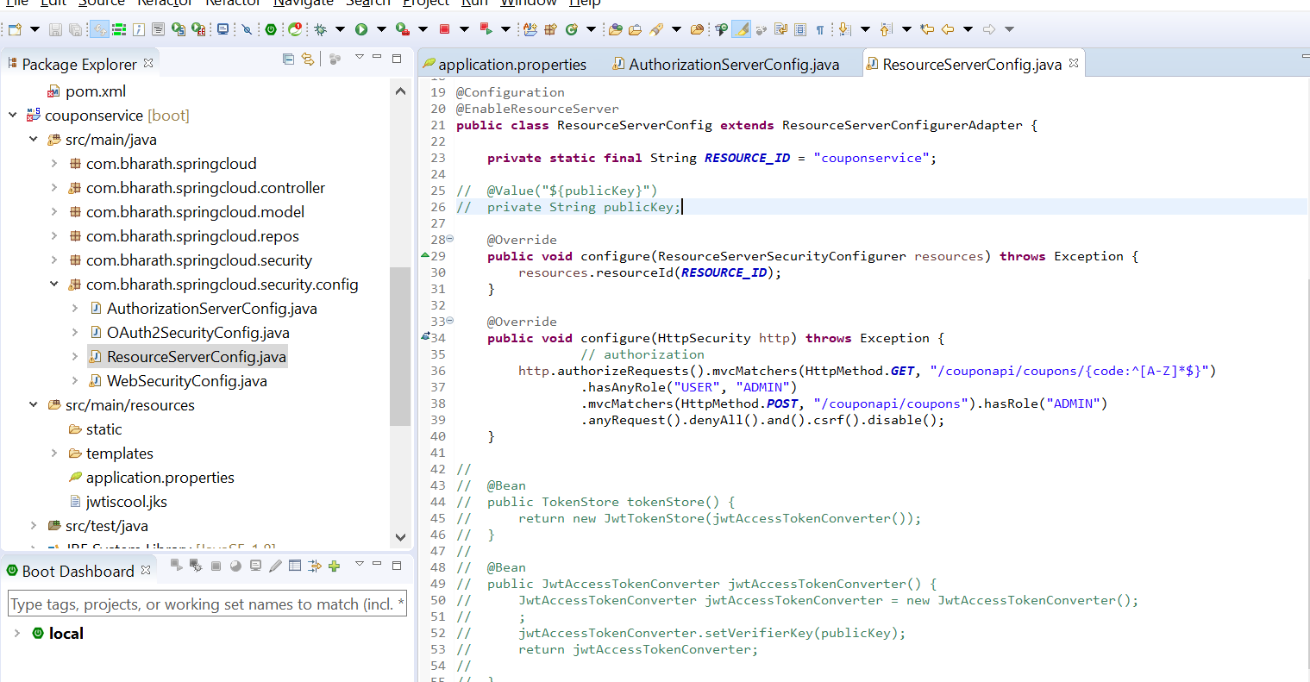

We are still able to get token

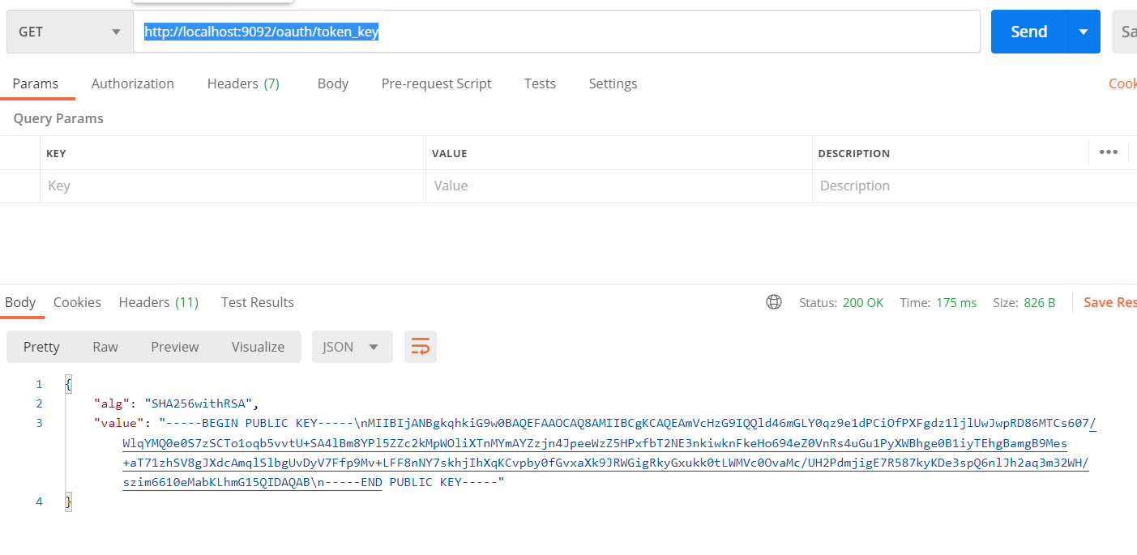

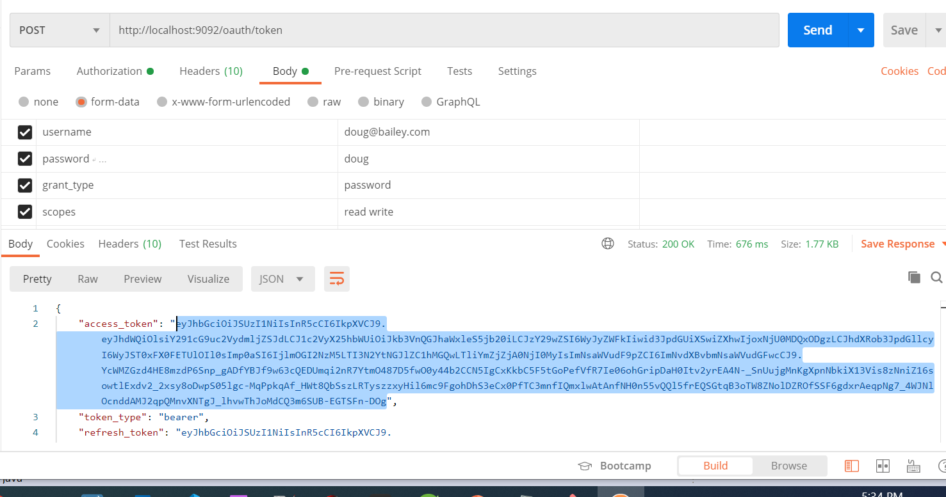

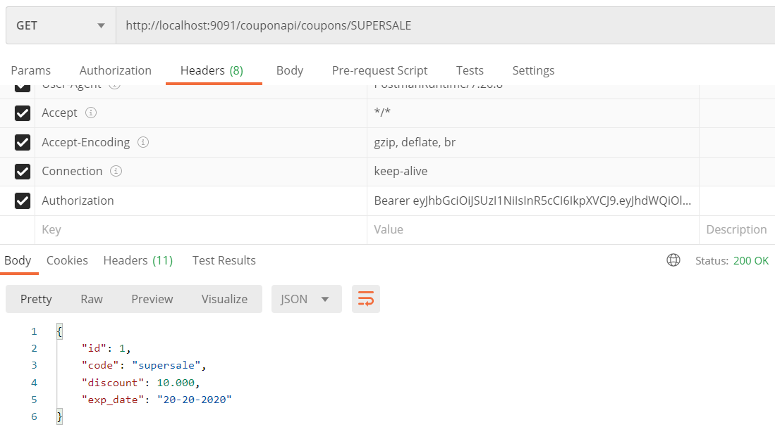

**Note :**

resource server using public key to validate the token

**Using Symmetric key**

Till now we learn how to pull public key and use asymmetric key to validate the token between authorization server and resource server

**Requirement:-**

Both authorization server and resource server will share same private key

**Note:**

We need to comment these lines and same key need to use by resource server to validate the token.

This is only change in authorization server

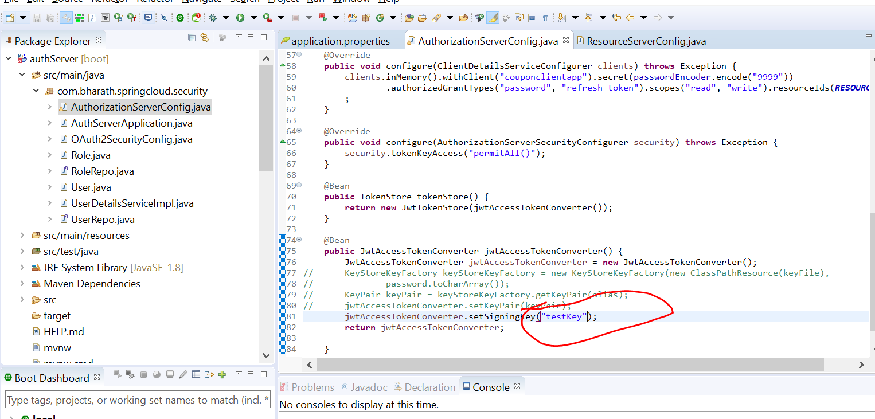

In resource server : now it will also use same private key to validate

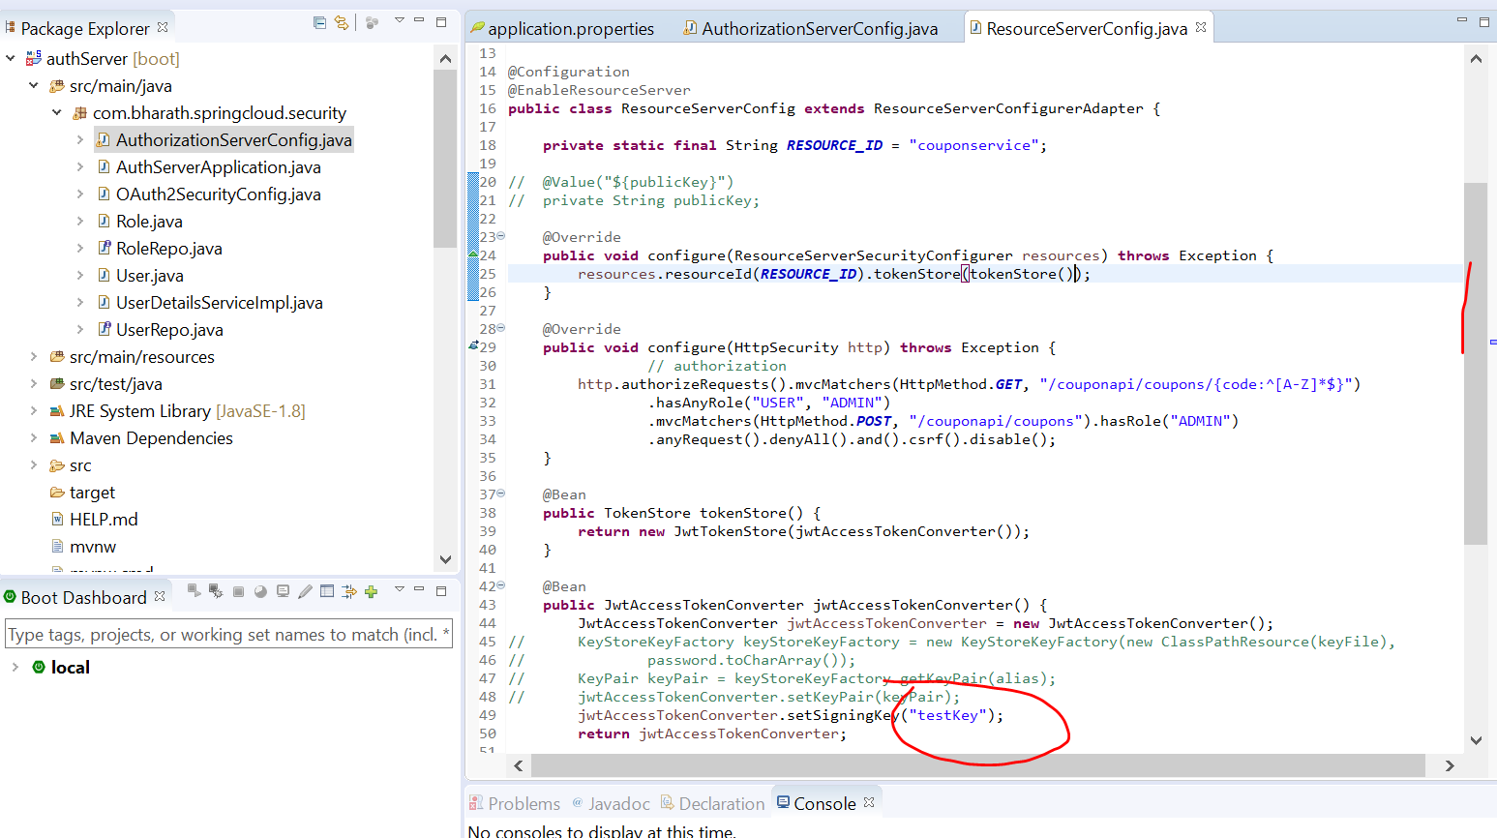

We need to comment this line because it no longer using public key

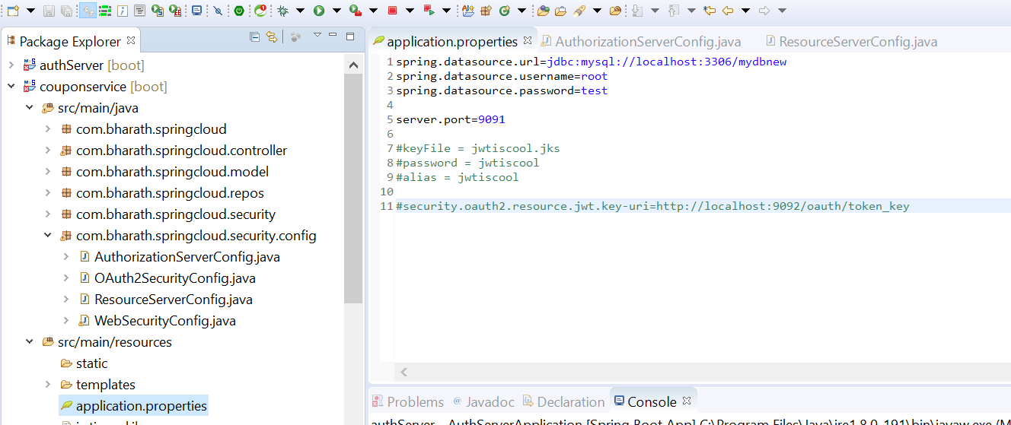

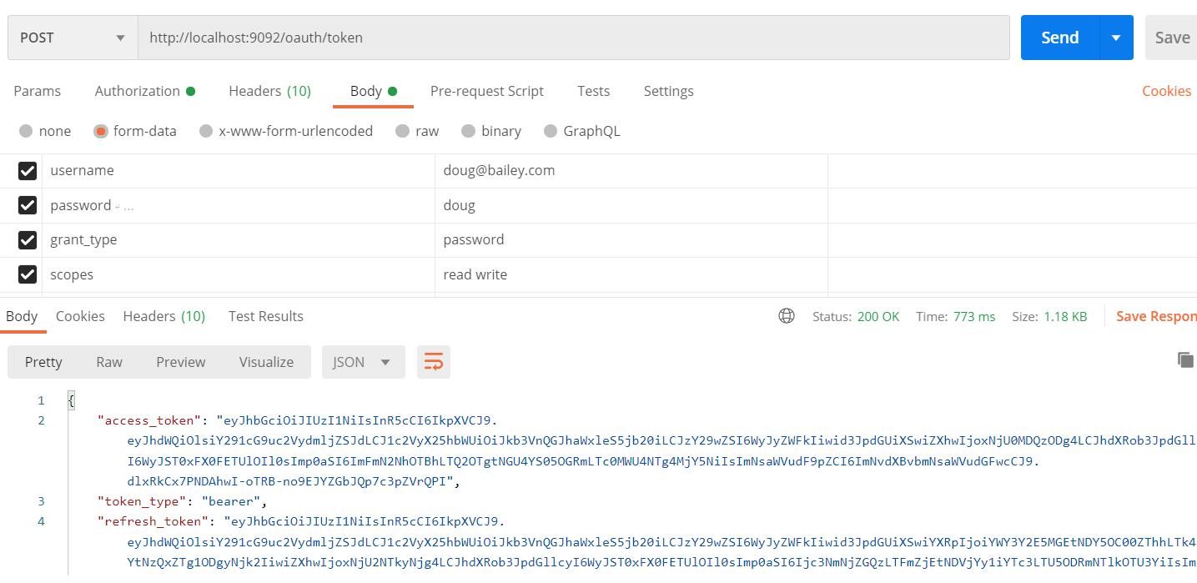

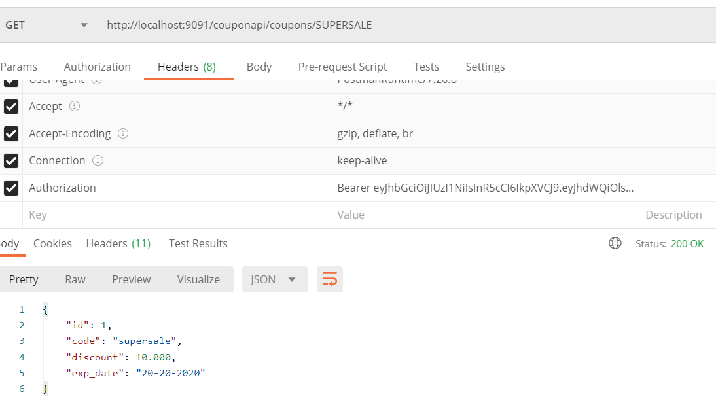

CSRF

CSRF :- cross site request forgery

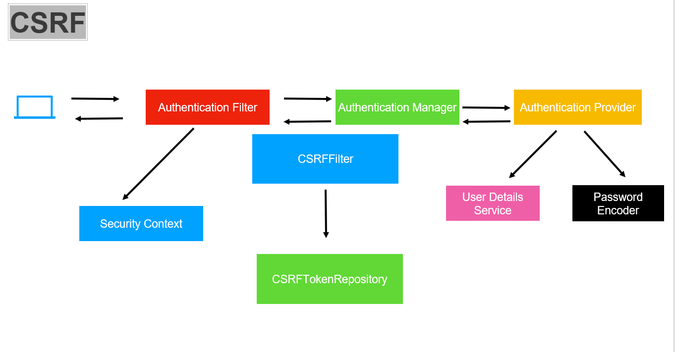

**Example:**

Suppose we open linked in site then cookies will create and maintain a session then we open some other site it will try to store cookies info of linked in and will try to get data in this scenario CSRF come in picture.

When we open linked in it is get request and hidden csrf filed is there and it will generate a csrf token.

So next time when any post occur it will check whether csrf token is match or not then only it will allow

**NOTE:**

By default when we use spring security for web application CSRF is turned on

**Csrf action**

**Objective :-** enable csrf in couponservice

Use this one

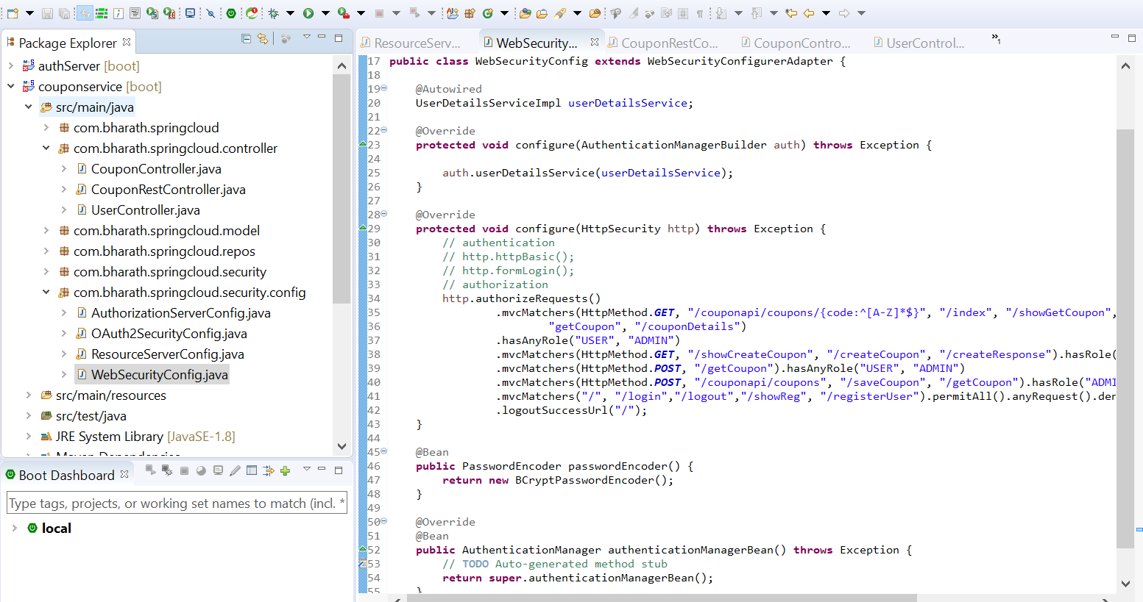

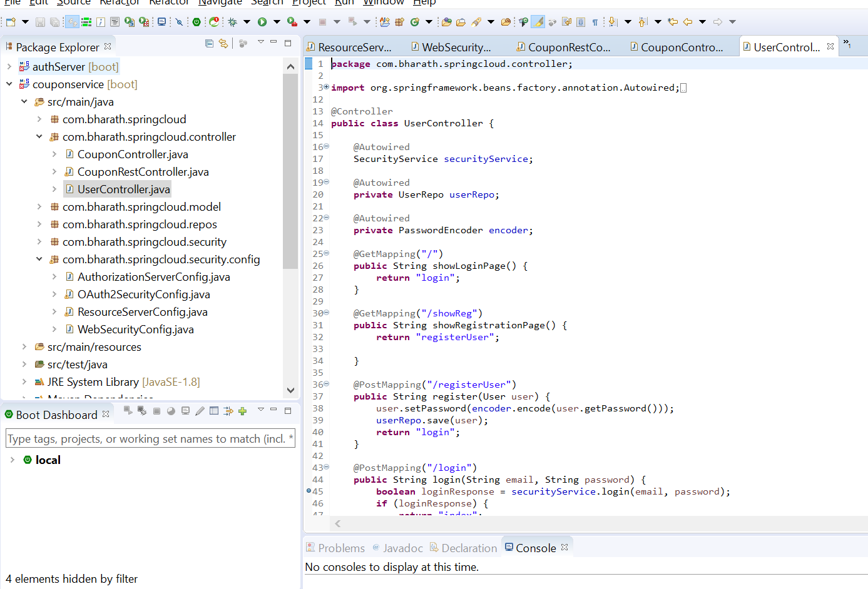

When application will start login page will come

**As of now csrf support is not there**

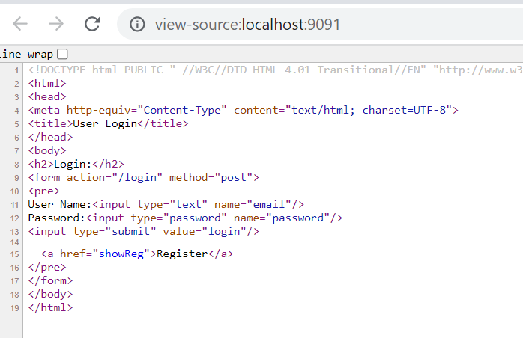

Remove this csrf

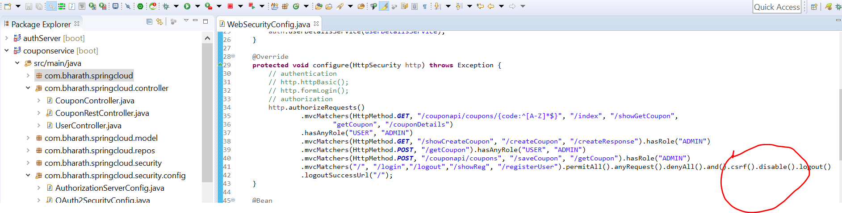

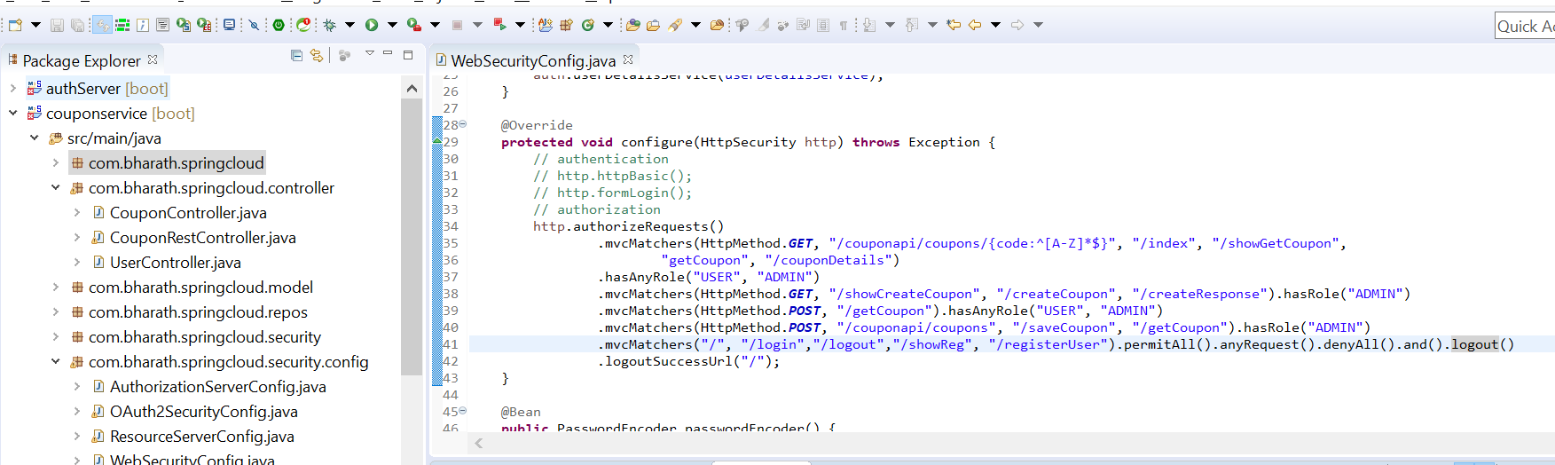

**Start application again**

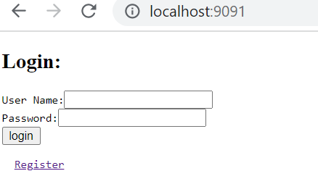

Even now there is no csrf token

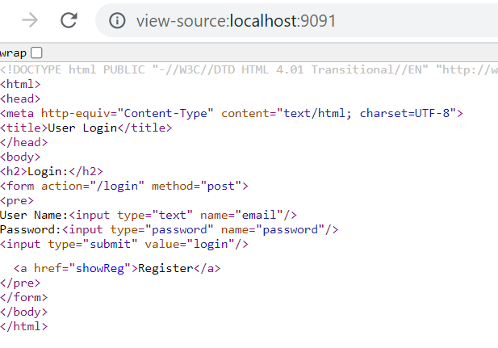

Because here we use plain html form we need to include manually csrf part but if we will use thymeleaf it will add automatically

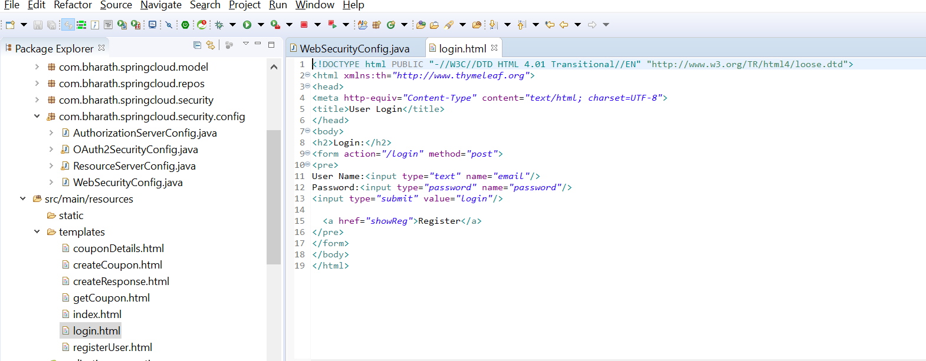

This we need to make a change in login.html

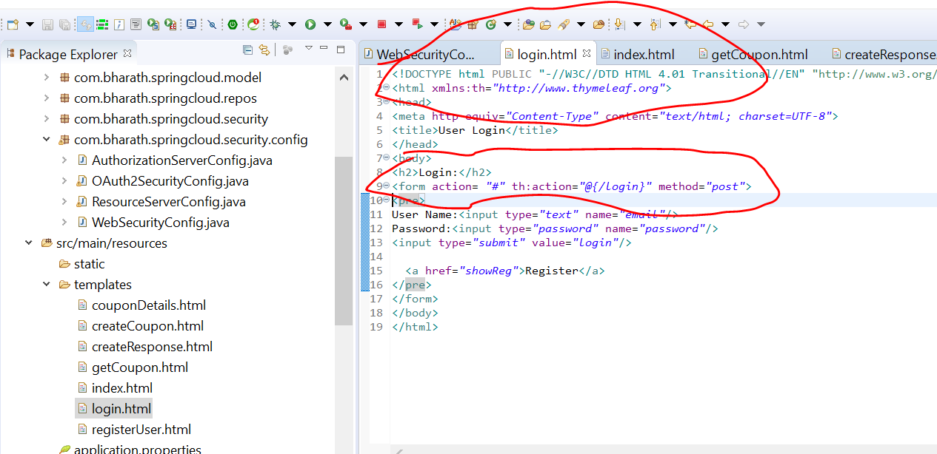

**Note :-**

Now the hidden field csrf will be added in form

A CSRF Token is a secret, unique and unpredictable value a server-side application generates in order to protect CSRF vulnerable resources. **The tokens are generated and submitted by the server-side application in a subsequent HTTP request made by the client**.

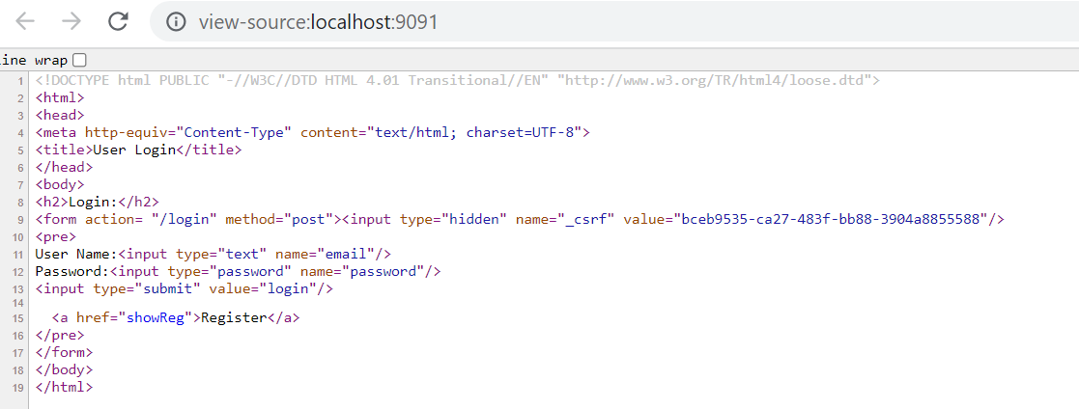

Suppose this is trying by hacker but it don’t have csrf field so it will not work only the page created by us will have csrf field and it will work

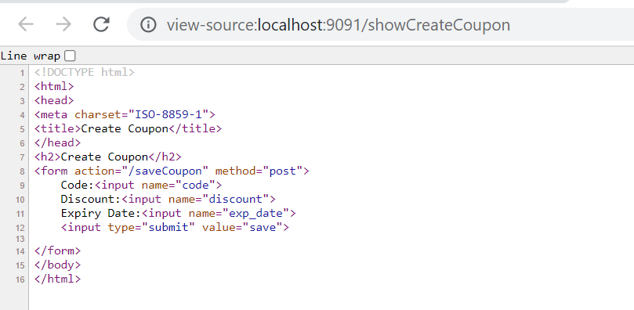

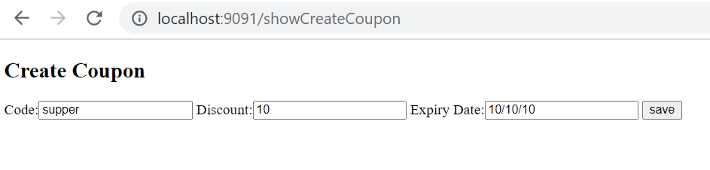

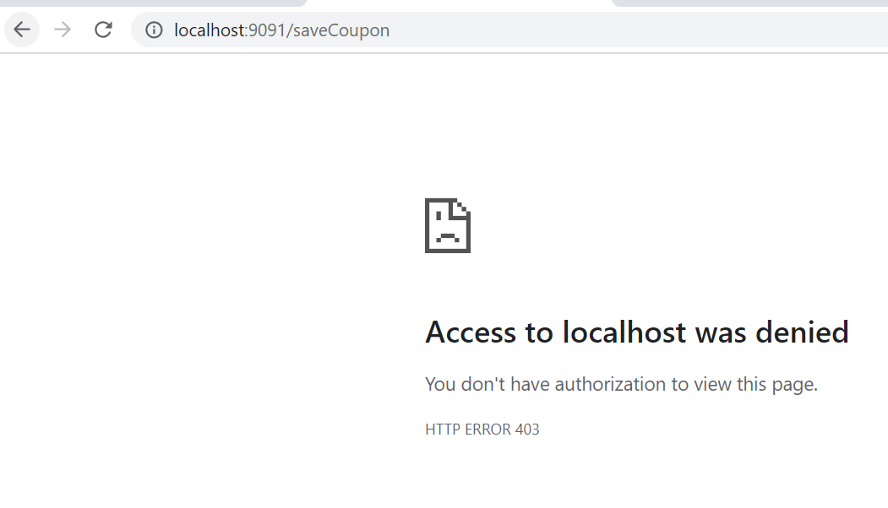

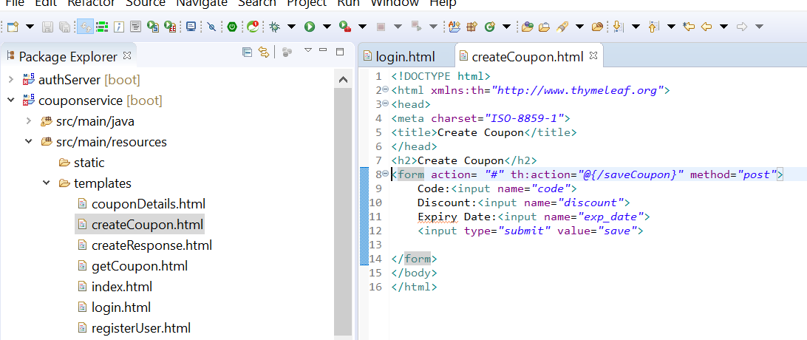

This time csrf value generate and we are able to create coupon

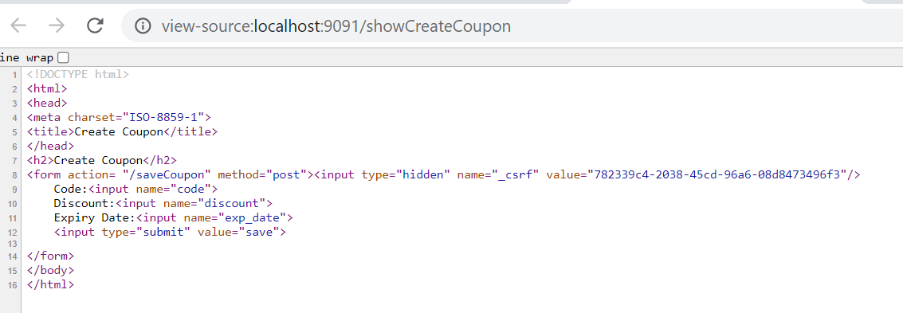

**Use Custom Configuration**

**Objective :---**

want to ignore csrf for few url

**CORS**

**Cross origin Request Sharing** is the way to tell a browser please allow certain request from one domain to another especially when front end is in angular and backend is in java

**Let see the problem first**

Couponservice is running on 9091 and react app is running on 3000 but the browser will not allow react application to communicate with backend

**Note :**

**Every browser will implement CORS policy according to that if one application is runinng on one port and other application is running on another port then browser will not allow unless**

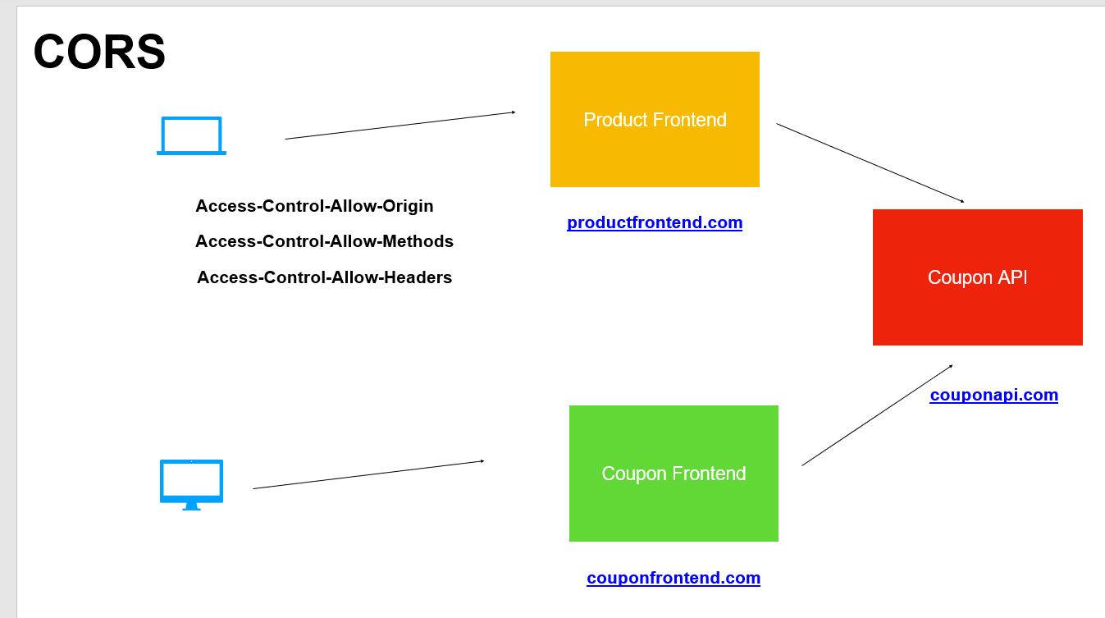

**Will use @CrossOrigin** at class level of restController . Now all rest ful method are available of cross site request

**Install node js and react cli**

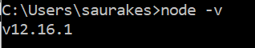

**Npm :-** node package manager

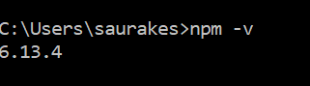

**Method Level Security**

**So far we add security at url level or http method level**

**Objective :---** we can add security directly on java method level

**To use global method level security**

**Step 1**

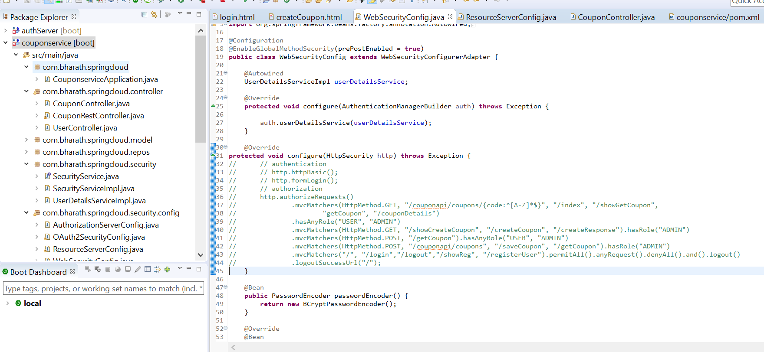

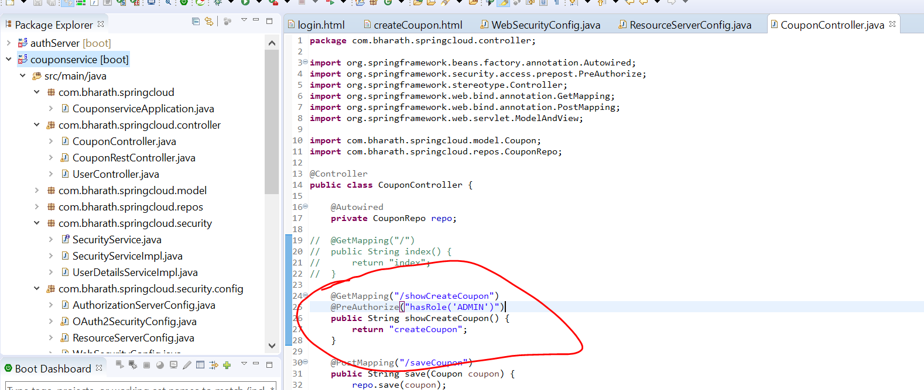

John not allowed to see createCouponPage it means security at method level is enabled

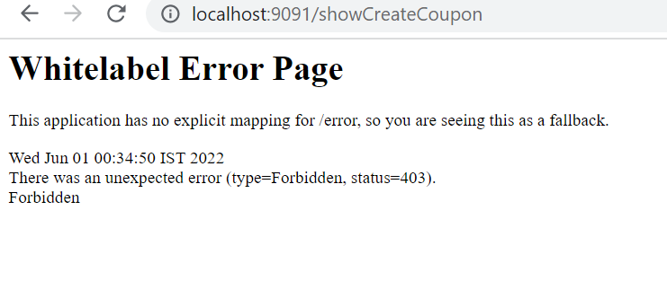

**Behind the scene it uses AOP**

**@PostAuthorize**

It will use after the method execution but before the response return like ex:-

We are using third party and we got data, we can validate data in @PostAuthorize

**Note:**

Coupon object will get stored in returnObject

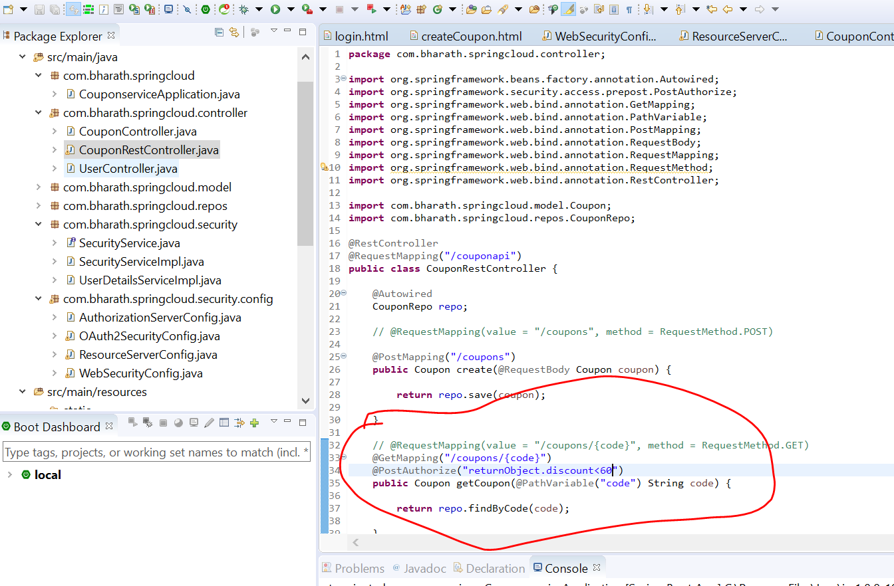

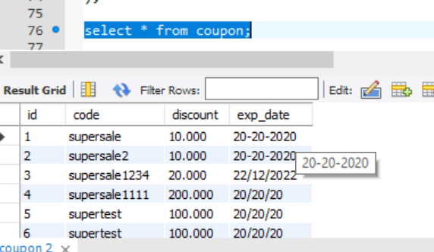

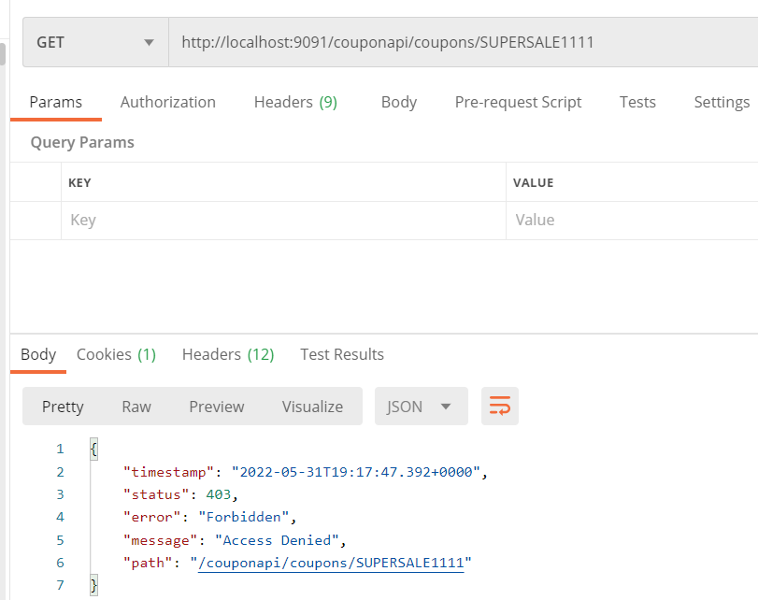

Since supersale1111 has discount >60

**Other Annotation**

**These two help us to use different annotation**

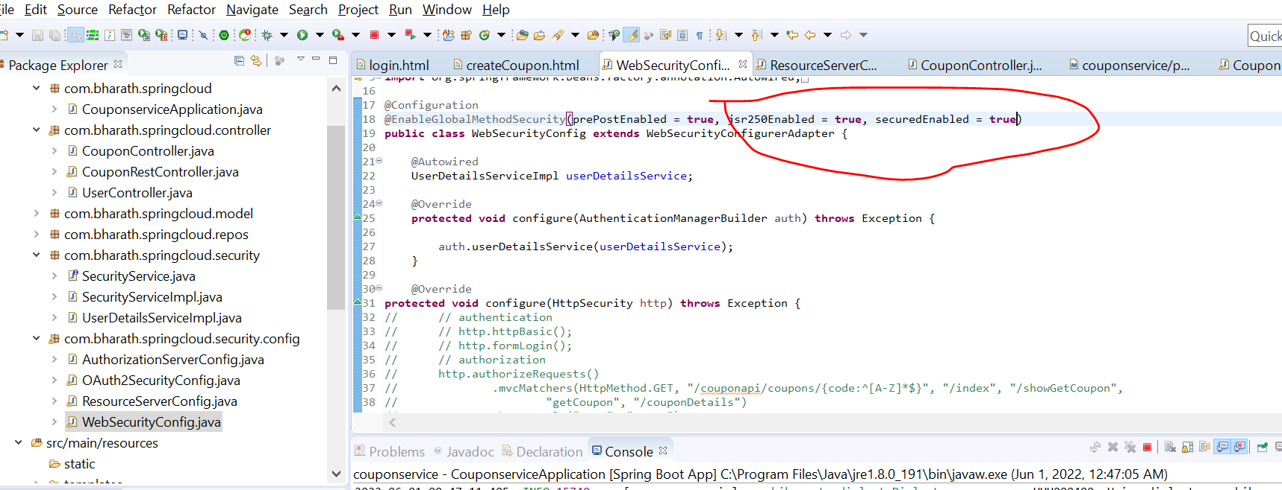

**Now we use at Method level @RolesAllowed("/ADMIN")**

**Security Testing**

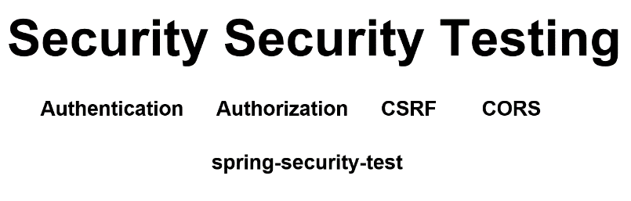

**Note :**

**When we will use @WithMockUser :**

it will create a default user and set in security Context and this security context will be use for test execution and entire flow which is marked in square bracket will be skipped and we can and by this user we can validate authorization by hitting ret end points

**When we will use @WithUserDetails :**

It will not mock user. Again authentication will be skipped. It will invoked userDetailsService and set into securityContext

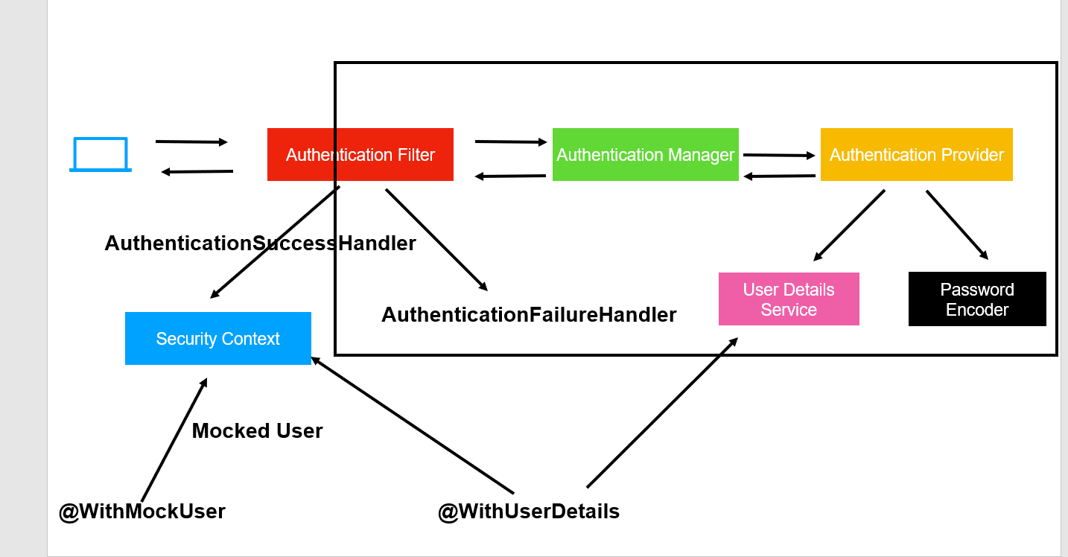

**withMockUser we can specify all these properties**

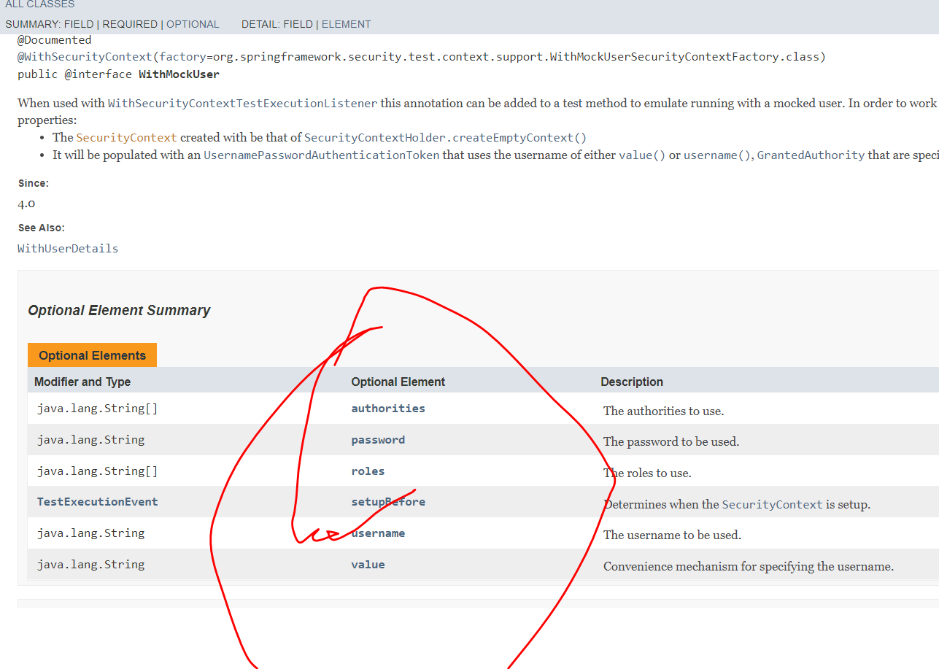

By default mockedUser have role user

**Steps**

**Objective :---**

will test security in CouponService

**Add this dependency**

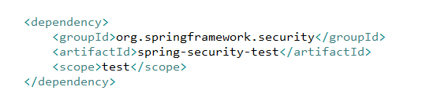

This will bring spring security annotation which will be use in our junit test

MockMvc :--

it will create environment for us to make restful call without running server

**Test Setup**

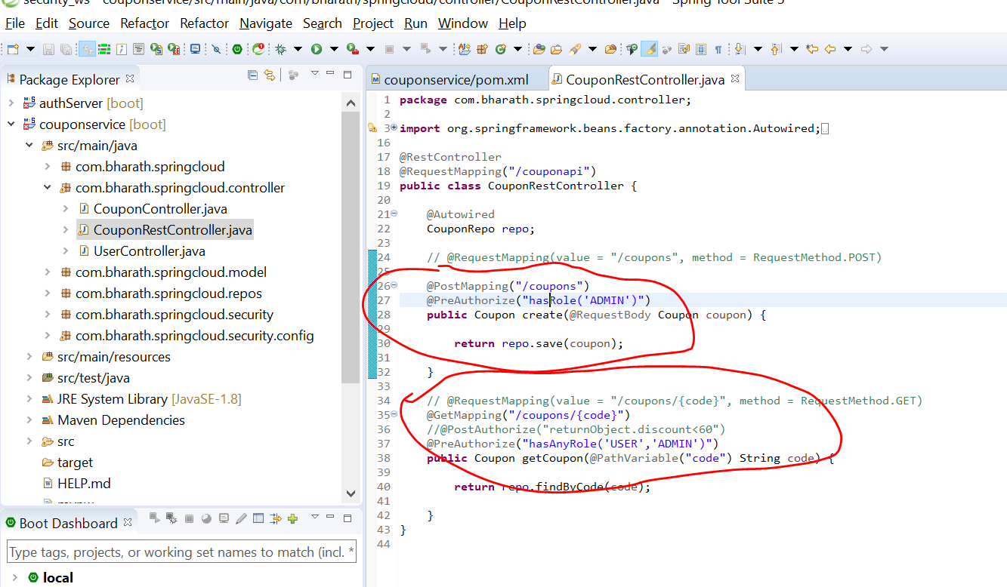

**Test with and without a user**

**Objective:-**

Will test security for getCoupon end point

1. MockMvc will use to hit the endpoints
2. MockMvc to be available at runtime will use @AutoConfigureMockMvc. Sprinc mvc will create MockMvc object and inject into it

By using this @AutoConfigureMockMvc

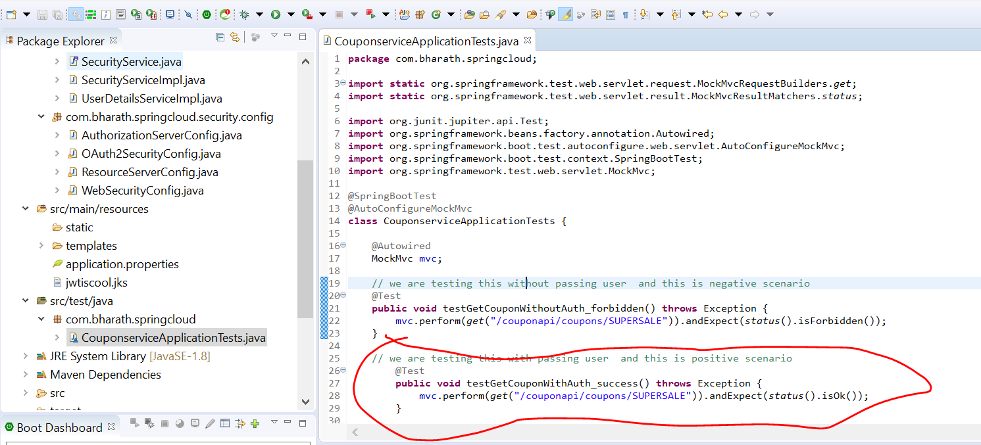

Note :

For positive scenario to send a user will user @WithMockUser , it will create a mock user with **user- user** and password- password and also create a default role called user

This will get pass since couponService we configure preAuthorize check above and all authentication call will bypass and user will set in securityContext

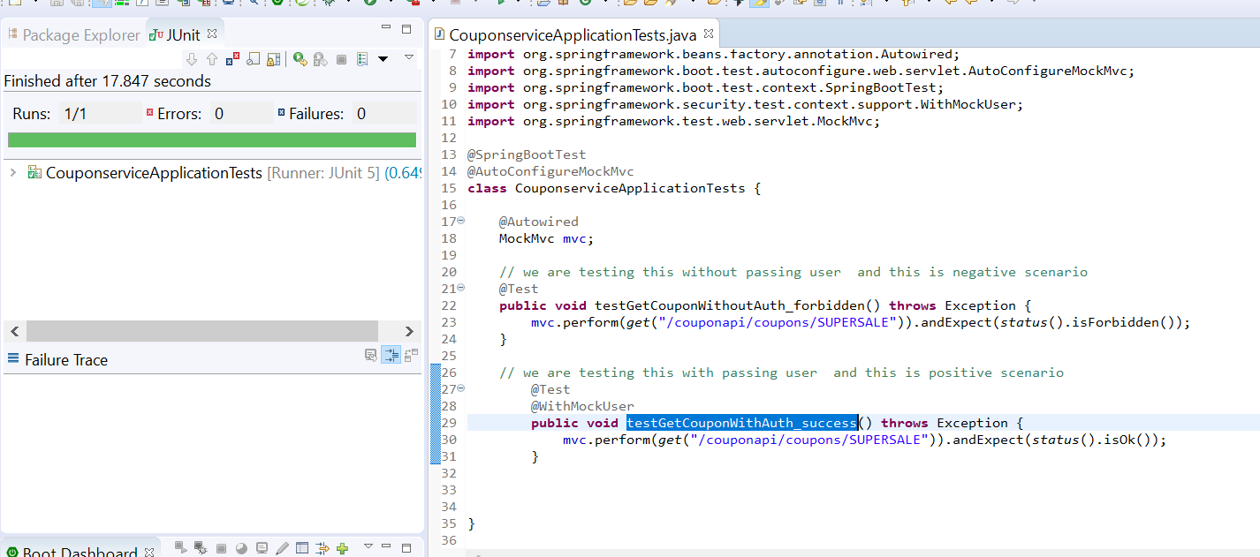

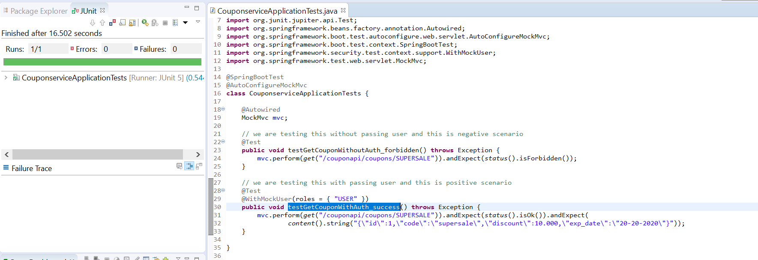

**Test CSRF and Roles**

Will test the security configured for this method

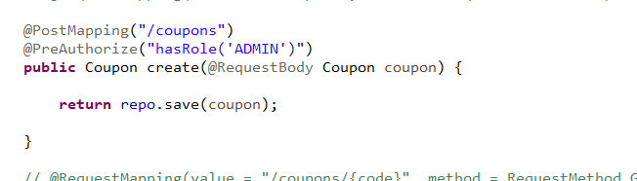

In this case request will not go through because there is no CSRF data

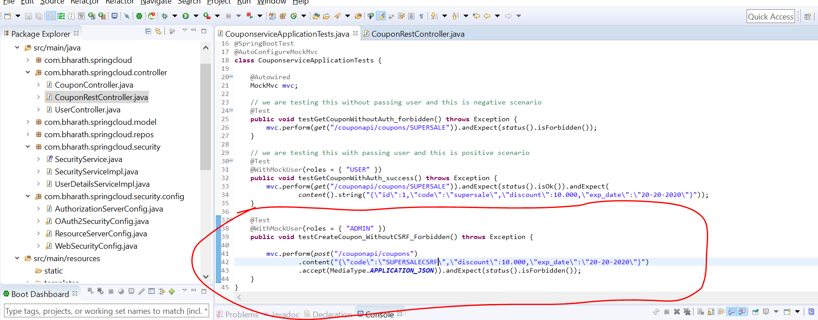

**This will get pass, it will configure a csrf token for us and pass same token**

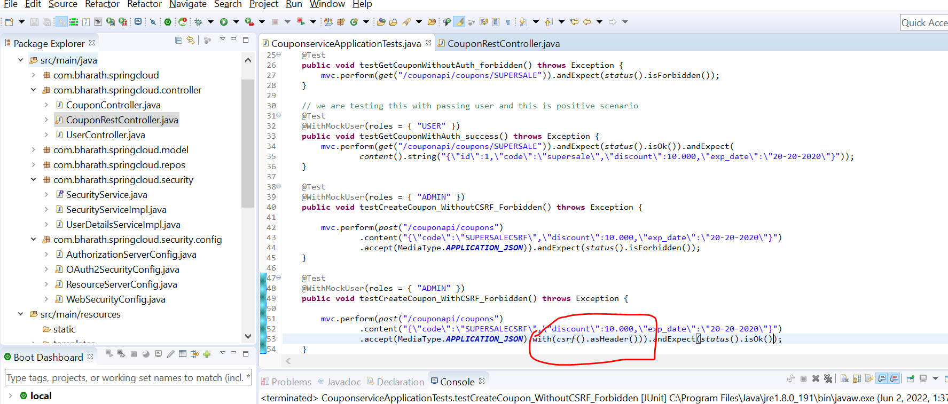

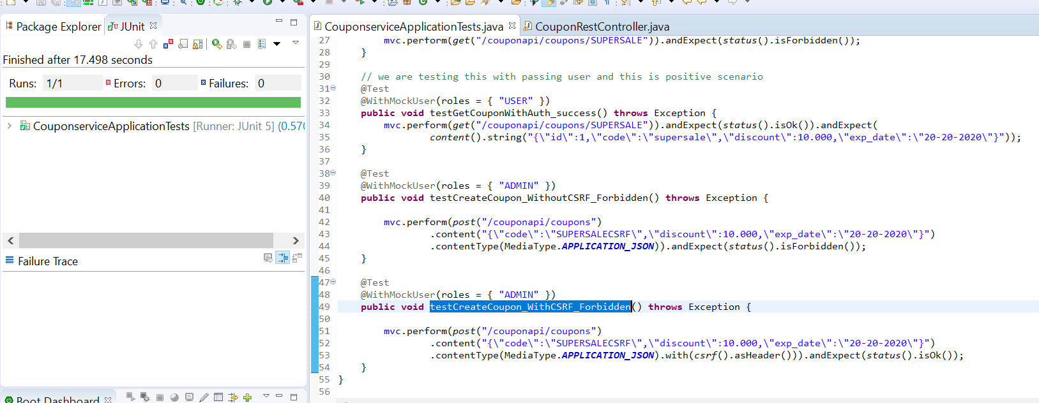

**CORS Testing Theory**

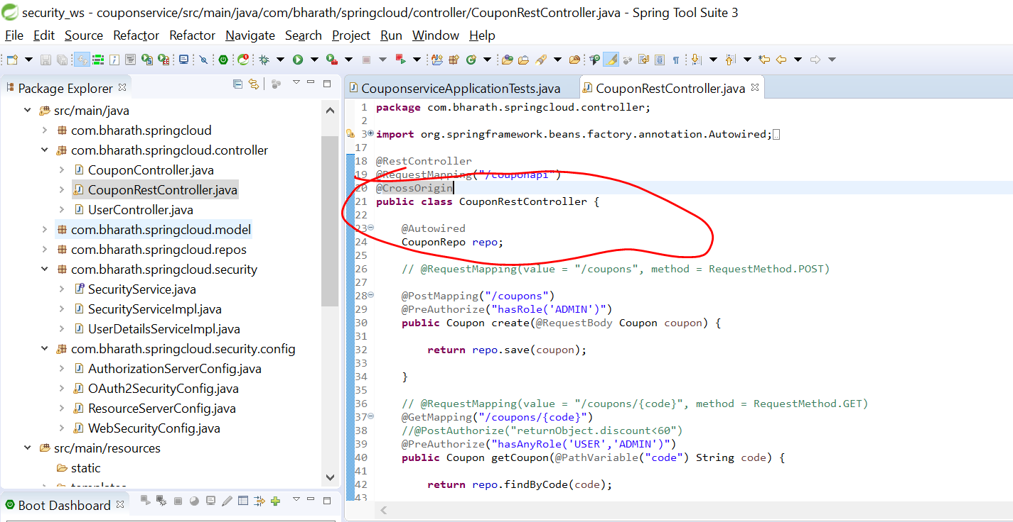

**Test CORS:--**

**Note :**

We are trying to mimic the behaviour of web browser

@CrossOrigin :--- it will allow all http method from any origin

Anyone from any site will able to hit couponservice url

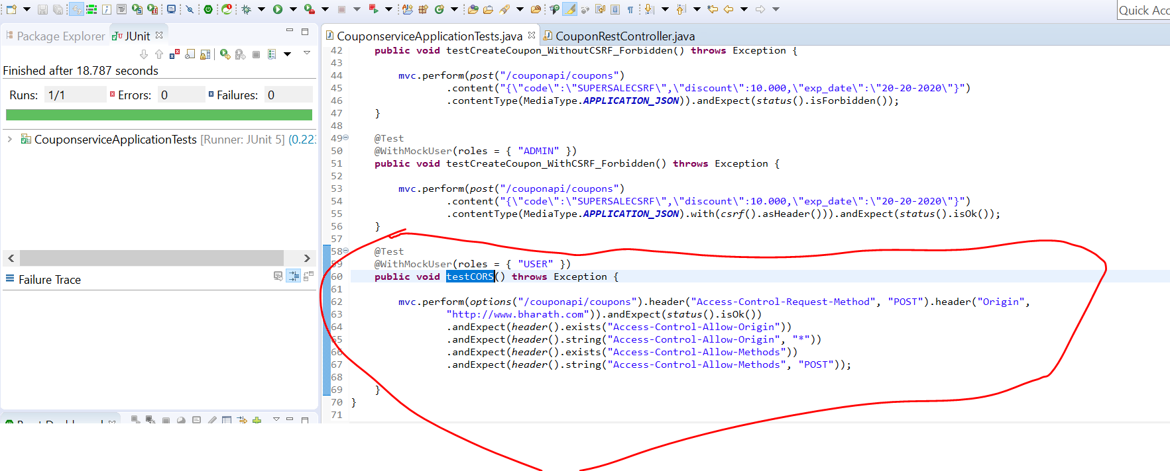

**Use @WithUserDetails**

**Note :**

Here we are going to use actual user and it fetch from d/b and set into security context

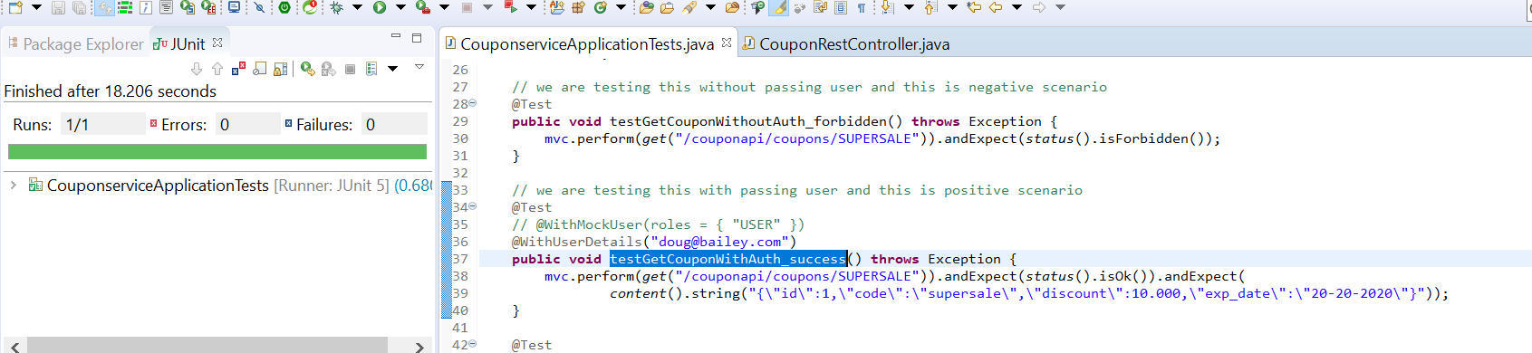

**Testing Authentication**

We are successfully tested authorization with both roles and also tested csrf and cors

**What does 401 mean?**

The HyperText Transfer Protocol (HTTP) 401 Unauthorized response status code indicates that the client request has not been completed because it lacks valid authentication credentials for the requested resource.

**403 Forbidden**

The HTTP 403 Forbidden response status code indicates that the server understands the request but refuses to authorize it.

**What does a 404 mean?**

404 is a status code that tells a web user that a requested page is not available. 404 and other response status codes are part of the web's Hypertext Transfer Protocol response codes. The 404 code means that a server could not find a client-requested webpage.

**Enable this line**

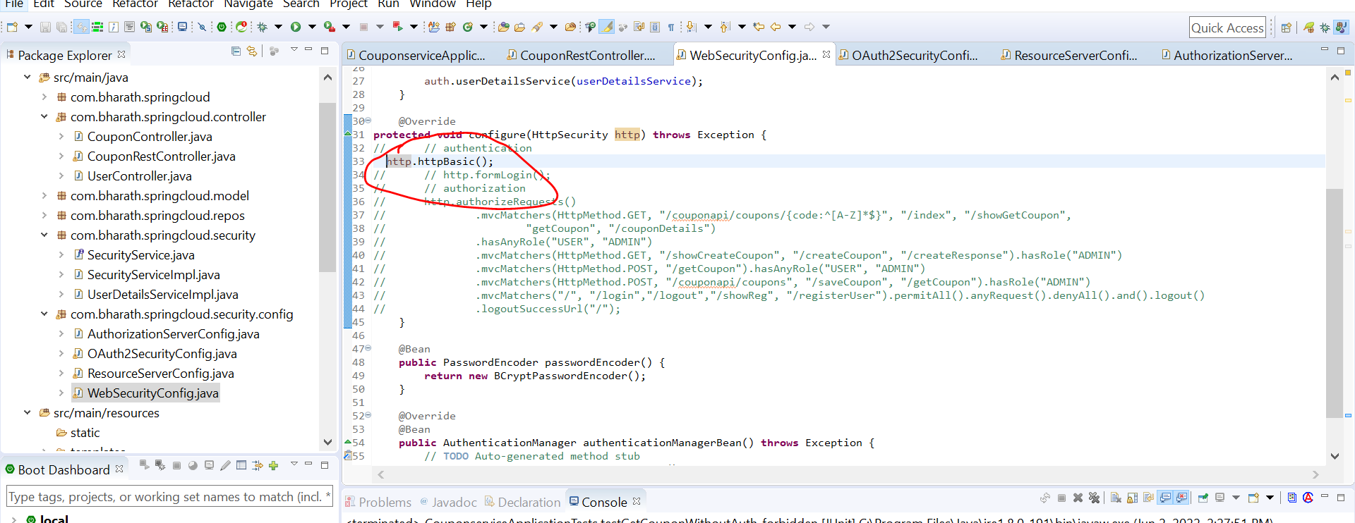

Passing without user then it will be unauthorized

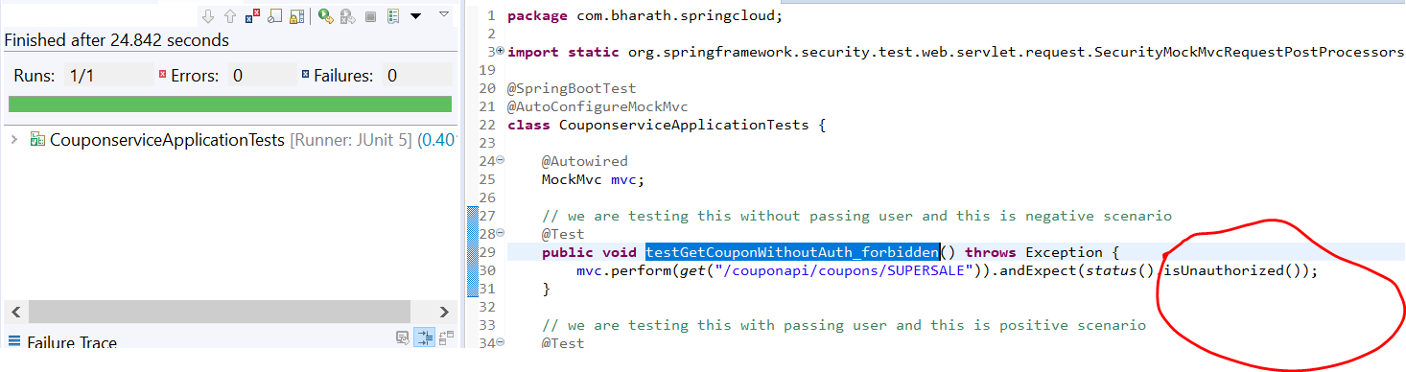

Oauth :- use authorization_code_grant type

Authorization code

The end user need not provide user name and pw to client app. The client app redirect user directly to auth server

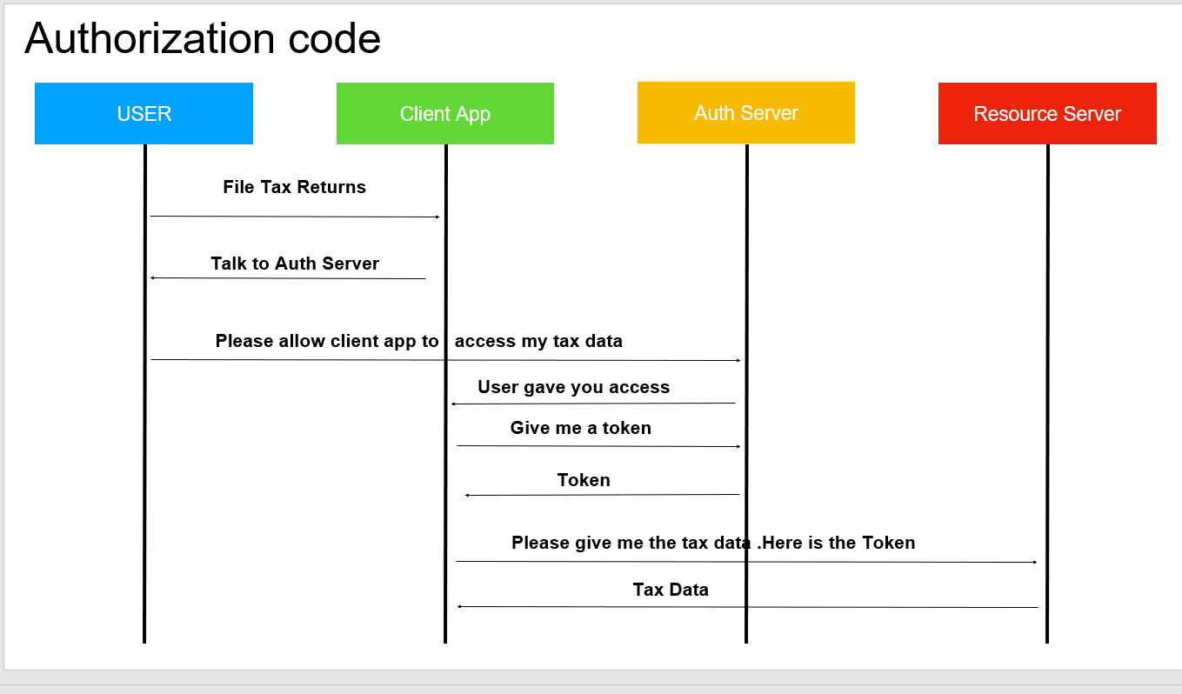

**Configure Authorization Code Grant Type**

When user access client app(CouponService) it will redirect the user to auth server .the auth server will ask user to enter user name and pw for that t0 happen the auth server need to add login page. Now auth server will show user login page.

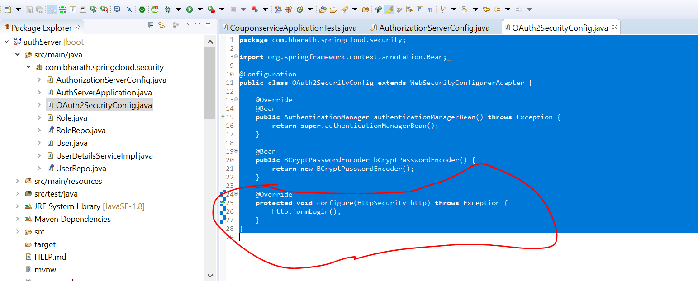

Once user enter successfully user name and pw the auth server will authenticate him and tell the client app yes user has granted you permission here is the code that u can use to get a token for that to happen the auth server know redirection url belonging to client application

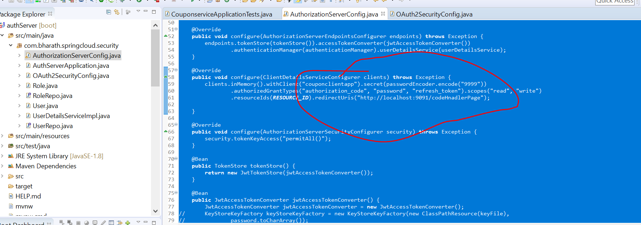

**Client app need to redirect user to auth server url and that url will looks like**

<http://localhost:9092/oauth/authorize?response_type=code&client_id=couponclientapp&scope=read>

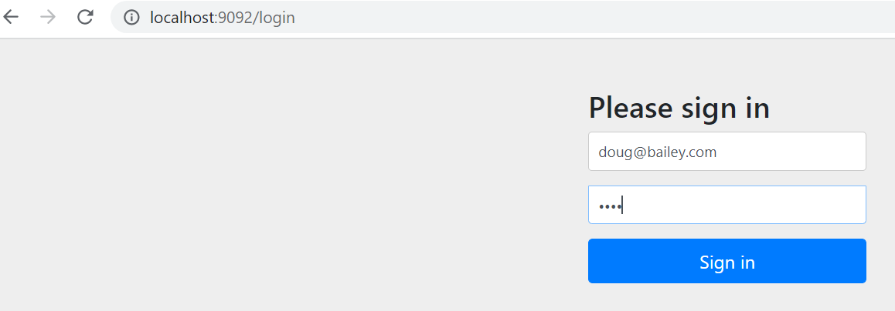

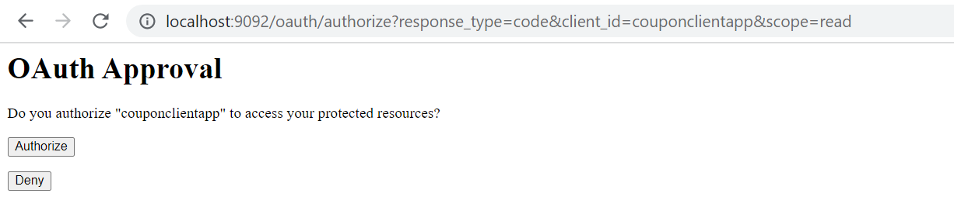

*Click on authorize :--- it will redirect to couponService since we configured different url it will return code*

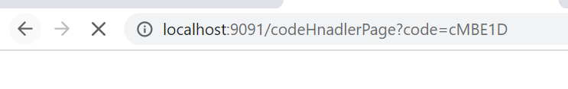

Note :

We got a code back from authorization server

**Use Code Get Token**

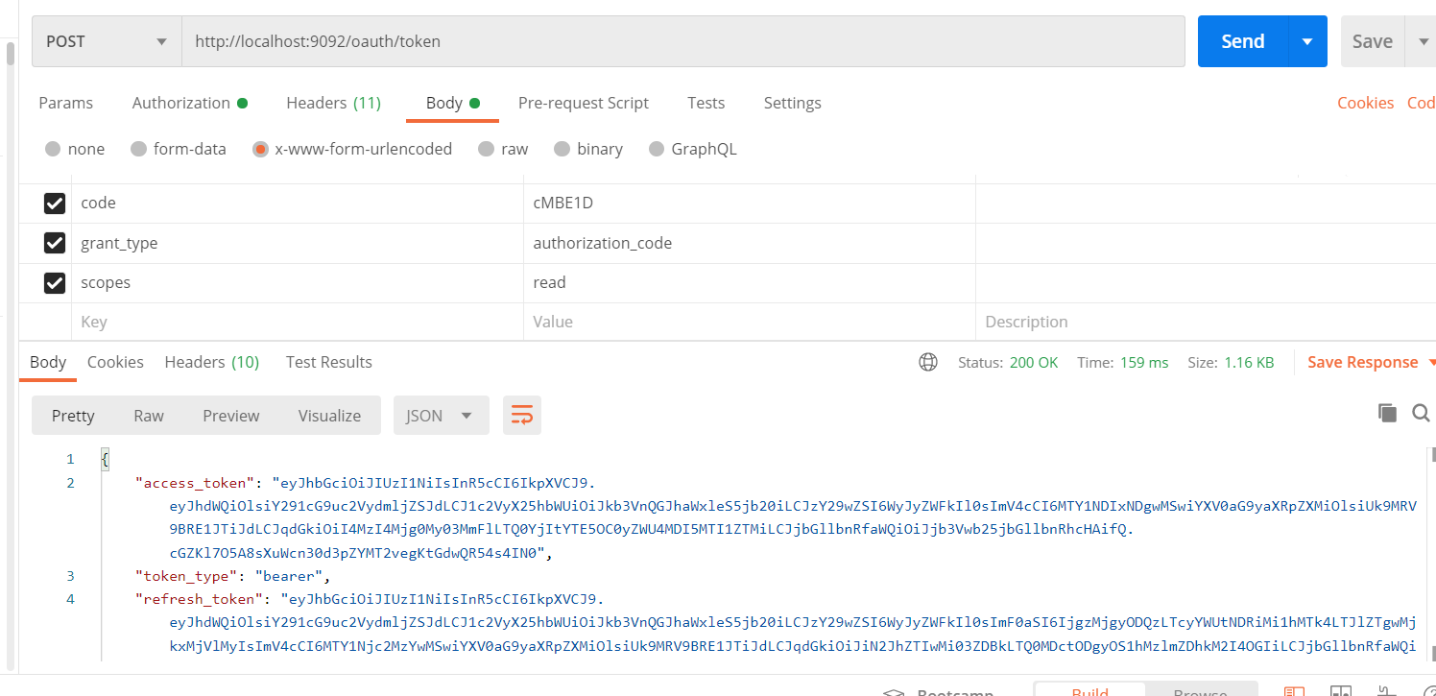

New Authorization Server

**Spring boot 2.5:**--- starting spring boot 2.5 the authorization server has been removed from spring security but it has own authorization server

**Note :-**

now authorization server is project of its own

**Code walk through**

Jwkset will both have public and private keys information that will be used by jwksource and jwtdecoder will use jwksource that how to encode and decode

**jwtSelector** knows how to read public and private key

jwtDecoder knows how to use public and private

**OIDC Debugger**

<https://oidcdebugger.com/>

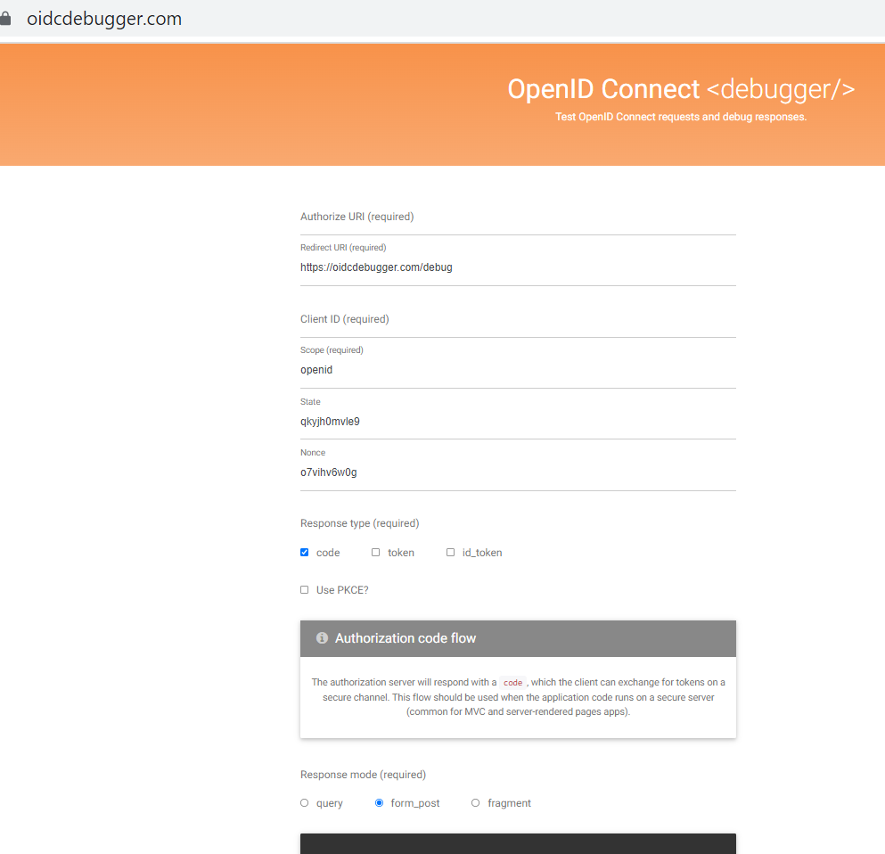

**Create Authorization Server Config**

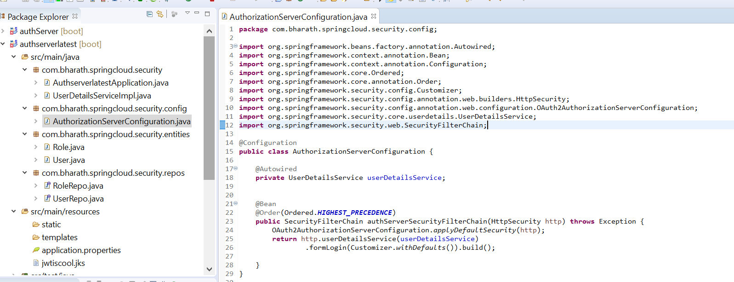

**Configure JWKSet**

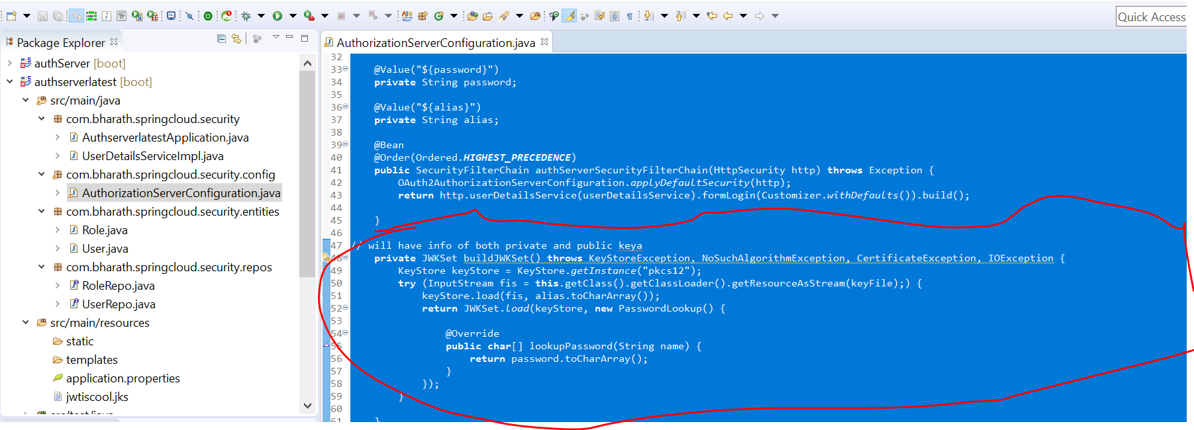

**Configure JWTDecoder**

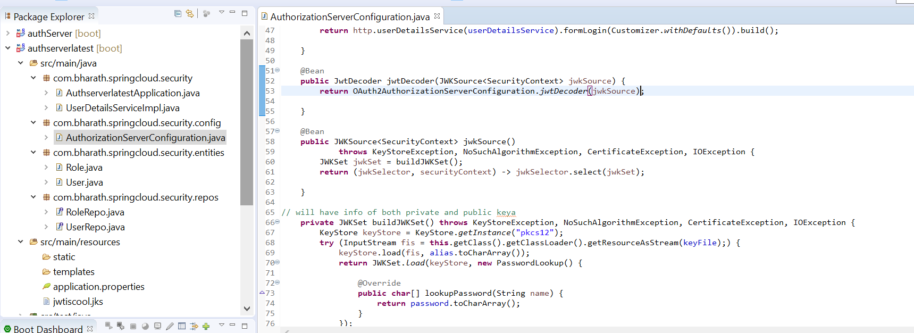

**Configure ProviderSettings**

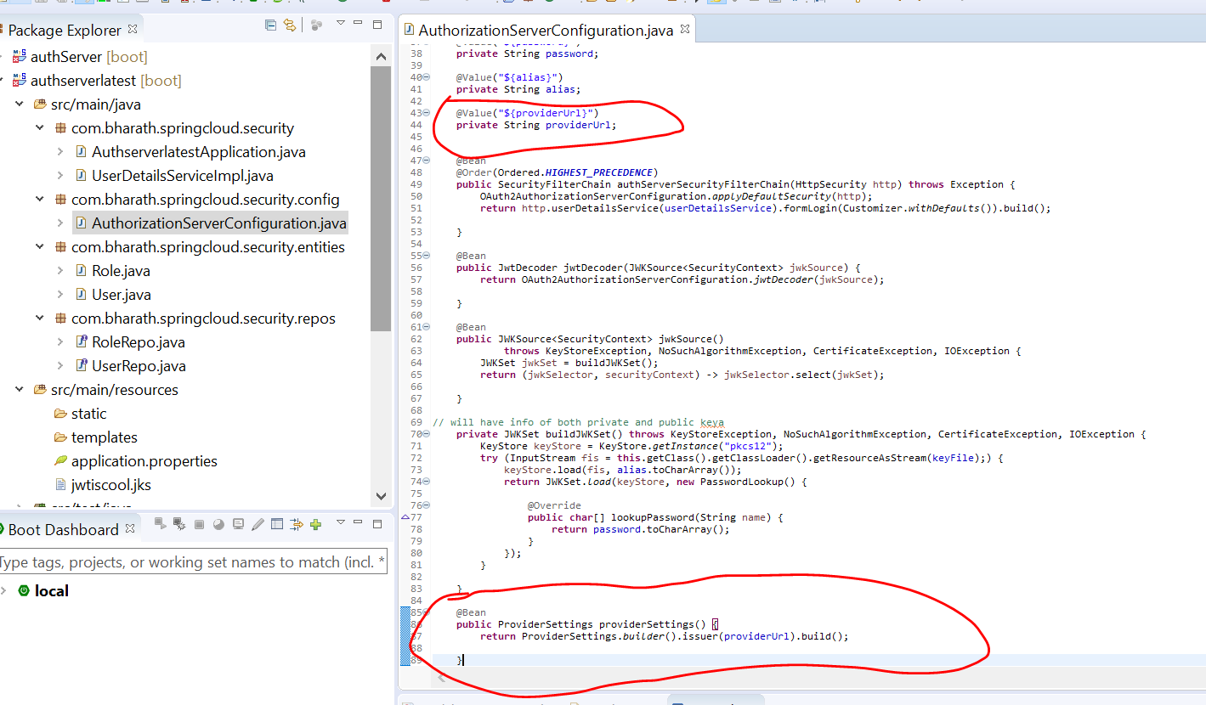

**Configure Default Security**

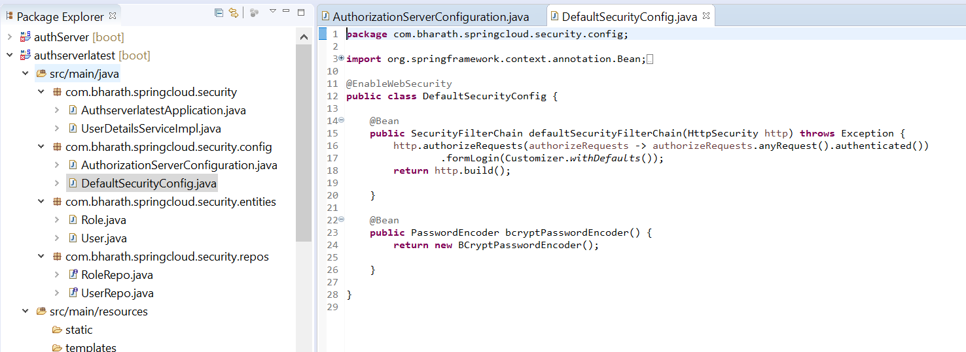

**Register Client Application**

**Objective**

Register our client application to authorization server

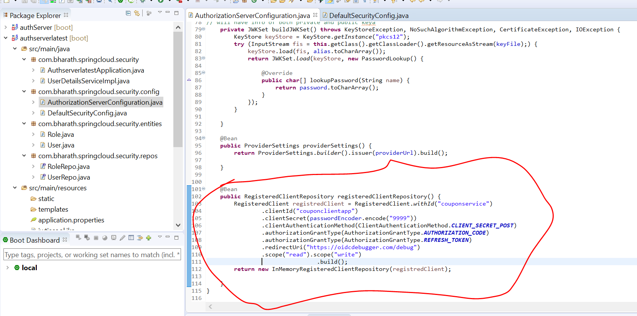

**Get Auth Code**

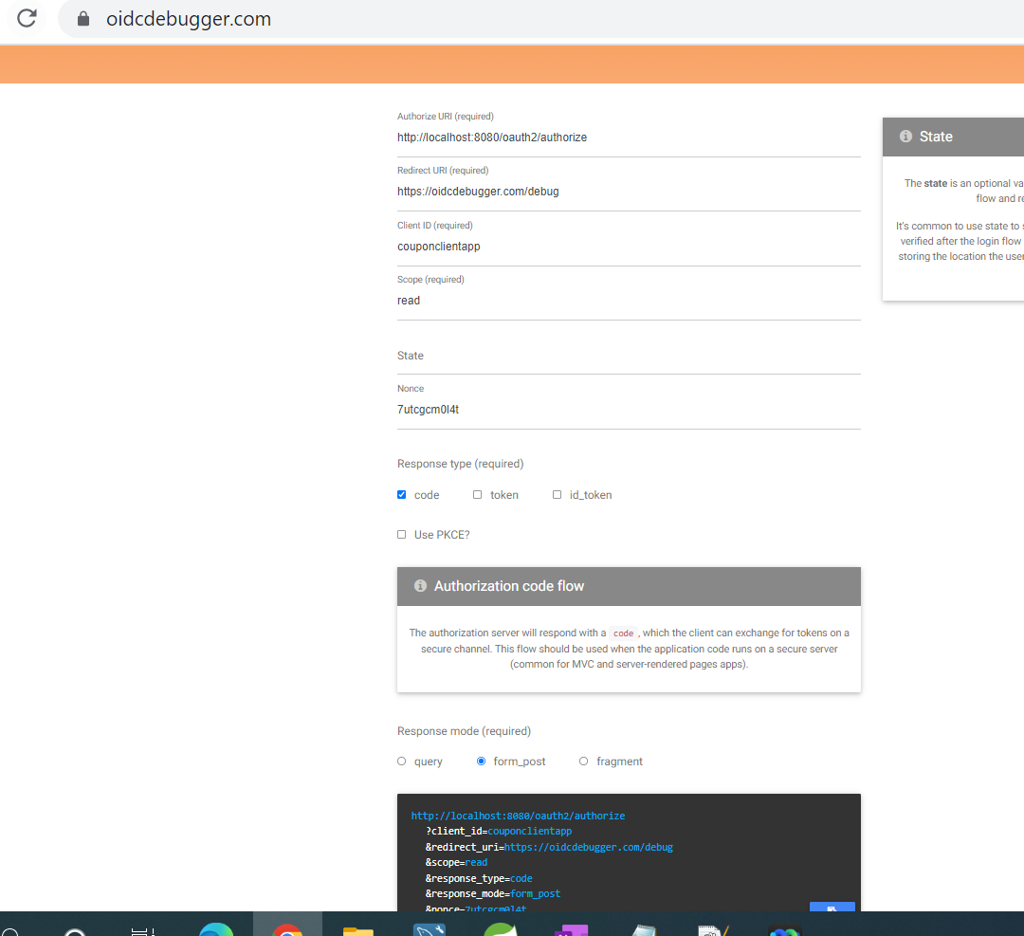

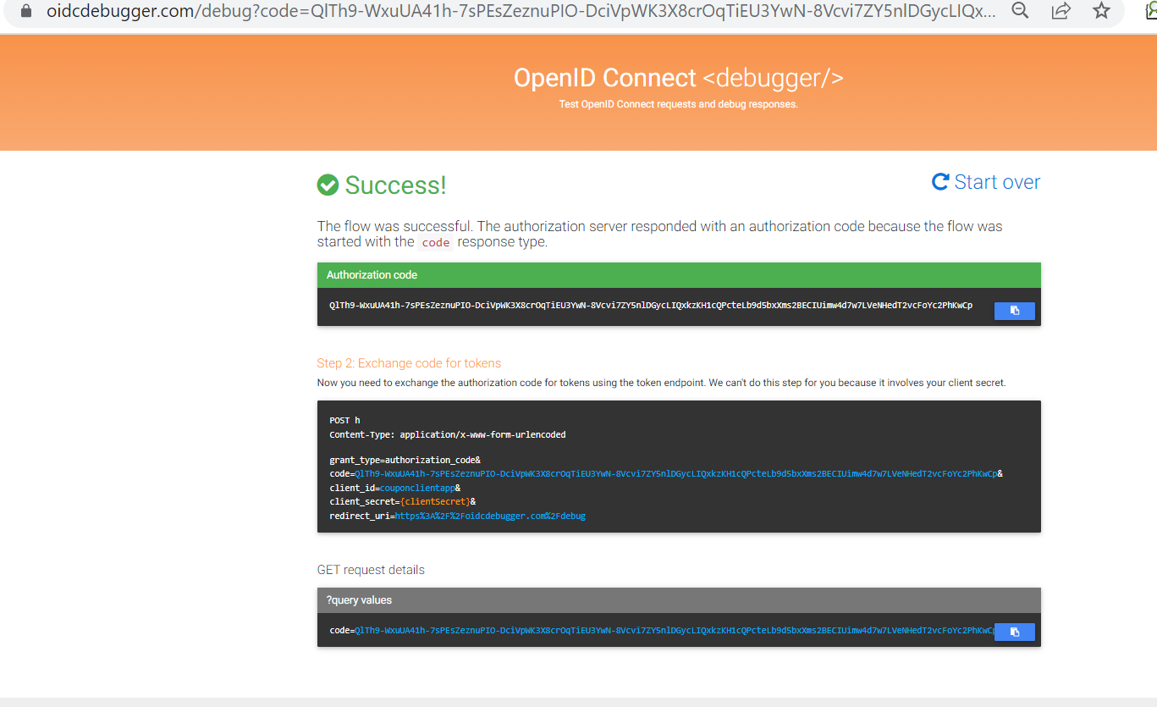

**Get Token**

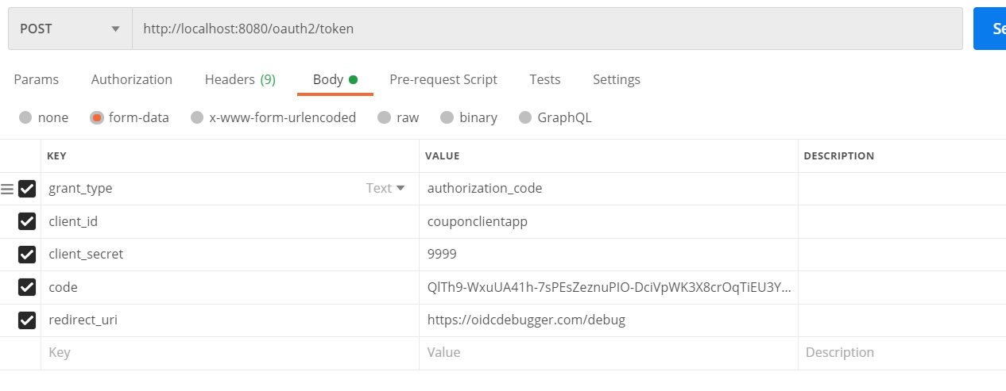

**Time setting increases**

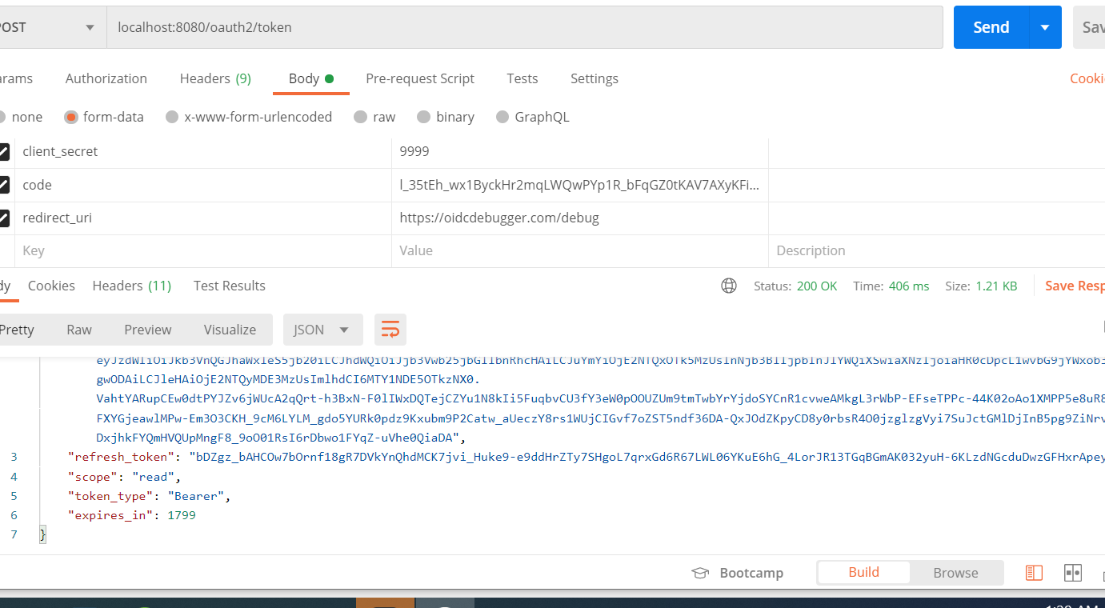

**Configure Token setting**

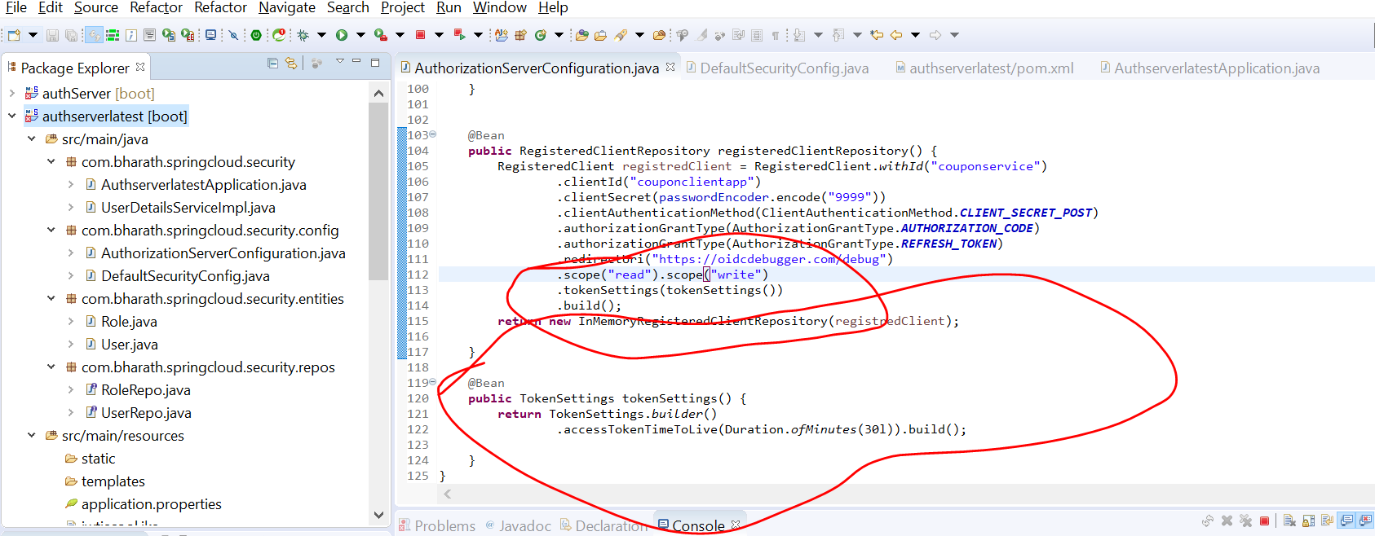

**Roles not included**

It does not have role information

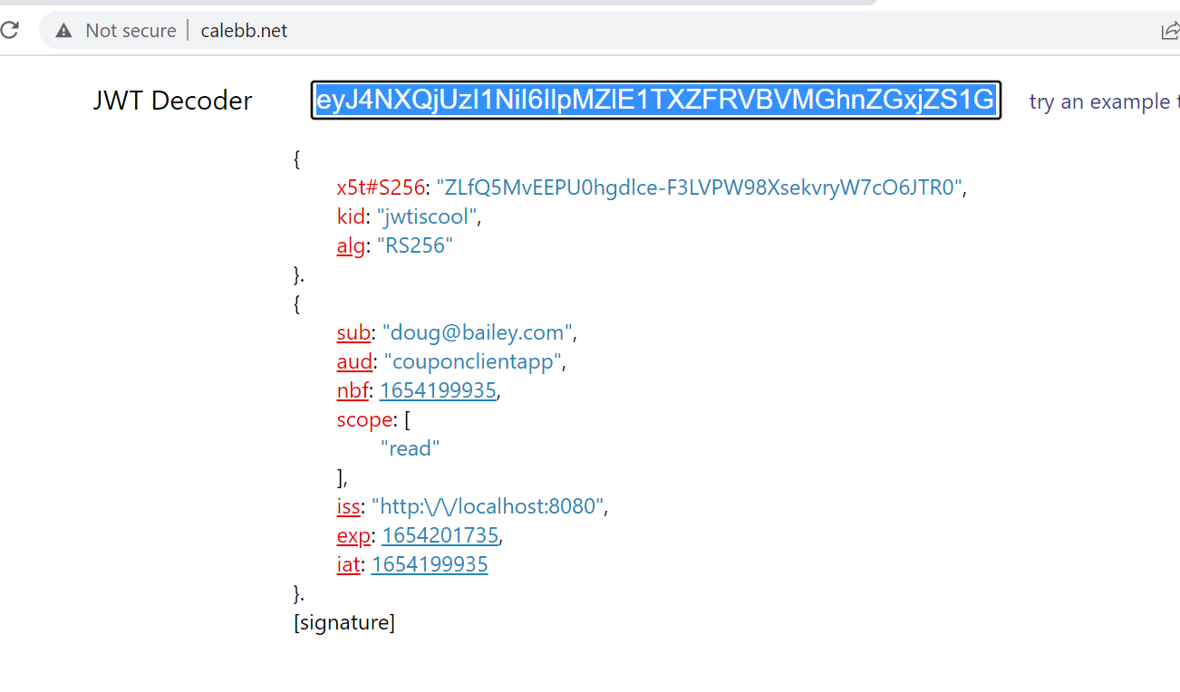

It does not include roles or authority here

Each part here is called claim

Note :

JwtEncodingContext will above image info . It has user details, role details and we can add new claim

**Configure Token Customizer**

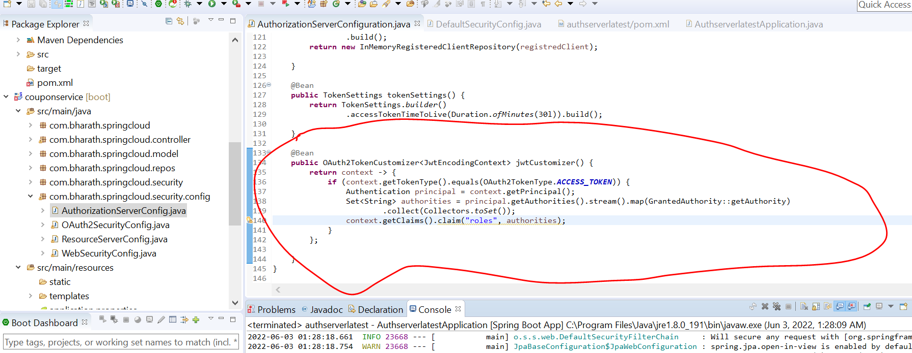

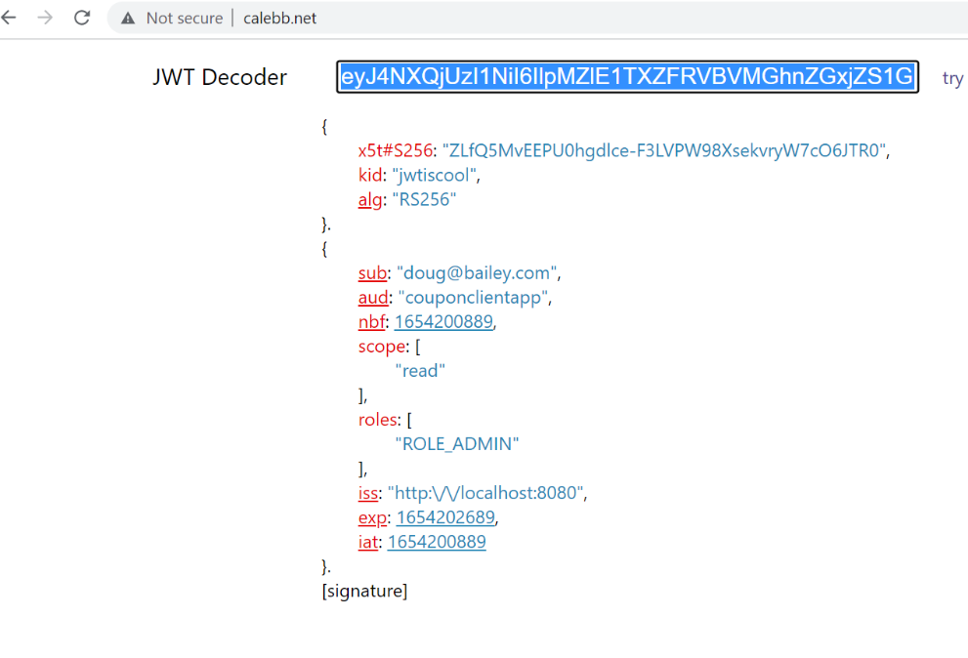

**Updated Resource Server**

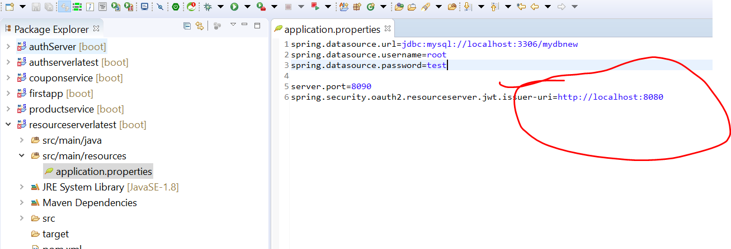

Resource server will try to connect authorization server on this url to validate the token

Notes :---

**we have extract the roles from incoming jwt token**

**Configure Resource Server and configure role converter**

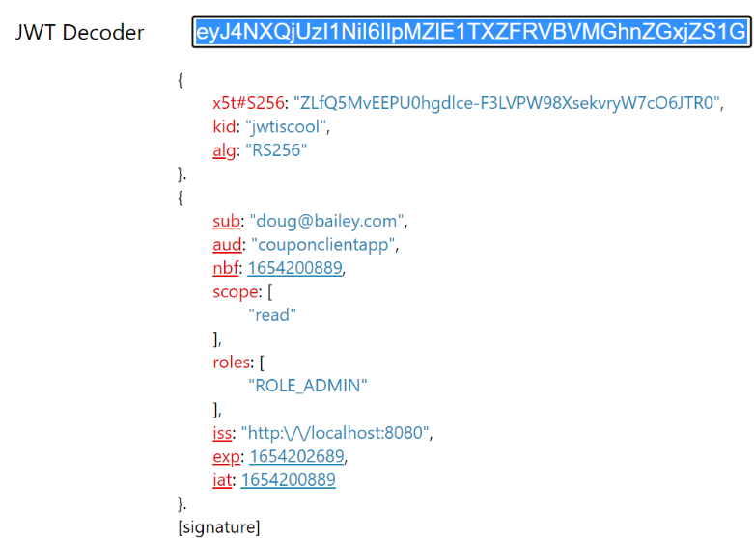

These roles should be extracted into custom converter and then exposed out as collection of granted authority

Converter :--

from what type we want to convert into what

**Jwt to grantedAuthority**

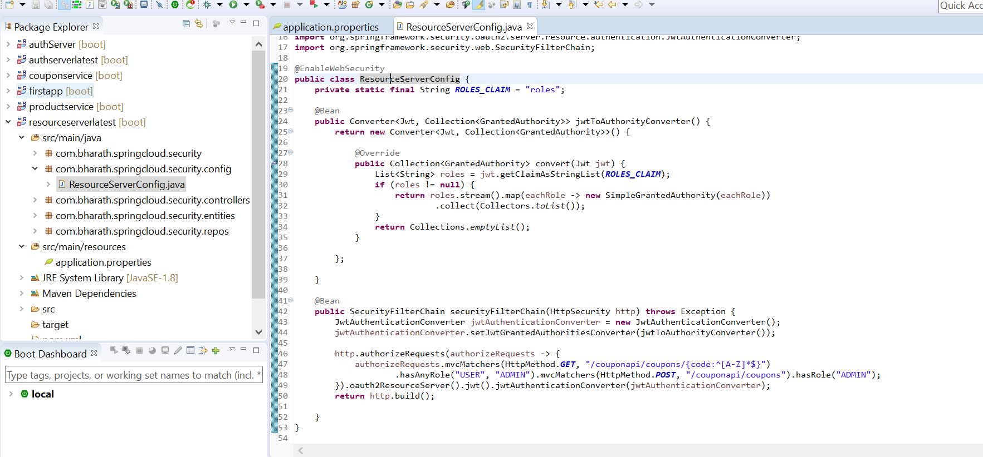

**Resource server in action**

